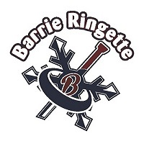
BARRIE AND DISTRICT RINGETTE ASSOCIATION NOMINATION FORM

POSITION NOMINATED FOR: _____________________

NAME: ______________________________________________________

ADDRESS: __________________________________________________

TELEPHONE: Res: (___) ______________ Bus: (___) ___________________

NOMINEE ACCEPTANCE: _______________________ _________________
SIGNATURE DATE

To accept this nomination, you need to fulfill the eligibility requirements as per the Barrie and District Ringette Association Constitution:
a) Be eighteen (18) years of age or older;
b) Not have been found under the Substitute Decisions Act, 1992 or under the Mental Health Act to be incapable of managing property;
c) Have the power under law to contract;
d) Have not been declared incapable by a court in Canada or in another country; and
e) Not have the status of bankrupt.

You understand that to be an executive member, you must comply with these requirements.

Signature: ____________________________ Name: _____________________________
_______________________________________________________________________

NOMINATED BY:

a) NOMINATING COMMITTEE 1) _____________________________
Signature of Chair

OR

b) MEMBERSHIP MEMBER 2) _____________________________
Print Name

_____________________________
Signature

_____________________________
Contact Number

*Please forward all completed forms to secretary at secretary@barrieringette.ca or contact James at 705-321-7463. Digital signatures are permitted with the above information.

