Protect Your Space |  | 
Understanding and being able to apply the notion of the cylinder is a very important concept in the game of basketball. It is most often talked about when describing a defensive player. We want to look at it from the offensive side of the ball. Below is the definition of the cylinder taken from the OFFICIAL FIBA BASKETBALL RULES 2014.

Art. 33 Contact: General principles
33.1. Cylinder principle
The cylinder principle is defined as the space within an imaginary cylinder occupied by a player on the floor. It includes the space above the player and is limited to:
• The front by the palms of the hands,
• The rear by the buttocks, and
• The sides by the outer edge of the arms and legs.

The hands and arms may be extended in front of the torso no further than the position of the feet, with the arms bent at the elbows so that the forearms and hands are raised. The distance between her feet will vary according to his height.

Cylinder principle
33.2. Principle of verticality
During the game, each player has the right to occupy any position (cylinder) on the playing court not already occupied by an opponent.
This principle protects the space on the floor which he occupies and the space above her when she jumps vertically within that space.

The offensive player, whether on the floor or airborne, shall not cause contact with the defensive player in a legal guarding position by:
• Using his arms to create more space for himself (pushing off).
• Spreading his legs or arms to cause contact during or immediately after a shot for a field goal.

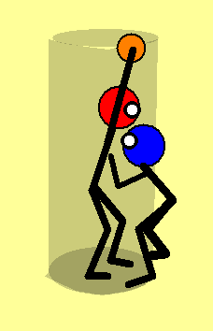 | One way that a defender will attempt to limit the effectiveness of an offensive player is by crowding or getting as close as possible to the offensive player’s cylinder as legally allowed. If unprepared for this method the offensive player can be severely hampered in her ability to play. A common error many players make is to make their cylinder smaller by getting taller with the ball. This plays into the defender’s strength as it allows her to get even closer to the player’s body.  In order to legally and effectively counter this action the player must learn to space pivot.
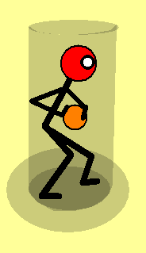 | The offensive player visualizes that she is standing on top of two circles. The inside circle is the space she occupies by her normal relaxed basketball cylinder. The outer circle is the area she must be prepared to pivot into to enlarge her cylinder and protect her body. Let’s call it her protection cylinder.
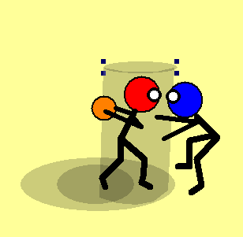 | By pivoting forward into the approaching defender she keeps the defender from getting into her body. She has shifted her cylinder forward and made it bigger by getting lower and wider. It is important that she is not pushing off with her arms. By rule she cannot extend out past her feet. A key point is that the offensive player wants to establish her space pivot to meet the defender, not wait until the defender is in place.  Note that the ball is at the back side of the cylinder, protected by the width of the offensive player’s body. Also her eyes are up looking through the defender at the actions of the other players.
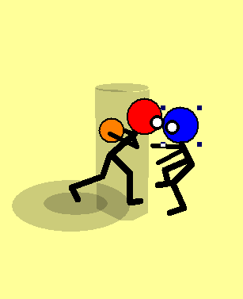 | One error players make is to step too far instead of pivoting. This puts the player in an off balance position. Also by rule she is outside her cylinder, since any body part in front of her feet is not in her cylinder. One way to check is to look at the back foot. If the player is raised up on the toe she is probably stepping and not pivoting. She is very slow to move from this position, except if she is moving forward. She usually loses her vision as well. The tendency is to look down in this position.
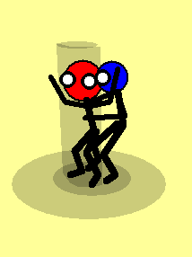 | Another situation that occurs where a small or narrow cylinder hampers an offensive player is when she is posting or sealing. If using a parallel post up, where the both feet a parallel to the passer, her cylinder is very narrow and easy for a defender to reach through to deflect a pass. It is also often confusing for the passer as to the intended target.
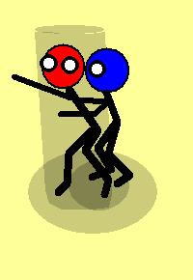 | If the sealing player can widen her cylinder by assuming a T-post up. She makes legal contact with her hip, scapula (shoulder blade) and tricep. This keeps the defender at the outer edge of her cylinder. She can now give a target at the other edge of the cylinder. This gives a clear target to the passer and makes it next to impossible for the defender to reach through the cylinder.  On receiving the pass the player can step with her foot away from the defender to keep the cylinder intact.

