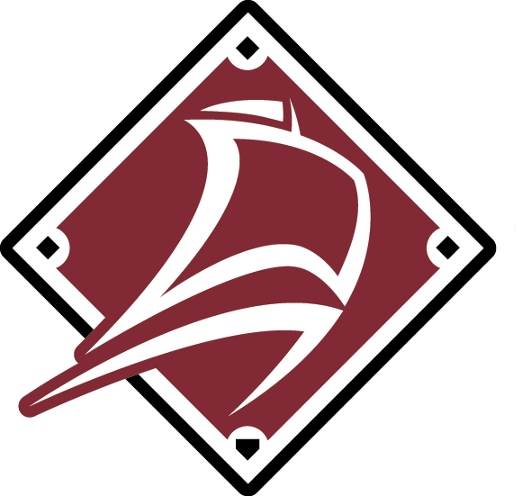
2024 Baseball New Brunswick – 13U High Performance Program
Contact Information:

Brittany Hunter
director@baseballnb.ca
506-267-0362 (office)
Baseball New Brunswick
900 Hanwell Rd. Suite 31
Fredericton, NB E3B 6A2

Information

Baseball New Brunswick will be holding tryouts for the 2025 13U High Performance team. This team will participate in the 2025 Baseball Canada 13U National Championship in Woodstock, Ontario. Players who were part of High Performance teams during the 2024 season are automatically part of the winter roster and do not have to participate in these identification sessions.

Players chosen for the winter roster will participate in winter training and practices starting in January and ending in May. Final rosters for each team will be selected in the spring.

Eligibility

The following birth years correspond with age categories.

13U – 2012 and 2013

All new players who wish to be considered for selection to a high-performance team must attend one of the evaluation sessions. Exceptions may be made for players playing in sanctioned Baseball Academies who have contacted Baseball NB before the evaluation sessions and indicated they wish to be considered.
Program Process

Stage 1 – Open Evaluation Tryouts (October 22nd & 28th)
- Saint John, September 21
- Moncton, September 22
- Fredericton, September 28
- Miramichi, October 5
Stage 2 – Winter Training
- See below
Stage 3 – Spring Season
- Spring Training
Stage 4 – Team Selection
- Final rosters will be determined for National Championships following the Spring Training/ Selection Camp
Stage 5 – Summer Season
- Bi-weekly practices
Stage 6 – Competition
- 13U National Championship, August 21st – 24th

Program Notes and Information

Winter Schedule:
Dates, times, and locations to be finalized.
Registration

Winter training registration will be available after the winter training roster is announced.

