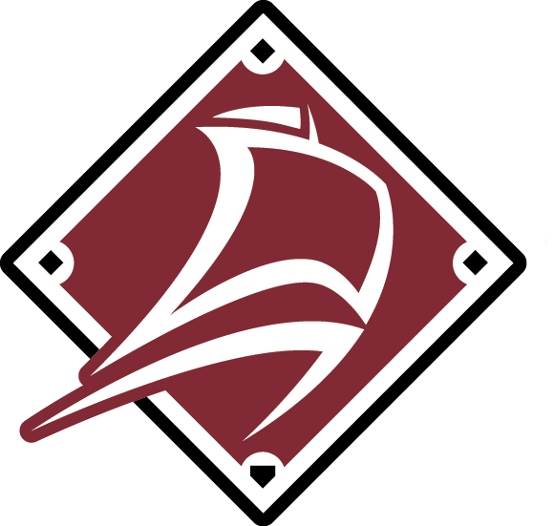
2024 Baseball New Brunswick – 15U & 17U High Performance Program
Contact Information:

Brittany Hunter
director@baseballnb.ca
506-267-0362 (office)
Baseball New Brunswick
900 Hanwell Rd. Suite 31
Fredericton, NB E3B 6A2

Information

Baseball New Brunswick will be holding tryouts for the 2025 Baseball Canada Games (17U) and Ray Carter Cup (15U) teams. These tryouts are open to any player of the appropriate ages for the 2025 events. Players who were part of High-Performance teams during the 2024 season are automatically part of the winter roster and do not have to participate in these identification sessions.

Players chosen for the winter roster will participate in winter training and practices starting in January and ending in May. Final rosters for each team will be selected in the spring.

Eligibility

The following birth years correspond with age categories.

15U – 2010 and 2011
17U – 2008 and 2009

All new players who wish to be considered for selection to a high-performance team must attend one of the evaluation sessions. Exceptions may be made for players playing in sanctioned Baseball Academies who have contacted Baseball NB before the evaluation sessions and indicated they wish to be considered.
Program Process

Stage 1 – Open Evaluation Tryouts (October 22 & 28)
- September 21st, Moncton
- September 22nd, Fredericton
- September 28th, Miramichi
- September 29th, Saint John
Stage 2 – Winter Training
- TBD
Stage 3 – Spring Season
- Spring training
- Exhibition Games
Stage 4 – Team Selection
- Final rosters will be determined for National Championships
Stage 5 – Competition
- Canada Games, St. John’s, NL
- Ray Carter Cup, Summerside, PEI, August 21-24

Program Notes and Information

Winter Schedule: Information to follow

Additional sessions will be booked in May when facilities become available.
*Dates, times, and locations subject to change.
Schedule
Registration

To register, please follow this link: http://nbbaseclub.rampregistrations.com

