ABA Annual Membership Purchase

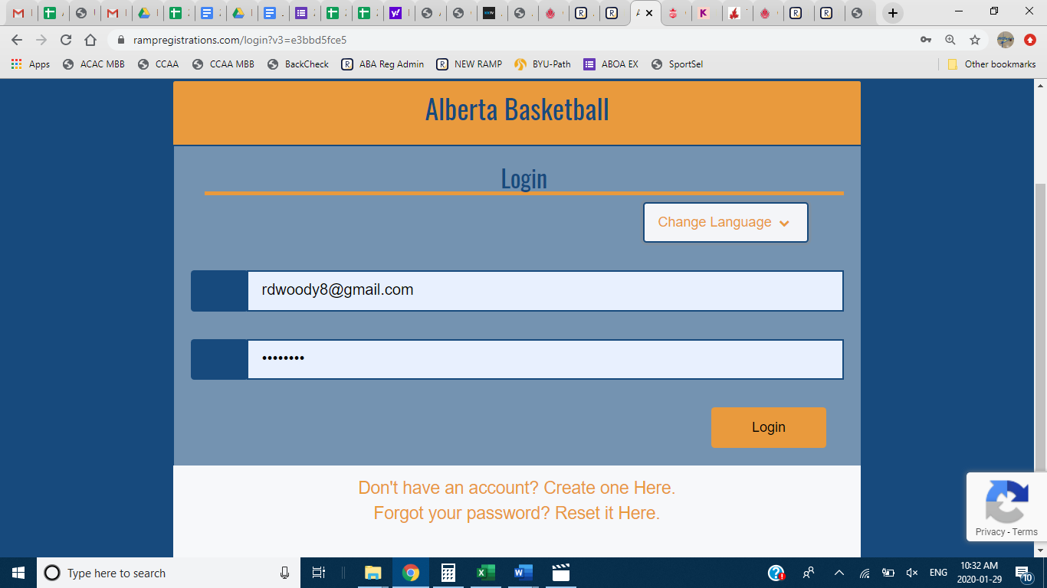
Password
Email address
- Log in with your RAMP credentials. If you have used RAMP before in any platform (other sport organization) you will be able to use that log in. If you have never been on RAMP before you will have to create an account.
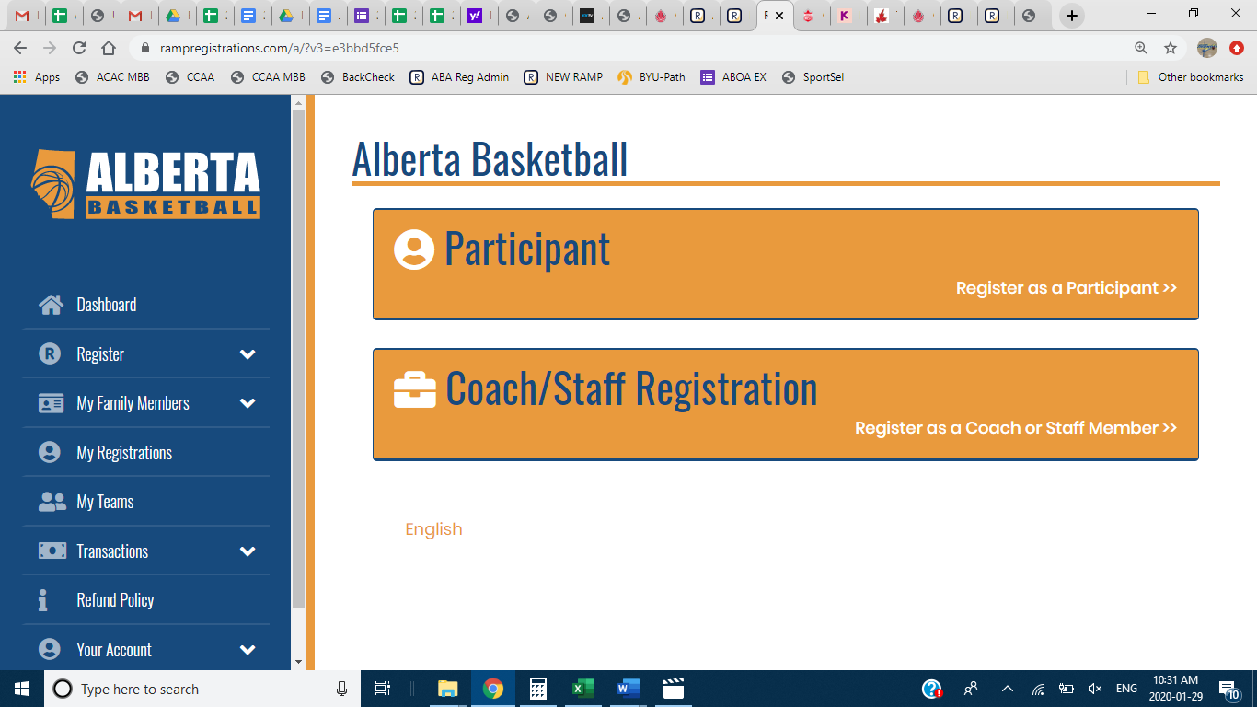
- Once logged in you will see the choice to register as a Participant (Player) or as a Coach/Staff. Please select the Participant option if you are registering your child for an ABA Membership.

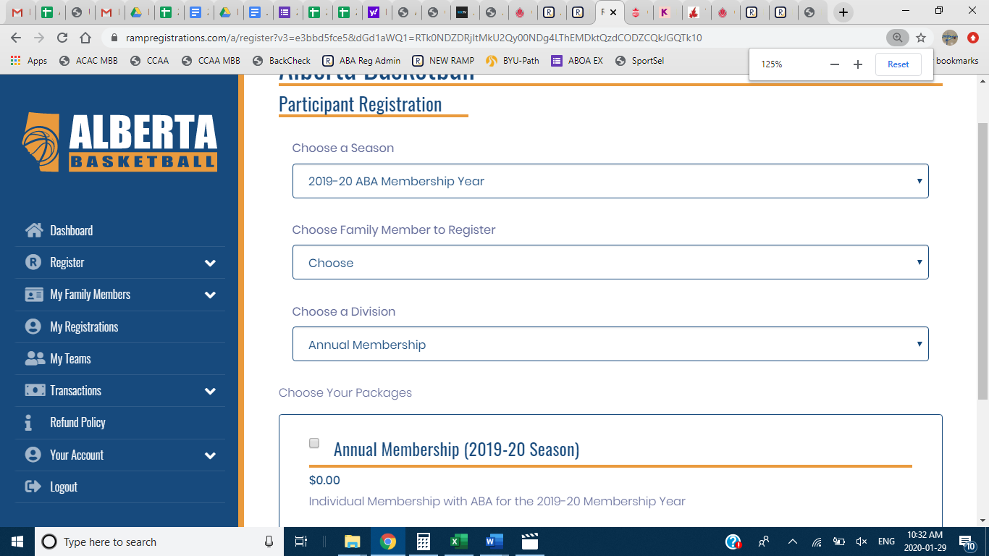
- You will select the family member you wish to register. If you are a parent registering your child you will have to “Add Family Member” if this is your first visit in the RAMP system. If you have been in previously their information should be there.
- You will then select the “Annual Membership” package. It will say $0.00. Select it anyways.

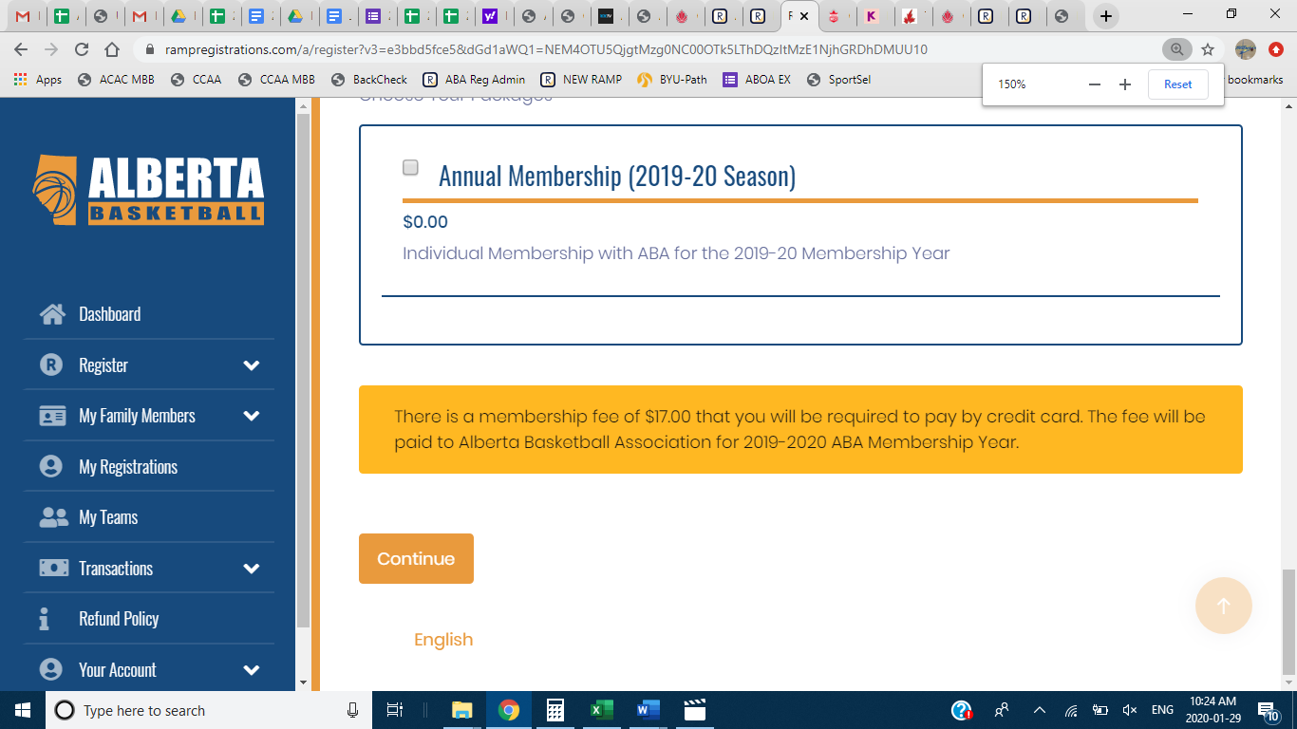
- Once you have selected that package you will see the orange dialogue box that will have the message you see above for the $17.00 ABA Membership Fee.
- Continue through the remaining steps until you reach the payment page. Under Pricing details, it will say $0.00. Under Membership Fees it will say $17.00. We have set it up this way so that you are not double charged for your membership. The system is set up so that your first package purchase in a Membership year with ABA requires you to purchase your annual membership. After you have completed this purchase on your first log in, the orange dialogue boxes regarding purchasing membership with ABA will not appear. The $17.00 Membership is to be paid online via credit card.

