2018/19 AAA Sharks- Directors Report
Board members:
Dave Amson-Director Darcy Peterson-Secretary Jeanne Gilchrist-Treasurer
BMHA Reps- Patricia Meiklejohn/ Bruce Yockey
Members at large- Rob Blais/Ashley Rafuse/Steph Green
Parent Reps- Dwayne Biever/ Dean Rowley
Coaching Staff
Kelsey Harder- Head Coach Doug Milne- Assistant Coach
Tammy Glynn/Vern Hiebert- Manager
Strength and Conditioning (Pipes Fitness)- Miranda Weise
The year started with the SHA mandating one team from the AAA SFMHL be eliminated from the league to allow a Bantam AA league to rise. Our board and volunteers in the NW hockey communities worked extremely hard to put a very professional and proposal in to SHA. We also created a video that went viral and had more than 16,000 views.
https://www.facebook.com/1447271205578615/videos/174755870076320/
Momentum is continuing to grow with one of our strongest records since the start of the AAA Sharks. We finished 6th in the league this year and set some franchise records for wins. We had some key players hurt over the year that impacted our record as well. We had a completely new coaching staff this year and along with managers. It was a big learning curve for all and everyone learned to work well together. I’m proud of the girls and know they have grown as players and young women.
We have 6 graduating players and they all received scholarships to continue playing hockey. That in my opinion marks the success of the team. Since the Sharks started in the SFMHL, there have been a total of 33 young women from the Sharks AAA Program advance with College scholarships. Keeping in mind,that all the girls that have played with the AAA Sharks have grown as players as they learn leadership and life valued lessons.
This year we picked 19 forwards, 2 goalies and 7 defence for the season. Seven of these players were rookie players and very young and will be key cornerstones to building our program going forward. The team attended a preseason tournament in Calgary and competed very well. The team also had a strong enough record to be invited to the Mandy Schwartz tournament and competed well.
The team ended the year in 6th place, 33 points with 7 Wins, 13 Losses with 8 OT games while winning half of these. Our goal is to continue on our path to improve on these numbers and to be a minimum 500-club while showing growth year over year in the program. We will strive to grow our player’s skill set, team work and abilities by working closer one on one.
The season ended in first round of playoffs against Swift Current.
Battleford’s drawing area is growing and needs to continue so we can build a competitive team. We need to work closely with surrounding towns within 1 to 1½ hours from Battleford to make them feel like they are local girls and hopefully they will look at Battleford as their place of choice to play AAA hockey. Growing a strong female program for all levels of hockey based in North Battleford is key.
We had more girls than ever billet this year, and I really appreciate the great group of billet families. We will be looking at growing this list since we are expecting more girls to billet next year.
We also had a great group of sponsors this year that we want to thank.
I would like to thank Kelsey and Doug for coaching, the AAA Shark’s Board and Tammy/Vern for helping with the growth of the Battleford AAA Sharks program this year. Everyone from the coaches, managers and Board Members put everything they can into this program with long hours and key advice. This will continue to build our program and make the Battleford AAA Sharks one of the top teams’ players will want to play for now and in the future.
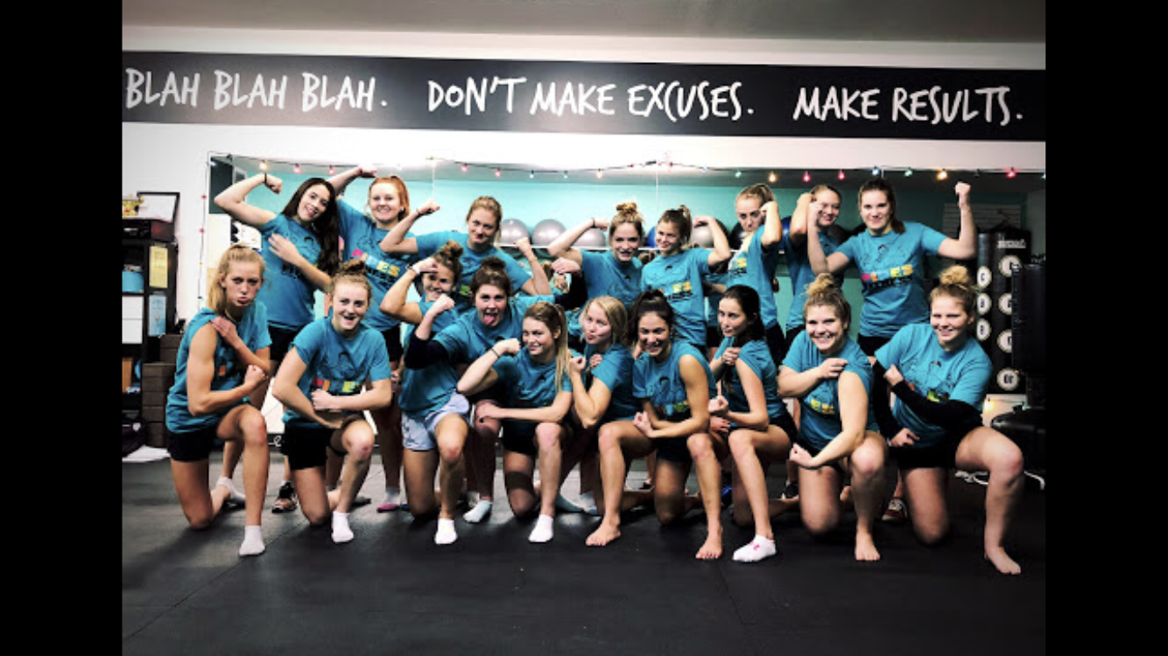

Dave Amson
Director Battlefords AAA Sharks

