Battlefords Minor Hockey Association – Coaching/Managing Guide
Table of Contents
Introduction…………………………………………………………………………………………………………………………Pg. 2
Code of Conduct, Social Media Policy, Bullying Policy……………………………………………….……….Pg….2
Certification Requirements……………………………………………………………………………………..…….Pgs. 3 - 8
U7…………………………………………………………………………………………………………………………..………..…Pg. 3
U9…………………………………………………………………………………………………………………………..…………..Pg. 3
U11………………………………………………………………………………………………………………………………………Pg. 4
U13………………………………………………………………………………………………………………………………………Pg. 5
U15………………………………………………………………………………………………………………………………………Pg. 6
U18…………………………………………………………………………………………………………………………..……Pgs. 7 - 8
U7 Player Development Chart and Practice/Drill Link…………………………………………………..……..Pg. 9
U9 Player Development Chart and Practice/Drill Link………………………………………………………….Pg. 9
U11 Player Development Chart and Practice/Drill Link……………………………………………………...Pg. 10
U13 Player Development Chart and Practice/Drill Link…………………………………………………….…Pg. 10
U15/U18 Player Development Chart and Practice/Drill Link……………………………………………...Pg. 11
Need Some Help?.…………………………………………………………………………………………………………....Pg. 12
General Information, CRC, Coach/Manager……………………………………………………………………….Pg. 13
Game Day, Parent Meeting……………………………………………………………………………………………….Pg. 15
24-hour Rule, Team Rules…………………………………………………………………………………………………Pg. 16
Budget, Financials, Fundraising…………………………………………………………………………………………Pg. 17
Jerseys, Tournaments……………………………………………………………………………………………………….Pg. 18
Referee…………………………………………………………………………………………………………………………….Pg. 20
Game Sheets, Bad Weather, Extra Ice Time, Website……………………………………….………………Pg. 21
Complaints, Suspended Players/Coaches………………………………………………………………………….Pg. 22
Reference Links………………………………………………………………………………………………………………..Pg. 23

Introduction
www.battlefordsminorhockey.ca
Thank you for volunteering to Coach/Manage in Battlefords Minor Hockey Association while everyone’s volunteer time is valuable, the coach/manager’s role is critical as he/she will directly influence the experience the players will have and the formation and development they will undergo as hockey players and young members of our community. The objective of this guide is to provide information to assist and guide the team coach/manager, with the necessary basic information required to successfully lead and operate your team in the BMHA / STEP/ AA Leagues. There is of course, no manual that can teach you to be a perfect coach/manager. Your success will depend on your commitment to acquiring the technical, interpersonal and leadership skills needed to fulfill the demanding position of being a coach/manager. If you choose to dedicate yourself to this development, being a coach/manager will be a fulfilling and gratifying experience for you. Through a selection process, the coach has been appointed by the Director of Hockey Operations and the Board of Directors. The Head Coach is ultimately responsible for the team during the season and will make any final decisions. The manager, usually a parent or someone who is associated with the team, is selected by the Head Coach. You are a critical member of your hockey team and we want to thank you and the other countless volunteers who generously give their time, resources, energy, and talents to our players and programs. This manual is to serve as an information guide that should make your jobs easier.
- Team Officials are responsible for the control and conduct of players on and off the ice.
- The coach is to ensure that all players receive an equal share of ice time, except where disciplinary action is required. AA ice time expectations may be different.
- Team Officials are responsible for thoroughly knowing BMHA Bylaws and Constitution posed on our Battlefords Minor Hockey website under the ABOUT tab.
- Coaching Requirements: ALL COACHES AND TEAM OFFICIALS MUST OBTAIN A CRC FROM THE RCMP EVERY THREE YEARS.
- Another goal we want to promote is the progression of coaches. Let your assistant coaches learn to plan and run a practice. That will give them confidence to Head coach a team moving forward.

CODE OF CONDUCT: https://hockeysask.ca/members/handbook/code-of-conduct
SOCIAL MEDIA POLICY: http://www.battlefordsminorhockey.ca/content/hockey-saskachewan--social-media-policy
BULLYING POLICY: https://hockeysask.ca/members/handbook/bullying-harassment-and-abuse---maltreatment

Certification Requirements

U7
CERTIFICATION REQUIREMENTS BY POSITIION
- Head Coach
  - Respect in Sport (Online)
  - Hockey University (HU) - Planning a Safe Return to Hockey (Online)
  - Coach 1 - Intro
    - Hockey University (HU) - Coach 1 / 2 (Online)
    - Hockey Sask - Coach 1 (Online Classroom)
    - Coach 1 - On-Ice Session
- Assistant Coach
  - Respect in Sport (Online)
  - Hockey University (HU) - Planning a Safe Return to Hockey (Online)
  - Coach 1 - Intro
    - Hockey University (HU) - Coach 1 / 2 (Online)
    - Hockey Sask - Coach 1 (Online Classroom)
    - Coach 1 - On-Ice Session
- Manager, Trainer, Volunteer, Bench Person
  - Respect in Sport
  - Hockey University (HU) - Planning a Safe Return to Hockey
ADDITIONAL CERTIFICATION REQUIREMENTS FOR TEAM
- Hockey Canada Safety Program
  - HCSP Level 1 or HU SAFETY – One (1) of the registered team officials (manager, coach, trainer or volunteer) must have this certification
*FEMALE REGISTERED TEAMS MUST HAVE A MINIMUM OF ONE (1) REGISTERED FEMALE COACH*

U9

MALE/CO-ED and FEMALE
CERTIFICATION REQUIREMENTS BY POSITION
- Head Coach
  - Respect in Sport (Online)
  - Hockey University (HU) - Planning a Safe Return to Hockey (Online)
  - Hockey University (HU) - Online Checking or Checking Skills 1
  - Coach 1 - Intro
    - Hockey University (HU) - Coach 1 / 2 (Online)
    - Hockey Sask - Coach 1 (Online Classroom)
    - Coach 1 - On-Ice Session
- Assistant Coach
  - Respect in Sport (Online)
  - Hockey University (HU) - Planning a Safe Return to Hockey (Online)
  - Coach 1 - Intro
    - Hockey University (HU) - Coach 1 / 2 (Online)
    - Hockey Sask - Coach 1 (Online Classroom)
    - Coach 1 - On-Ice Session
- Manager, Trainer, Volunteer, Bench Person
  - Respect in Sport
  - Hockey University (HU) - Planning a Safe Return to Hockey
ADDITIONAL CERTIFICATION REQUIREMENTS FOR TEAM
- Hockey Canada Safety Program
  - HCSP Level 1 or HU SAFETY – One (1) of the registered team officials (manager, coach, trainer or volunteer) must have this certification
- Goalie Certification
  - Either the Head Coach or Assistant Coach MUST have this certification
*FEMALE REGISTERED TEAMS MUST HAVE A MINIMUM OF ONE (1) REGISTERED FEMALE COACH*

U11

MALE/CO-ED and FEMALE
CERTIFICATION REQUIREMENTS BY POSITIION
- Head Coach
  - Coach 2 Level
  - Respect in Sport
  - Hockey University (HU) - Online Checking or Checking Skills 1
  - Hockey University (HU) - Planning a Safe Return to Hockey
- Assistant Coach
  - Coach 2 Level
  - Respect in Sport
  - Hockey University (HU) - Planning a Safe Return to Hockey
- Manager, Trainer, Volunteer, Bench Person
  - Respect in Sport
  - Hockey University (HU) - Planning a Safe Return to Hockey
ADDITIONAL CERTIFICATION REQUIREMENTS FOR TEAM
- Hockey Canada Safety Program
  - HCSP Level 1 or HU SAFETY – One (1) of the registered team officials (manager, coach, trainer or volunteer) must have this certification
- Goalie Certification
  - Either the Head Coach or Assistant Coach MUST have this certification
*FEMALE REGISTERED TEAMS MUST HAVE A MINIMUM OF ONE (1) REGISTERED FEMALE COACH*

U13 (AA)

MALE/CO-ED and FEMALE
CERTIFICATION REQUIREMENTS BY POSITIION
- Head Coach
  - Development 1 or High-Performance 1
  - Respect in Sport
  - Checking Skills 1
  - Hockey University (HU) - Planning a Safe Return to Hockey
- Assistant Coach
  - Coach 2 Level
  - Respect in Sport
  - Hockey University (HU) - Planning a Safe Return to Hockey
- Manager, Trainer, Volunteer, Bench Person
  - Respect in Sport
  - Hockey University (HU) - Planning a Safe Return to Hockey
ADDITIONAL CERTIFICATION REQUIREMENTS FOR TEAM
- Hockey Canada Safety Program
  - HCSP Level 1 or HU SAFETY – One (1) of the registered team officials (manager, coach, trainer or volunteer) must have this certification
- Goalie Certification
  - Either the Head Coach or Assistant Coach MUST have Goaltending
*FEMALE REGISTERED TEAMS MUST HAVE A MINIMUM OF ONE (1) REGISTERED FEMALE COACH*

U13 (A/B/C/D)

MALE/CO-ED and FEMALE
CERTIFICATION REQUIREMENTS BY POSITIION
- Head Coach
  - Coach 2 Level
  - Respect in Sport
  - Checking Skills 1
  - Hockey University (HU) - Planning a Safe Return to Hockey
- Assistant Coach
  - Coach 2 Level
  - Respect in Sport
  - Hockey University (HU) - Planning a Safe Return to Hockey
- Manager, Trainer, Volunteer, Bench Person
  - Respect in Sport
  - Hockey University (HU) - Planning a Safe Return to Hockey
ADDITIONAL CERTIFICATION REQUIREMENTS FOR TEAM
- Hockey Canada Safety Program
  - HCSP Level 1 or HU SAFETY – One (1) of the registered team officials (manager, coach, trainer or volunteer) must have this certification
- Goalie Certification
  - Either the Head Coach or Assistant Coach MUST have Goaltending
*FEMALE REGISTERED TEAMS MUST HAVE A MINIMUM OF ONE (1) REGISTERED FEMALE COACH*
U15 AA

MALE/CO-ED and FEMALE
CERTIFICATION REQUIREMENTS BY POSITIION
- Head Coach
  - High Performance 1 (Certified)
  - Respect in Sport
  - Checking Skills 1
  - Hockey University (HU) - Planning a Safe Return to Hockey
- Assistant Coach
  - Development 1 or High-Performance 1 (Certified)
  - Respect in Sport
  - Hockey University (HU) - Planning a Safe Return to Hockey
- Manager, Trainer, Volunteer, Bench Person
  - Respect in Sport
  - Hockey University (HU) - Planning a Safe Return to Hockey
ADDITIONAL CERTIFICATION REQUIREMENTS FOR TEAM
- Hockey Canada Safety Program
  - HCSP Level 1 or HU SAFETY – One (1) of the registered team officials (manager, coach, trainer or volunteer) must have this certification
- Goalie Certification
  - Either the Head Coach or Assistant Coach MUST have Goaltending

U15 (A/B/C/D)

MALE/CO-ED and FEMALE
CERTIFICATION REQUIREMENTS BY POSITIION
- Head Coach
  - Coach 2 Level
  - Respect in Sport
  - Checking Skills 1
  - Hockey University (HU) - Planning a Safe Return to Hockey
- Assistant Coach
  - Coach 2 Level
  - Respect in Sport
  - Hockey University (HU) - Planning a Safe Return to Hockey
- Manager, Trainer, Volunteer, Bench Person
  - Respect in Sport
  - Hockey University (HU) - Planning a Safe Return to Hockey
ADDITIONAL CERTIFICATION REQUIREMENTS FOR TEAM
- Hockey Canada Safety Program
  - HCSP Level 1 or HU SAFETY – One (1) of the registered team officials (manager, coach, trainer or volunteer) must have this certification
- Goalie Certification
  - Either the Head Coach or Assistant Coach MUST have this certification
*FEMALE REGISTERED TEAMS MUST HAVE A MINIMUM OF ONE (1) REGISTERED FEMALE COACH*

U18 AA

MALE/CO-ED and FEMALE
CERTIFICATION REQUIREMENTS BY POSITIION
- Head Coach
  - Development 1 or High-Performance 1
  - Respect in Sport
  - Checking Skills 1
  - Hockey University (HU) - Planning a Safe Return to Hockey
- Assistant Coach
  - Coach 2 Level
  - Respect in Sport
  - Hockey University (HU) - Planning a Safe Return to Hockey
- Manager, Trainer, Volunteer, Bench Person
  - Respect in Sport
  - Hockey University (HU) - Planning a Safe Return to Hockey
ADDITIONAL CERTIFICATION REQUIREMENTS FOR TEAM
- Hockey Canada Safety Program
  - HCSP Level 1 or HU SAFETY – One (1) of the registered team officials (manager, coach, trainer or volunteer) must have this certification
- Goalie Certification
  - Either the Head Coach or Assistant Coach MUST have Goaltending
*FEMALE REGISTERED TEAMS MUST HAVE A MINIMUM OF ONE (1) REGISTERED FEMALE COACH*

U18 AA (A/B/C/D)

MALE/CO-ED and FEMALE
CERTIFICATION REQUIREMENTS BY POSITIION
- Head Coach
  - Coach 2 Level
  - Respect in Sport
  - Checking Skills 1
  - Hockey University (HU) - Planning a Safe Return to Hockey
- Assistant Coach
  - Coach 2 Level
  - Respect in Sport
  - Hockey University (HU) - Planning a Safe Return to Hockey
- Manager, Trainer, Volunteer, Bench Person
  - Respect in Sport
  - Hockey University (HU) - Planning a Safe Return to Hockey
ADDITIONAL CERTIFICATION REQUIREMENTS FOR TEAM
- Hockey Canada Safety Program
  - HCSP Level 1 or HU SAFETY – One (1) of the registered team officials (manager, coach, trainer or volunteer) must have this certification
- Goalie Certification
  - Either the Head Coach or Assistant Coach MUST have this certification
*FEMALE REGISTERED TEAMS MUST HAVE A MINIMUM OF ONE (1) REGISTERED FEMALE COACH*
U18 AAA

MALE and FEMALE
CERTIFICATION REQUIREMENTS BY POSITIION
- Head Coach
  - High Performance 1 (Certified)
  - Respect in Sport
  - Checking Skills 1
  - Hockey University (HU) - Planning a Safe Return to Hockey
- Assistant Coach
  - Development 1 or High-Performance 1 (Certified)
  - Respect in Sport
  - Hockey University (HU) - Planning a Safe Return to Hockey
- Manager, Trainer, Volunteer, Bench Person
  - Respect in Sport
  - Hockey University (HU) - Planning a Safe Return to Hockey
ADDITIONAL CERTIFICATION REQUIREMENTS FOR TEAM
- Hockey Canada Safety Program
  - HCSP Level 1 or HU SAFETY – One (1) of the registered team officials (manager, coach, trainer or volunteer) must have this certification
- Goalie Certification
  - Either the Head Coach or Assistant Coach MUST have Goaltending
*FEMALE REGISTERED TEAMS MUST HAVE A MINIMUM OF ONE (1) REGISTERED FEMALE COACH*

U7
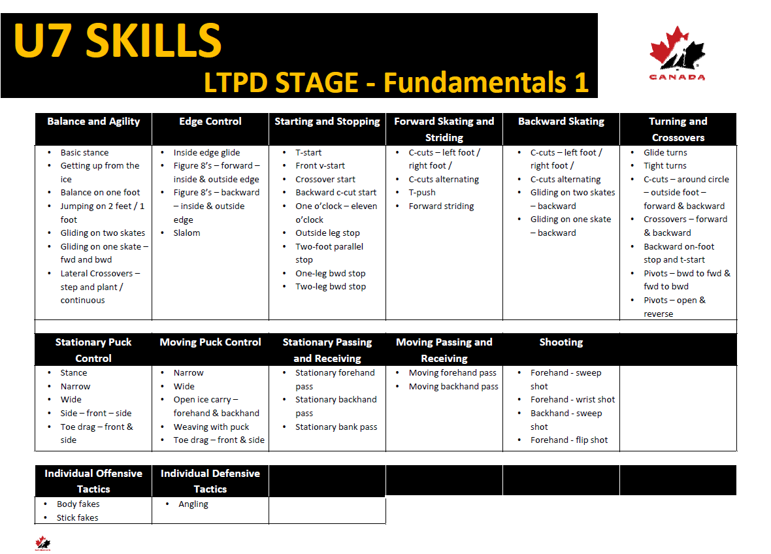
Practice Plans - https://www.hockeycanada.ca/en-ca/hockey-programs/drill-hub/under-7
U9
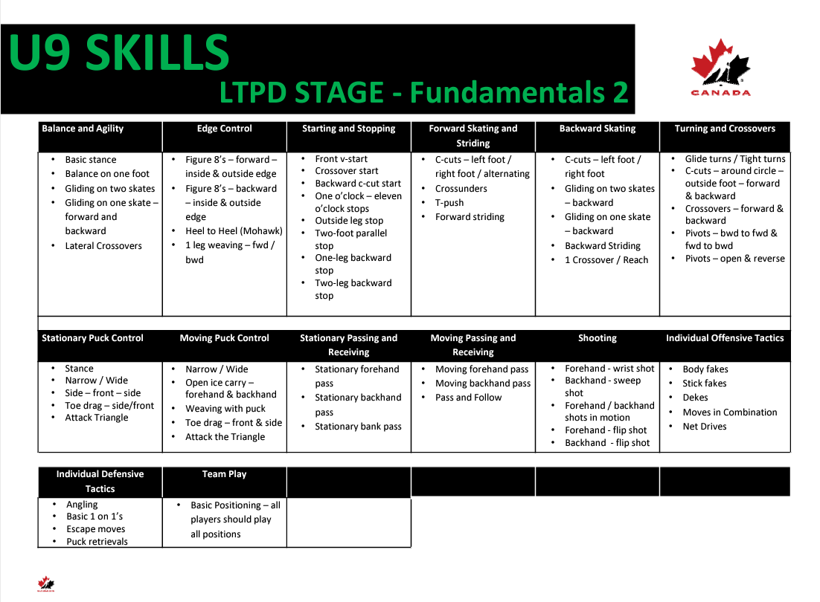

Practice Plans -https://www.hockeycanada.ca/en-ca/hockey-programs/drill-hub/under-9
U11
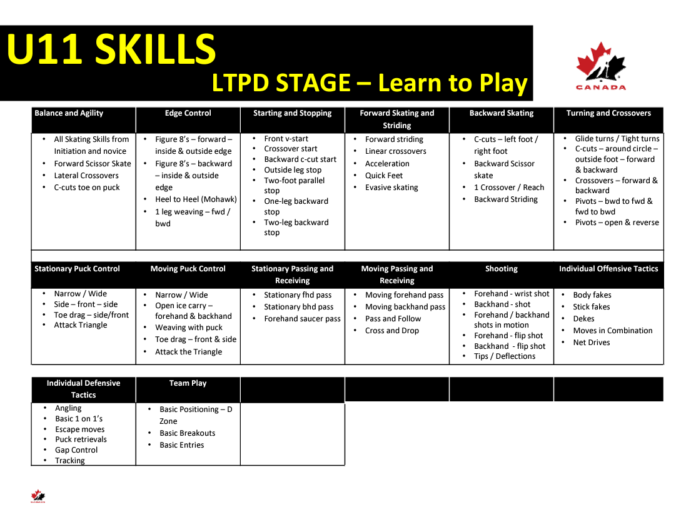
Drill Hub - https://www.hockeycanada.ca/en-ca/hockey-programs/drill-hub
Pick the appropriate Age level – Skill - Search
U13
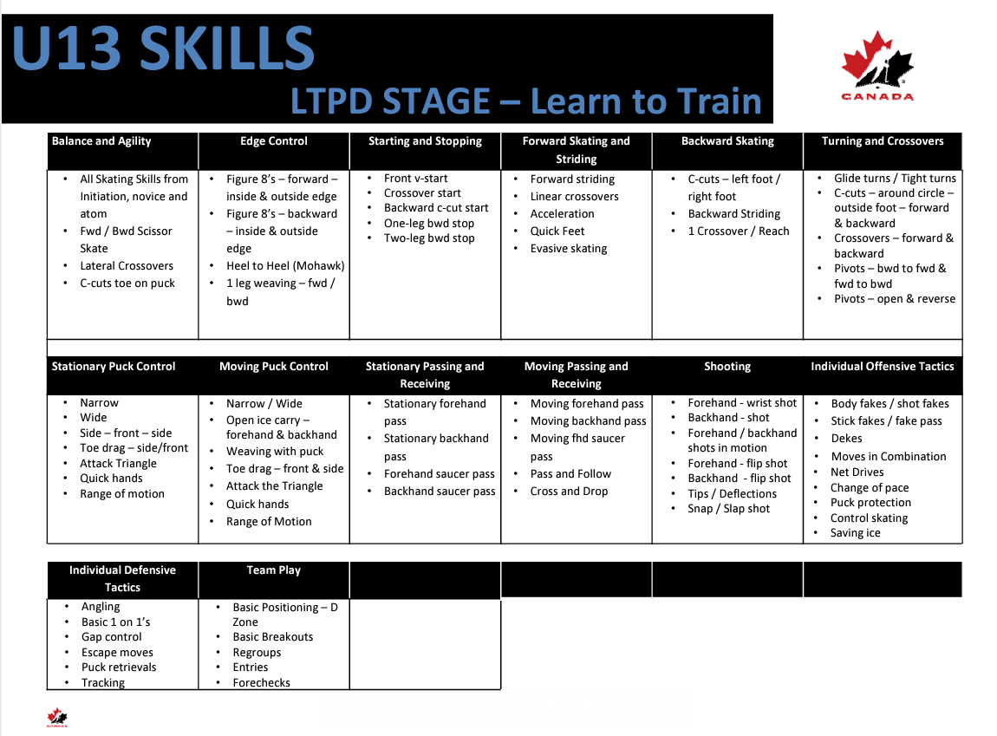

Drill Hub - https://www.hockeycanada.ca/en-ca/hockey-programs/drill-hub
Pick the appropriate Age level – Skill – Search

U15/U18
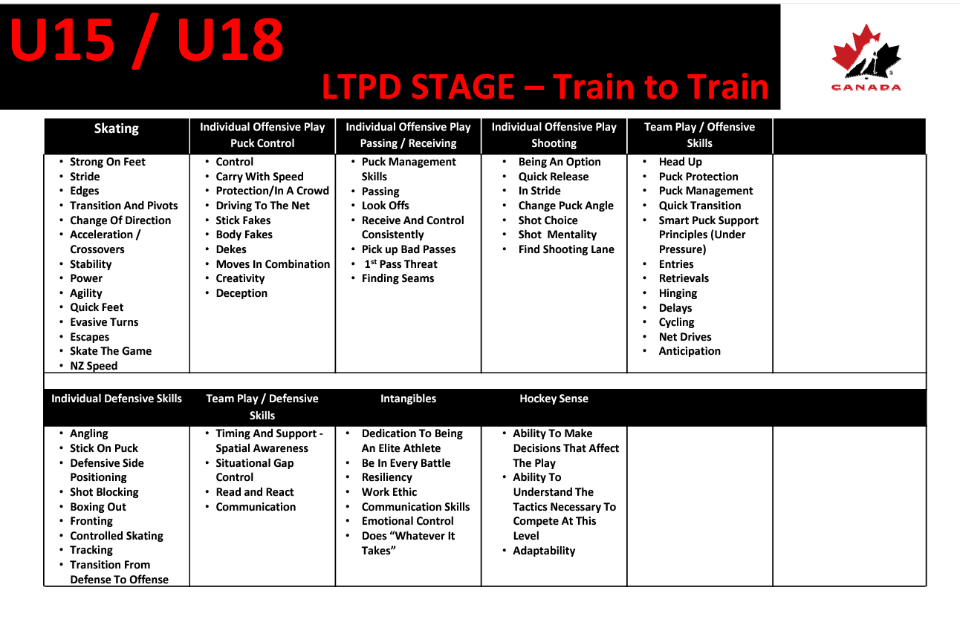
Drill Hub - https://www.hockeycanada.ca/en-ca/hockey-programs/drill-hub
Pick the appropriate Age level – Skill - Search

Do you need some help? Practice ideas, practice plans, or general ideas/plans on help run a team. Please reach out. Coach mentorship available.

Contact
Todd Heck – Coach Liaison -bmharep@sasktel.net
Kim Kramer – Coach Liaison - kkramer@ritchiebros.com

Coaches
U7 - http://www.battlefordsminorhockey.ca/division/0/3867

U9 - http://www.battlefordsminorhockey.ca/division/0/3868

U11 - http://www.battlefordsminorhockey.ca/division/0/3869
U11 A - http://www.battlefordsminorhockey.ca/team/6483/0/3869/155843

U13 - http://www.battlefordsminorhockey.ca/team/6483/0/3870/155043
U13 A - http://www.battlefordsminorhockey.ca/team/6483/0/3870/154528
U13 AA Stars - http://www.battlefordsminorhockey.ca/team/6483/0/3874/138927
U13 AA Sharks – http://www.battlefordsminorhockey.ca/team/6483/0/14349/138930

U15 - http://www.battlefordsminorhockey.ca/division/0/3871
U15 A - http://www.battlefordsminorhockey.ca/team/6483/0/3871/155963
U15 AA Stars - http://www.battlefordsminorhockey.ca/team/6483/0/3874/138928
U15 AA Sharks – http://www.battlefordsminorhockey.ca/team/6483/0/14349/138931

U18 - http://www.battlefordsminorhockey.ca/team/6483/0/3873/154628
U18 A - http://www.battlefordsminorhockey.ca/team/6483/0/3873/156400
U18 AA Stars - http://www.battlefordsminorhockey.ca/team/6483/0/3874/138929
U18 AA Sharks – http://www.battlefordsminorhockey.ca/team/6483/0/14349/138932

General Information
*All registered team officials aged 16 and over must have the Respect in Sport certification. A registered team official is any individual listed for insurance purposes. This is an individual who will be on the ice with the team at practice or on the bench during games. #8.01.01. f)
January 10 - final date for all team officials to obtain appropriate certifications. Teams will be fined $50 per infraction by Hockey Sask as per regulation 8.01.01 a)
Please remember: If an individual will ever be on the ice with the team or on the bench with the team, they must be registered with Hockey Canada for insurance purposes. Any unregistered individual who is injured on the ice or on the bench will NOT BE INSURED.
- A maximum of five (5) team officials (coach, manager, trainer and assistant coach(s)), as listed on the Hockey Sask certification form will be allowed on the team bench during the game. All coaches and assistant coaches are required to have their proper certification level as per Hockey Sask regulations. Even if circumstance arise that may prevent team officials from helping on the bench it is still that person’s responsibility to attend and complete all certification required.

CRC/VSC
It is mandatory that all Team Personnel listed on the team roster obtain a CRC/VSC no later than November 30th as per BMHA Bylaws. Coaches will be removed from bench until CRC/VSC is submitted to BMHA Office

Team Coach/Manager Duties
- Get to know the affiliation (AP) process and protocol
- Organize team meetings. This will give the parents and the Coaches a chance to meet and talk. Some teams will hold this meeting at the arena; others will plan an evening in another private area away from distractions.
- Prepare an agenda in which items such as team rules, budget, parent participation, etc., should be discussed.
- Distribute copy of the season schedule or email copy to parents. Follow up and make sure all have notification.
- Prepare a Team roster with the parents and player’s full names and addresses, phone numbers and e-mail addresses. A copy of this list should be supplied to all team members. (Some families wish to keep some of their information private so ensure all have agreed to the information being shared before sending out the information.)
- Prepare a budget based on the results of the parents meeting and what the Team wishes to accomplish for the season.
- Tournaments should be addressed immediately as they fill up fast.
- Arrange with BMHA Equipment Manager to receive the team jerseys. At the end of the season make sure they are cleaned and repaired if necessary and make arrangements with BMHA to return them as soon as your hockey season ends. Make sure all name bars are removed
- Communicate with parents regarding the league schedule, schedule changes, team news, etc.
- Complete a Tournament and Exhibition Game Form prior to any tournaments you may be attending or exhibition games.
- There are various team duties which must be done throughout the season and it is the responsibility of the Team Coach/Manager to delegate these duties to the parents on the team. A schedule should be prepared for Time Keepers, Score Keepers. Ensure parents are trained in the proper completion of game sheets and the operation of the score clocks. Further, for game volunteers a course of action should be discussed or distributed regarding whom the parent is to contact should they no longer be able to work one of their shifts – e.g., the parent may be responsible for swapping shifts or finding their own replacement.
- Help to arrange Committees e.g., Tournament Committee, Fundraising Committee
- Plan an end of the year celebration for all team members and coaching staff.
- Assisting in any team/player conflict resolution processes.
- Preparing, submitting and retaining copies of all team travel permits. Submitting exhibition games sheets to the BMHA office within 72 hours of the game
- Any other administrative duty that may arise from time to time.
- Other tasks may be fundraising, tournament committee/tournament finder, jersey care, social events, website, etc.
- Prepare and distribute a team contact list which includes player’s names, jersey numbers, telephone numbers, and parent’s names.
- Telephone/email players regarding changes in the schedule. A telephone/email committee involving several parents can also be set up to do this task. Email can be used but it’s important that ALL families have access to the information in time. For example, work emails could mean that a message sent Friday would not be received until Monday.
- Organize extra ice time either indoors or outdoors for practices or exhibition games in consultation with the Coach.
Part of the Team Coach/Manager’s role is to ensure games run as smoothly as possible. The Coach/Manager will be involved in pre-game prep, at-the-game organization, as well as post-game wrap-up.
The most important thing the Team Coach/Manager can do is delegate – it is almost impossible for a Team Coach/Manager to do everything without help. Not only will the Team Coach/Manager’s stress levels decrease, but having parents take a hands-on approach with their child’s team will increase communication among the parents. A strong parent base will make for a strong team.
Most parents will be prepared to volunteer in some capacity; a good rule of thumb is that each family should take on at least one role. There are a number of roles that need to be filled throughout the minor hockey season and most parents are more than willing to help.
The Team Coach/Manager is the keeper of the Team’s personal information. Because one never knows when a specific piece of information is needed, it is a good idea for the Team Coach/Manager to create a binder of forms and handouts that can be taken to meetings, games, etc. to keep data easily accessible. Documentation will have to be completed following all games. It is a good idea to have extra forms on hand.

Documents to include in a binder:
• Roster
• Contact lists
• Player medical forms (in a confidential folder within the binder)
• Schedules (practices, games and parent volunteers)
• Current financial information
Game Day Duties
Pre-Game
    - Open the dressing room door and if required, monitor team until coaching staff is in the room.
- Ensure you have volunteers for game clocks and game sheet
- Verify to see if game officials have arrived.
- Ensure game sheet is filled out including noting absent, affiliated or suspended players
- Ensure jersey colors do not conflict
- Ensure your game sheet matches the players who have been dressed (critical in the case of suspensions and affiliates)
- Secure the dressing room once all the players have gone on the ice.
Post-Game
    - Obtain a copy of the game sheet. Do not leave the arena without your copy of the game sheet. Send game sheet to League if they require.
    - Pay Officials and fill out officials tracking book provided by BMHA
    - Make a final check of the dressing rooms.

Parents Meeting
Team meetings are essential in the development of formal communication amongst a team and they encourage participation from all members. An initial meeting should be set up shortly following the formation of the team – for many this will be the first time they meet other parents and coaching staff.
Suggested items to cover during this meeting include:
Suggested Topics:
  - Introduction of coaches and parents
  - Coaching overview-credentials and philosophy
  - Budget
  - Team fees
  - Team jersey safekeeping of jerseys–IT IS IMPERATIVE THAT SOMEONE COLLECT ALL JERSEYS AFTER EACH GAME. THE JERSEYS ARE NEVER TO GO HOME WITH THE PLAYERS.
  - Fundraising activities: All fundraising MUST be approved by BMHA Vice President
  - Team apparel if interested
  - Coaches’ rules for players and parents
  - What are the parents’ expectations of the coaching staff?
  - Games: Regular season, exhibition, tournament
  - Practices: Structure, number, indoor or outdoor
  - Team goals
  - Possible tournaments
  - Distribute any form that needs parent attention.
  - Questions

“24 Hour Rule” –
Should an issue arise between a player/parent and coach, a 24-hour cooling off period must take place prior to any discussion of the problem. All problems of this nature are to be first brought forward to the Manager. The coach and player/parent should meet privately to address any issue and hopefully arrive at a mutually acceptable resolution. If the player/parent is still not satisfied with the outcome of this meeting, an official complaint should be lodged with the Team Manager.
No player/parent should approach any team official, referee or opposing team coach, under any circumstances. All complaints are directed through the Team Manager who will then determine the correct method of action through appropriate channels. Failure of a parent/team member to abide by these rules or procedures may mean the discipline of the person and or the player found in violation.
THIS MUST BE READ AT THE TEAM MEETING
Team Rules
- These should be determined at the first meeting of the year. These rules should be decided through input from Coaches, players and parents. Participation by all parties is important if team rules are to be followed.
• Rules should be written out and handed to each family, so they are aware of the team rules both on and off the ice. These rules are over and above association rules and deal with items such as missing practices, game arrival times, talking to the coach, parent conduct, etc.
- Ask about special concerns such as medical problems and the unavailability of players who will be on vacation or planning special trips.
- Coach should go over his/her feelings about sportsmanship and the behavior that is expected from the players during the season, win or lose. Emphasize the conduct that will not be tolerated.
- Direct special comments to the parents and emphasize the parental behavior you expect from them as part of the team and this association.
- Some parents will cover the clock and others will contribute in another manner. A list should be prepared at the beginning of the season and given to parents so they know when it will be their turn.
- Explain how the Team Manager or Coach(s) can be reached if there are any problems or concerns.
- Additional people in dressing rooms i.e., siblings, after games, women in boys’ dressing rooms, men in girls’ dressing rooms etc. should be addressed.

Budget
Budgeting issues should be discussed with the parents at the beginning of the season to ensure team expectations are reasonable. Determine what expenses cannot be avoided, what additional activities the team would like to participate in and their additional cost to the team and then, how the necessary funds will be raised and distributed.
It is then the responsibility of the Team Coach/Manager/Treasurer to formulate a “team budget” that takes account of expenses related directly to hockey. These expenses can include:

• Team Fees to the association; Jersey Rentals (AA teams, pucks etc.)
• Tournament fees
• Extra ice time
• Ref fees for exhibition games
• Year-end celebration

A. TEAM FINANCIALS
1. The teams playing in the Sask AA Hockey League will follow the AA Manual.
2. The AA teams playing in the Sask Female Hockey League will follow the SFHL Manual.
3. Team fees may be paid up front or in installments, with team manager approval.
4. Any fees above this must be achieved through team fundraising.
5. Parent Participation-any team refunds at the end of the season are dependent upon parent participation throughout the hockey season (examples: working time clock for league games/tournament shifts/fundraising endeavors/collection of jerseys after each game.)
6. As a team you CANNOT return money to your parents at year end in the amount greater than their Startup Fee.

Teams should collect at least partial team fees before purchasing team apparel, extra ice or going to tournaments. Purchasing these items before you have collected any fees may leave your team struggling to collect from some parents and thus putting the expense of these items on the remaining parents on the team. Apparel and tournaments are extras and if you have not received fees from all parents on the team you should not be purchasing such items.

Fundraising
With fundraising activities, it is important to build community support for future years; therefore, it is important not to step on the toes of any other groups or to pressure anyone into donating funds.

Teams may use a variety of means for fundraising, most typically bottle drives. Fundraising should be determined on need and parents’ commitment. As a team, it is important to discuss what set costs and what extra costs the team will face throughout the year (from tournaments to a yearend celebration). The Team Coach/Manager needs to ensure the team’s goals are reasonable and that the team has the ability and dedication to perform the chosen fundraising initiative. The team should determine up front whether the fundraiser is a team event or on a per player basis and whether minimum participation levels are required/expected, etc.

The teams budget along with the fundraising plans need to be sent to bmhavp@sasktel.net for approval.

Team Jerseys-name bars-care of uniforms (U11-U18 Teams)

Game jerseys are to be worn during games only and shall NOT be worn at practices
Game jerseys may be worn by players who are involved in a fundraising event in order to identify themselves but will not be worn to any events in which damage may occur to the jerseys.
Garment bags are to protect and carry team jerseys.

Jerseys should NEVER be given out to individual players but kept together in the jersey bag. The team coach and manager are ultimately responsible for the care of the jerseys. It is a good idea to have a dedicated Jersey Parent Volunteer. Please ensure they understand the responsibility associated with caring for the jerseys, and that proper washing instructions are followed. At the end of the season, it is the team’s responsibility to return ALL jerseys. Players not returning jerseys will be unable to register the following season or be released to another association.

  - Name bars can may be put on Team jersey’s but must be easily removed without damage to the jersey

  - Stop signs are not to be moved or covered up to have name bars added.

Tournaments
Hosting a tournament

Tournaments not only give players a great opportunity to play a tournament on their home ice but is also an essential fundraising tool for teams and. Each player’s family will be required to volunteer time to ensure a successful tournament.

      - Divisions that request tournaments will be assigned a weekend that their tournament is booked. This will mean all teams in that one division will need to work together to organize their tournament. The dates for all tournaments are indicated on the BMHA website. The registration fee for each tournament will be set by the Tournament Committee or the Division Director
      - Each team will need to have a tournament contact person for their team who is responsible for working with the other teams in your division to organize the tournament
      - BMHA teams are responsible to find visiting teams to attend the tournament, as well as to organize the game schedule and coordinate volunteers to work at the tournament.
      - Several meetings with the other teams in each division will be needed before each tournament to cover all the details.

Things to discuss at tournament meetings:

Set the Tournament fee

  - The main contact person for the entire division. This person will be the contact person for the visiting teams to find out more information about the tournament. It is important this person is established early in the season, so visiting teams know who to direct their questions to and register with in the tournament.

  - The rules for the tournament—tie breaker rules

  - The rink boss for each arena – often each division’s tournament is played at more than one arena, so there will need to be a person in charge at each arena to answer questions or to discuss problems that may arise. The rink bosses are also in charge of communicating the scores at each arena with each other, so as to keep the standing sheets updated.

  - If you will be having: prize tables player of the game awards trophies or banners for winner’s puck toss 50/50 tickets each game or one large one for whole weekend

  - Worker schedules/ Game Pucks

  - Game sheets-these will need to be picked up from BMHA filled out, and returned to BMHA by the Monday morning after the tournament

  - Posting of sanctions – sanctions are applied for by BMHA and sent to the Division Directors and will need to be posted at each rink where games are played

  - Printing of and posting of the game schedule and standing sheets for the tournament

  - Organizing of and printing of a tournament program for the weekend

  - Sending Tournament Draw to BMHA Referee Assignor minimum 2 weeks prior.

Going to a Tournament

Tournaments should be addressed immediately as they fill up fast. It is the Team Coach/Manager’s job to register for these tournaments by completing the tournament registration form and sending the required fee. Hotel accommodations must be arranged at the same time as the registration to the tournament. Accommodations will fill up fast. Tournament schedules are usually available one week prior to the tournament. Teams should be prepared to play early on Friday for most tournaments.

Managers are to review and understand all tournament rules prior to arrival at the tournament and ensure that the parents and players are aware of these rules too. This will prevent any misunderstandings upon their arrival at tournaments.

Team rules should be distributed prior to the trip. Teams must at all times remember they are representing the Battlefords Minor Hockey and that BMHA rules apply.
Suggested topics include:

- Team members and parents/guardians are representing BMHA at the rink and at the hotel.
- Be respectful to other teams both on the ice and at the hotel should you find another team staying there (i.e., no swearing or putting down other teams).
- Any damage done at the rink or hotel is the sole responsibility of the parent(s)/guardian.
- Parents/guardians are responsible to supervise their child both at the rink and the hotel at all times (unless otherwise determined).
- Team members are encouraged to have fun with their teammates but must be aware of other families, other teams with varying schedules and other hotel guests.
- Team members arrival at the rink prior to game start time is determined by the coaching staff.

Referee’s

Teams are responsible to pay for the referees for exhibition games.

Complaining to the Director, other coaches, the President or anyone in BMHA does nothing to get you heard, but only makes you look like a complainer.
Referees are not obligated to explain call to coaches and can skate away.
Getting upset at the referees by you or your staff only get your players upset.
Upset players will spend even more time in the penalty box.
Never attempt to “coach” young referees. That intimidates them and makes them more nervous and mistake prone.
Referees have good memories they will remember a coach who gives them problems.
Referees are not perfect, but they will make fewer mistakes in a game than you.
Never yell, curse or make gestures at officials, you may get a game misconduct.
Do not discuss calls or non-calls at the post game handshake. They are under no obligation to answer these.
You have no rights to critique a referee at any time.
You are still able to get suspended from the game once the final buzzer has sounded and this suspension will carry over.

If you have anything to say to a referee, a friendly approachable manner would be best, between periods or on an extended break. But remember they are NOT obligated to speak to coaches

Never approach a referee once off the ice or approach the ref room. This goes for all parents, players and team officials. Failure to observe this rule will result in immediate suspension pending review by the board.

If you feel the Referees aren’t doing a good job, BMHA hosts a referee clinic every fall. Feel free to sign yourself up. Contact our Referee Director for dates and times!

Game Sheets
Fill out the game sheet with:
- Players full names and jersey numbers (Labels are efficient and quick but remember you need three for each game sheet)
- Suspended Players must be recorded on the game sheet.
- AP players must be added to the game sheet and the letters “AP” must be beside their name.
- Game number and date should already be identified on top of game sheet if you are using a blank game sheet make sure to enter the date and teams playing.
- Date, Home team, Visiting team, league or exhibition game

- Time keeper and score keeper, usually parents of team members, should know how to record all penalties, scores, etc. Referees will sign off game sheet when game is over.
- Once a team prepares the game sheet, please then give it to the opposing team so they can complete their team information.
- After the game, a copy of the game sheet is given to the both teams. Game sheets should be kept until the conclusion of the year.
- Supplies of game sheets are available at the Arenas or the Minor Hockey Office

Bad Weather
Stormy Weather Conditions: In the case of stormy weather conditions that may prevent teams traveling on highways for league games the following process is to be used: Safety of the players is the primary concern however teams should make every effort to play scheduled league games where possible. If cancelled it is both teams’ responsibility to contact the arena, hockey coordinator and the referees to let them know of the cancellation.

Extra Ice Time
Scheduling extra ice time for exhibition games or additional practices can be done.
Booking and paying another rink for additional ice time is the team’s responsibility.
Booking and paying for the referee is the team’s responsibility, and must be approved by the Division Director.

Website
The website contains a lot of great information and links. You are encouraged to go online and check out the site.
Each team is required to put your team roster and coaches contact information on the site

The website is an effective tool for team games, practices, meetings, team events and should be utilized for your benefit as well as parents and players
Each team has their own page on the website where all this information can be put you can also put in the parents’ emails to make short work of sending out a mass email to your team

Complaint process

Over the course of the season, it’s possible that you will run into a situation that requires some form of resolution. This may be behavioral issues with a player, a parent, or even another official on your bench. When there is a disagreement or a conflict, expressing feelings and opinions in a respectful manner is vital. There may come a time where a Team Coach/Manager will have to act as a liaison between the team parents and coaches to resolve disputes. The parent should be comfortable knowing they can bring concerns to the Team Manager for any reason. The Team Manager should work with the coach and parents to first try to resolve disputes at the team level. Open communication, consistency, and mediation by the Team Manager are key. If a dispute cannot be resolved at the team level, the Team Coach/Manager should contact their Association for the appropriate next step.

Please stress to your team and parents that all conflicts require quick resolution! It is not in anyone’s interest to let problems fester. It is our goal to resolve all issues quickly and efficiently. Please help us by being diligent and not allowing things to get out of hand.

Reminder: Please use the 24-hour “cool down” period before submitting and/or responding to a complaint.

Suspended players or coaches

- Should one of your players or coaches receive a major penalty and you are unable to contact the office to receive a ruling on the infraction, DON’T LET THE PLAYER OR COACH PLAY OR BE INVOLVED IN ANY FURTHER GAMES! It is the team’s responsibility to ensure ineligible players are not playing. Playing an ineligible player could lead to forfeiting games and indefinite suspensions for Coaches, Managers and Players.

- Should one of your players or coaches receive a major penalty resulting in a suspension, that player or coach shall not be permitted to be involved in any game activity until the suspension, as handed down, has been served in its entirety. Ensure “SUSP” is noted on the Game Sheet, this provides documentation that the suspension was served.

- Any suspended Player or Coach is not permitted to go into the dressing room or go within 50 feet of the player’s bench.

- If you are ever unsure of a pending or possible suspension, please contact the office for clarification

References
Hockey Saskatchewan Certifications Requirements – hockeysask.ca
Hockey Canada Downloads - https://www.hockeycanada.ca/en-ca/hockey-programs/players/essentials/downloads
Hockey Canada Player Development -https://www.hockeycanada.ca/en-ca/hockey-programs/players/essentials
Hockey Canada Coaching Program - https://www.hockeycanada.ca/en-ca/hockey-programs/coaching/essentials
Hockey Canada Drill Hub - Drill Hub
Hockey Canada YouTube Skills Development Videos - Skills Videos
Hockey Canada Fair Play Code
Hockey Canada - Concussion Awareness
Hockey Canada - Player Medical Information
Player Communication - http://www.zoomreports.com/Asset/ZoomReports-HowToGetAthletesToListen.pdf

