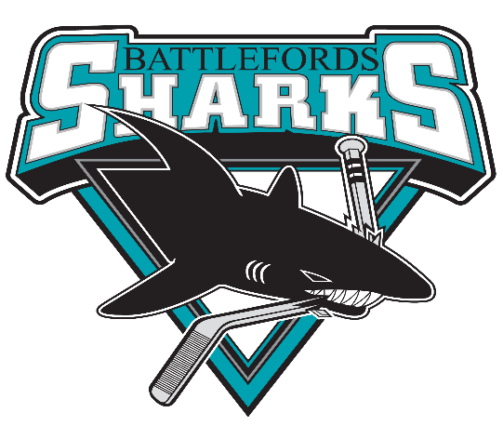

Dear Potential Sponsor,

On behalf of the Battlefords U11 Sharks, we would like to invite you to consider sponsoring our team of 18 eager young girls. We are currently seeking sponsors for our 2024/2025 season.

Our team would not be able to provide such a successful hockey program without the generous support of our community businesses and team sponsors. Through exceptional coaching and training, we will develop high quality young female hockey players with an improved game knowledge and hockey sense, while building friendships and having fun.

Your sponsorship would go directly to developing our young hockey players, not only physically but mentally and socially. Part of their growth involves practices, exhibition games, tournaments and team building activities. With the high cost of ice time, referees, tournament fees, travel and player development fees this quickly becomes a very costly endeavor.

We hope that you will be able to help support the players by sponsoring our team and we, in turn will help to advertise and promote your business.

In return for your sponsorship, we will proudly display your company’s logo on either the items you sponsored or at any home games we have.

Thank You,



Krista Nickell

Manager Battlefords U11 Sharks

[nickellkrista@gmail.com](mailto:nickellkrista@gmail.com)

1(306)441-2617