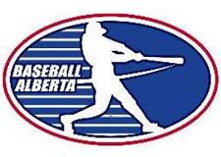

BASEBALL ALBERTA RETURN TO TRAIN COACH/VOLUNTEER ACKNOWLEDGEMENT/ AGREEMENT

I have read, understand, acknowledge the guidelines put in place by Baseball Alberta’s Return to Train document and will ensure that I, along with those players and volunteers I am responsible for, are made aware of and will follow these guidelines during all baseball activities when they are permissible to resume in my association’s jurisdiction.

X
Individual Responsible for Baseball Activities

Date

