Inputting Scores Into The Website Instructions
Step 1 - Login to your teams admin account (access to the login is shown below) on the BCSA website using the teams login and password for that season. This is provided to you by BCSA. If you do not know your teams admin information, reach out to BCSA.

Screenshot of BCSA homescreen with admin login underlined in blue
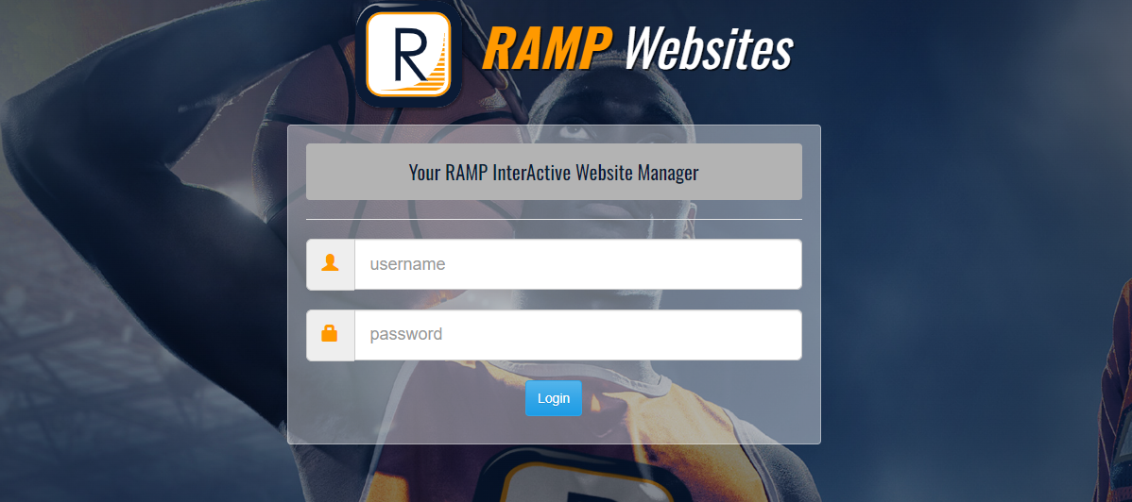
Admin login screen
Step 2 – Select “League Games” on the left side of the main dashboard.
Step 3 – Click “Gamesheet” on the right side of the game that was just finished. *This option is only available for the home team!
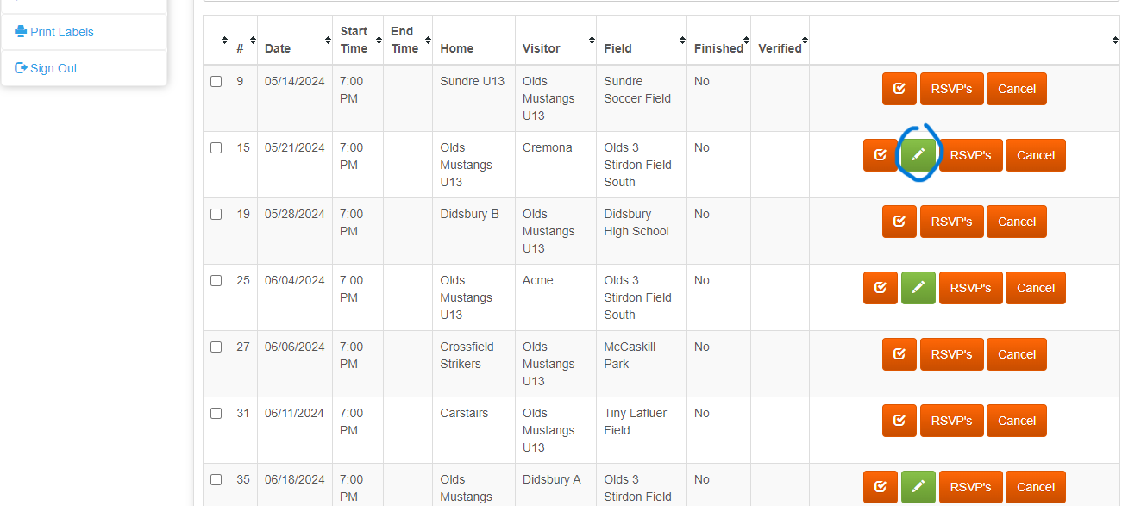
Gamesheet button circled in blue
Step 4 – On this page, the coach will have the opportunity to input the scores, update the rosters and staff, select who scored goals and upload an image of the paper game sheet. Once this is completed, simply exit the page by going to the top of the screen and clicking, “Back To Games”. This will update the game status on the BCSA page.
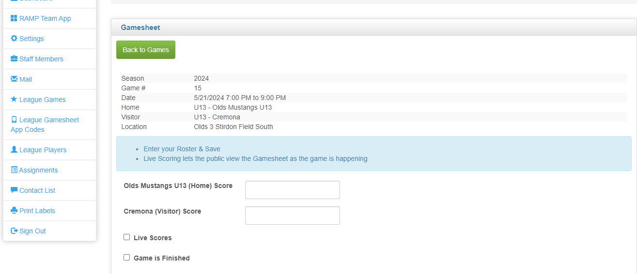
Top of the gamesheet screen where the home team will input scores, update rosters, staff and upload image of game sheet (if wanting to)
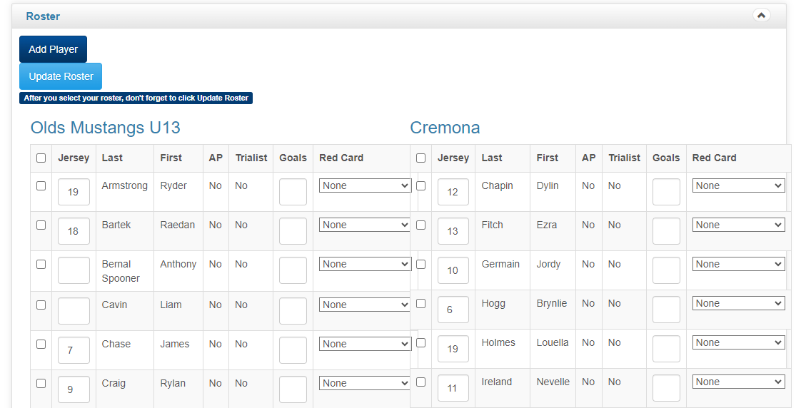
Player
Player
Player
Player
Player
Player

Player
Player
Player
Player
Player
Player

Roster section of gamesheet screen where the home team will use the original game sheet to input and confirm rosters and who scored goals and received fouls
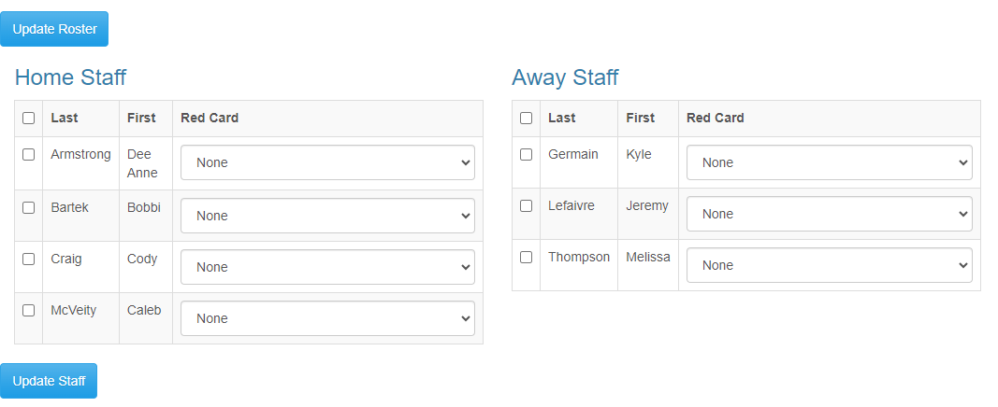
Staff
Staff
Staff
Staff
Staff
Staff
Staff
Staff section of gamesheet page where the home team coach will update staff based on the original game sheet
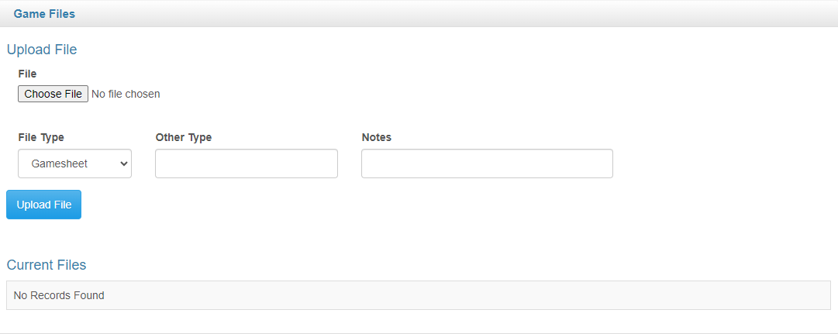
Game File section of gamesheet page where the home team coach will upload the file or image of the original game sheet if they wish to do so
Step 5 – You are now complete! Thanks for all your hard work!

