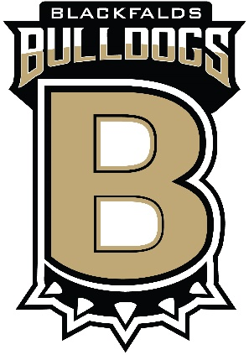

Dear Prospective Sponsor:

Blackfalds Minor Hockey Association (BMHA) is a not-for-profit, youth sports organization, operated by a Board of elected volunteers. BMHA has over 200 players ranging from 4 to 18 years old.

As we enter our 2022/23 season – Our team is currently looking for sponsorship via monetary donations for the Blackfalds (Team Name). This is a team of (# of players) players ages (Age Group) looking to gain enough funds to help cover costs for tournament entry fees. In conjunction with on and off ice training and tournaments, we will also use this money to purchase our team apparel.
All donations are greatly appreciated – with anything over $25.00 receiving a tax receipt. Company logo can be added to any team apparel purchased.
If you wish to sponsor our team for this year with any domination, please contact our fundraising rep, (Team Representative).
Thank you for supporting Blackfalds Minor Hockey.

Sincerely,

(Team Representative Name and contact info)

