Black Gold League

Minutes of Start Up meeting

August 21, 2018 – Percy Page Centre

Attendance: Brian Hoyano (BGL), Jackie Shimko (BGL), Rhonda Kew (BGL), Janice Tymkow (BGL/PEM), Sandra Fenton (BGL), Mike Sellium (RDR), Michelle Madson (PEM), Jeff Morgan (FSK), Kristen Bodnarchuk (SARA), Ron Heigh (SARA), Jason Sweet (HIN), Shannon Langstrom (EFCLRA), Duncan Wade (EFCLRA), Tamara Hyska (SPK), Darren Poole (SPK), Chris Wright (BMT), Roxanne Moore (BMT), Krista Wood (SGV/BGL), Terri Schade (NARRA), Darrel Pidhirniak (Z5AA), Shauna Ahlquist (LAC), Karol Werner (LAC), Laura Shannon (DVRA), Pam Horn (LED), Christine Kearney (ERC), on phone: Jim Cullihall (FMC), Traci Pluister (CEN)
- Call to order - Brian called to order at 7:04pm

- Introductions & Additions to the Agenda - none

- Approval of February Minutes
- Motion to approve February meeting minutes: Pam; second: Darrel, AIF – Carried
- Introduction of new BGL Executive & Association Reps
President: Brian Hoyano
Vice President: Jackie Shimko
Secretary: Janice Tymkow
Scheduler: Sandra Fenton
Webmaster/Statistician: Rhonda Kew
Treasurer: Krista Wood
Association Representatives introduced themselves, including members via phone.
- Financial Report (Krista)
- report handed out
- Referee-In-Chief (Terri)
- reported that new RIC is Sylvie Dubois. She is a level 4 ref, she is the RIC for FSK, and she lives in Ardrossan.
- Information for Ice Allocators & Critical Dates (Sandra)
- met with Ice Allocators early to share changes, report given to them
- Session 1 to start weekend after Thanksgiving
- Christmas break Dec 22-Jan 5
- advised of Session 1 & 2 changes, ‘no reschedule week’
- 6 games up to repooling, 2 games during ‘repool week’
- 2nd session schedule released Dec 2nd, start Dec 8th
- NRL AA ice request/review
-NRL already have their schedule. Would like Associations to host 1-2 games. Associations to cover cost. Anything over two games, NRL teams will pay for ice

- BGL Website & Statistic entry for 2018-19 (Rhonda)
- no changes to RAMP. Status quo for the season. Rhonda has no change recommendations.
- request was made for calendar to be posted, that Associations could input etc. Could be set up as a ‘team’ and league members could input info, events etc. Critical dates could be posted as events. Rhonda will look into and advise
- BGL Operations – changes for 2018-19, game number review U10/U19.
  - U19AA play in BGL : CAS, SGV, ERC, SPK, STA interested in playing in BGL this season (not Open A)
Z5AA wants stability of team numbers and schedule (possibility of teams retreating is a concern). Discussion around pros and cons to playing in league and/or playing in Open A. Discussion around fact that since AGM, teams can now be forced to retreat, as well as advance. Abstained from vote to move to BGL
No teams interested in playing in both, as that would be too much. BGL to advise Open about 5 teams moving to BGL being up for consideration.
Discussion around increase in games. ERC would like 16games. SGV is OK with # of games & blackouts. 12-14 games is enough but most not too married. Some say 16 is a lot.
AA teams would like league games to mean something, BGL to find out cost of a banner.
- Motion: to change the policy, to remove AA tournament blackouts (x5) and replace with additional league games: Sandra; Second: Krista. AIF – Carried
- Motion: 2018-2019 AA will play 14 league games. 6 games in the 1st session and 8 games in the 2nd session: Sandra; Second: Krista. AIF – Carried
- Motion: 2018-2019 individual AA team blackouts will increase to 3 and reschedules to 4: Sandra; Second: Ron. AIF – Carried
  - Rule changes reviewed and discussed.
Rhonda to add to instructions for managers, on where to enter information for game suspensions. Suspensions need to be written on the game sheets.
- Motion: to amend Policy 1802C to include a player who gets ejected for 10minutes of penalty time in a game, in the last 10minutes of regulation time, will be suspended for an additional game: Chris; Second: Roxanne. AIF
- Motion: to remove Policy 1802E ‘Penalties Assessed at the end of the game’: Terri; Second: Christine. AIF
c) U10 playoff format – Sandra discussed the same proposal that she gave the ice allocators.
- Motion: For the 2018-2019 all U10 teams will end the season with a single weekend event. U10-S1: Tournament style, 2 games each, no finals, everyone gets a medal. Associations will be encouraged to “host” an entire pool and organize off-ice activities. Entire event to take place in one day. U10-S2: tournament style, 3 games each, no finals, medals for everyone. Associations will be encouraged to “host” an entire pool and organize off-ice activities. Event will take place over the course of a single weekend. U10-S3: round robin tournament style. Number of games will be determined by the number of teams in the pool. Teams will be seeded based on league play, finals, medals for gold & silver only. Event will take place over the course of a single weekend. Second: Chris. AIF: Motion Carried
d) Travel Policy:
- Motion: to adopt proposed wording on travel policy update: Brian; Second: Krista. AIF: Motion Carried
- 2018-19 Season Review
11.1 Estimate # of teams & Divisions
Reminder that it’s $170/team. Bring cheques to next meeting (Sept 25th Declaration)
Numbers below are for age division, not Tier – too many did not know where they would be: 148 Total

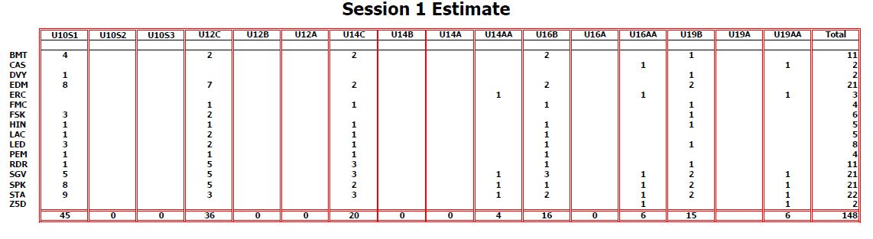

- FMC – review for season, change in travel subsidy
- no travel subsidy from FMC
- FMC trying to form a Rec league, looking for an Open C tournament (BMT mentioned theirs in Oct)
- Thinking they will have 2 U12 teams. Discussion started about how FMC (in the past) used to split a team. Discussion with the members brought up questions about Provincials; ranking; travel; will teams be balanced; could/would teams travel for less games each?? FMC was asked to advise of number for U12 (division that questions arose from) at Sept meeting.
- FMC hosting U19B Provincials
- RAB Policy updates (Sandra/Jackie)
- U14C was passed. Associations will assign refs for U14C
- Association Round Table
RDR – due to CWG, could home games be front loaded in 2nd session. Likely no playoff ice. Tournament Jan 4-6
LED – tournament Jan 11-13
FSK – tournament Nov 30-Dec 2
DVY – gone
SGV – only having one Sweetheart tournament this season, in February
LAC – tournament Nov 16-18
SPK – tournament Nov 9-11
BMT – tournament Oct 19 wknd (LED ice for part of the tournament)
PEM – in need of goalies for U14 & U16
Z5 – nothing
STA – Turkey Ring Thanksgiving wknd. Hosting Westerns March 27-30
ERC – U14AA goalie needed. Nov 23-25 Wood tournament
EFCLRA – Silver Ring tournament Jan 18-20. Need U14 goalies
HIN – tournament Oct 26-28. Need goalies at all divisions
CEN – tournament Dec 14-16
FMC – tournament Oct 28 wknd
Motion to adjourn: Brian; Second: Krista
- Next Meeting: Tuesday September 25, 2018 @ 7pm Percy Page Centre

