Black Gold League AGM - May 23rd, 2020 Zoom Meeting: 9am
Attendance(38):
BGL | Brian Hoyano |  | HIN | Jason Sweet
BGL | Sandra Fenton |  | HIN | Loralie Dammann
BGL | Wayne Martin |  | LAC | Deanna Lawrence
BGL | Rhonda Kew |  | LAC | Karol Warner
BGL | Janice Tymkow |  | LED | Chelsea Cameron
BGL | Sylvie Dubois |  | LED | Pam Horn
BMT | Jeff Craik |  | NAR | Kevin Nestor
BMT | Kirk Mccarville |  | PEM | Robert Weiss
CAS | Darin Gill |  | PEM | Michelle Madson
CGY | Eva Hasell |  | RDR | Carolyn Normand
DVY | Sara Emmonds |  | SGV | Krista Wood
DVY | Melissa Trider |  | SGV | Michelle Viney
EDM | Duncan Wade |  | SPK | Amanda Forster
EDM | Shannon Langstrom |  | SPK | Lindsay Maloney
ERC | Christine Kearney |  | STA | Tricia Smith
ERC | Lynne Gurba |  | STA | Lyssa Duniec
FMC | Jeff Macdonald |  | Z2D | Tammy Summerfeldt
FSK | Rob Peirson |  | Z2D | Rob Wasylyniuk
FSK | Jeff Morgan |  | NARRA | Terri Schade

- Call to Order: 9:06am
- Welcome and Introductions: attendance list confirmed as per RSVP list
- Additions to and Adoption of Agenda: Brian motion to adopt agenda, 2nd Krista; CARRIED (Zoom Poll)
- Review and approval of 2019 BGL AGM Minutes:
Brian motion to adopt 2019 AGM minutes; 2nd Chelsea; CARRIED (Zoom Poll)
- First Call for Nominations: Wayne opened up first call for nominations – Chelsea and Tricia had questions/expressed interest.
Krista nominates Brian for President, Brian nominates Krista for Treasurer, Wayne nominates Janice for Secretary, Sandra nominates Rhonda for Webmaster/Statistician, Krista nominates Sandra for Scheduler, Krista nominates Wayne as VP
- Executive Reports:
President: Brian 4th year as BGL President. Great experience with a great board. Approved and made minor adjustments. Procedures are always a work in progress, U10-S1 half ice, U10 wind-up went great this year. 2nd year hosting U19AA. This year welcomed Z2AA and Calgary in later half of the season. Feedback was positive. Pandemic cancelled U12 playoffs and some Provincials. Decisions by league had to wait until RAB decisions were made.
Vice President: Wayne first year. Enjoy it greatly with the exception of unfortunate way the season ended. Thankful for board support and assistance. First season with Spectator Liaison was successful. A review of game sheets showed over 80% compliance. Thanks to the associations for administering and supporting the program. There were three 1-game suspensions given throughout the year, all for excessive penalty minutes. 2 were against players and 1 on a head coach. One situation prompted looking at policy to deal with high penalty minute averages. Two fines issued this season; one forfeiter and one conduct violation.
Treasurer: shared financial report. Healthy balance. Profit/loss: quite high league fees – movement of money due to U12 championships. Medals and lanyards and banners – these were accounted for in fees but looks high in report. Loss of approx. $5000 on year. This time of year is busy but as of today we sit fine…lots of cheques coming and going still.
Janice motion to adopt 2019 BGL financials as presented 2nd Tricia CARRIED (verbal poll)
Stats & Web: Rhonda webmaster shared report and responsibilities. Overall smooth and successful
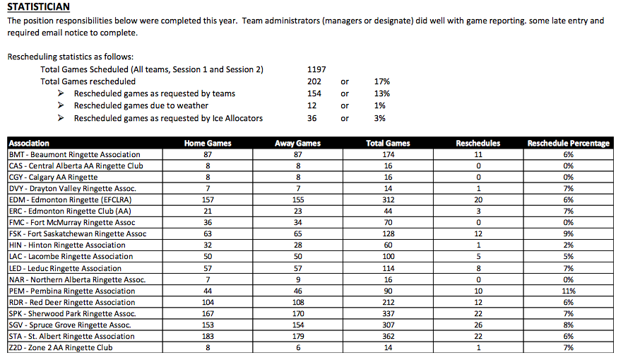
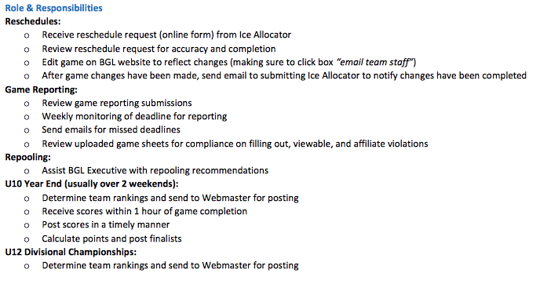
Terri/NARRA: Retainer and changes up for discussion. Refs now being paid by e-transfer, so all are paid right at beginning of month. Retainers have to cover payroll. Retainers need to be increased. NARRA retainer history shared. Proposal for retainers moving forward. Retainer will be refunded to BGL and request for retainers will be asked of by each Association ($225/team) this will cover a buffer to be sure to cover payrolls. Report presented dates back to 2009. Discussion around what to do, where money goes when it is refunded to BGL. Options to be discussed and determined by membership and board. Discussion to be taken off line and researched to help determine where retainer is to go.
Sylvie/RIC: nothing to bring to light. RAB dealt with things provincially. A couple minor hiccups but nothing major. Associations encouraged to poll members regarding officiating and how it went at U10-S1. Possibly discuss with RAB for moving forward.
Scheduler: Sandra shared report. Associations reps need to continue education of coaches/parents about travel to Fort Mac and what that commitment looks like. Concern about NRL and having larger Associations being pressured to provide ice. Complaints about U10 Wind Up locations – all Associations in the membership have a right to host. It is not up to the league to explain to coaches why Wind-Ups/U12 Championships are where they are. Reps need to clarify this process to coaches within their Association. If you want to host, apply. If you don’t, then coaches and teams are expected to travel to locations that did apply to host.
- U10 and U12 Playoffs Process Review: Process goes to ice allocators and it is posted on BGL website. Ice just needs to be submitted in order to apply. U12, there was a tech package that was distributed to reps and ice allocator. Discussion around sending concerns and complaints to Associations, about issues brought up to the league.
- Season Ending Review: Worked hard to build a process for hosting U12 Championships, to host something locally. Then pandemic hit, so we were unable to go through with that. Issues and concerns unknown. Will have to see how it goes next year. Sandra states the process went well. We were fortunate that RAB supported the Leagues with funding, so fees could be reimbursed to host Associations and teams. Feedback brought up was that Associations not necessarily in favor of Championships at this level vs making it more of a wind-up. Most of the membership agreed that U12 Championships is a nice transition from U10-U14, with the wind-up, championships then on to Provincials. Will keep it the same for coming season, to see how it actually plays out.
- Ringette Alberta (RAB) Zoom meetings Update: message that we are getting is that, nothing is for sure and anything can happen. We need to plan as though we are moving forward with the season. RAB waiting to hear from Ringette Canada, as they will be the deciding factor. Options being discussed. All depends of what happens with COVID-19. Quantum released a document with a return to play plan. Only issue right now, is the warning about tournaments. It is believed that those will be significantly impacted. Associations are encouraged to budget without accounting for tournaments, especially those hosting tournaments in the beginning part of the season. There will be no changes to the Children’s Ringette plan that was in play, so U10-S2 will go on to be half ice.
- Second Call for Nominations: no nominations
- League play in 2020-2021: talk about BGL & Chinook being affected by possible pandemic second wave shut down of the season. Options: tournament play, no league OR only league, no tournaments. Large tournaments may have impact for years to come. Will ice still be available if not used for this season? Associations seem to be in favor of going ahead with tournaments, with plans to honor social distancing requirements. Concern does arise for some Associations regarding ice and that is dependant on each individual Association. Poll to membership as to whether they plan to host tournaments and are they in favor of an extended season. Most Associations don’t know at this point but are encouraged to have those discussions with their memberships. Season doesn’t start until October, ice comes in in September, so we can delay that if need be. Discussion about how many games we would look at of we didn’t have to account for tournaments, as well as discussion around pros and cons to each scenarios (league play vs tournament play only). Executive will work on proposal for structure and review with membership close to season startup.
- Scheduling 2020/2021: Proposed schedule for season presented. Scheduler shared game amounts from last season. U10-S1 and U10-S2 will be half ice, and step 2 game number can still be achieved (14 games). U19AA: CAS say it went well with Z2 and CGY. CAS, won’t know until summer, as to whether or not they have a team. Rob/Z2: nothing but positive things to say about joining the league. Would like to revisit proposal to get to a more expanded league game based format for AA ringette rather than tournament format. Freeing up tournament ice at AA level would free up ice for younger kids. Idea presented, to possibly forming an offline strategy group, to discuss possibilities for a league play/tournament play format (Rob/Z2 to initiate that). Intent for 2020-2021 U19AA: STA, ERC, SGV, SPRA, NARC (ukn), Z2, CAS (ukn), CGY
Idea of tournament structure being important for players to familiarize themselves with tournament play, when it comes time for Provincials. Exposure to out of Province teams, at tournaments is great.
- Season Length and Game count recommendations: U19B games were added last season – no concerns brought forward. Based on the proposed schedule, 16A/19A Feb 12-14th playdowns to roll out. First set of Provincials (AA) is Feb 26-28. We want to finish league play 2 weeks prior to Provincials. Webmaster to post proposed critical dates.
- Discipline Review: Spectator liaison feedback seemed positive. To proceed with SL for coming season. Excessive penalty minutes: Excessive Penalty Minute Average Policy (1805 (d) proposal was presented. Discussion around divisions to start policy at, how many minutes average and what penalties.
Krista motioned to adopt Policy for Excessive Penalty minutes (1805) for U14 and up for next season; 2nd Chelsea; 83% in Favor 17% Opposed CARRIED (Zoom poll – results shared)
- Third Call for Nominations – final call. No nominations.
- Fort McMurray and play in BGL: Discussion around travel and subsidy. Will remain the same for coming season. Fort Mac has agreed to travel first weekend of both sessions for 2020-2021 season.
- Election / Appointment of Officers: 2020-2021 season
Brian as President, Wayne as VP, Krista as Treasurer, Rhonda as Webmaster/Statistician, Sandra Scheduler and Janice as Secretary
- Association Round Table:
BMT – nothing
CAS – U19AA hope to put team together, need commitment from 1st and 2nd year players. Fingers crossed to pick up odd player in RDR that may have moved in for college.
CGY – Hoping to field 2 teams at U19AA with the intent to play in league.
DVY – nothing
EDM – Still planning on Silver Ring so long as things move forward
ERC – in need of goalie for U16AA
FMC – FMC will possibly have 2 U12 teams and 1 each at U14, U16 and U19
FSK – they had a comment from U12 B-A, coaches and players felt one of those teams was pulled down incorrectly. Understand season is over with but would like this concern known.
HIN – Feb 5-7 tournament
LAC – Tournament Nov 27-29 (later than normal)
LED – Hoping for season and tournament in January
NAR – U19 program, 13 eligible players. Working on finding out intent and hoping for a team. Hoping to gain players moving to Edmonton for University.
PEM – nothing
RDR – Tournament Jan 8-10
SGV – lots of concern around U12 hybrid pool, not well received. To be discussed later but wanted that known. Feb tournament
SPK – U10 lots of feedback, water bottles was not appropriate – would prefer medals
STA – hoping for season. Tournament idea is a Christmas turkey ring possibly. Planning survey for membership and plans to return to sport due to economic and covid effects.
Z2AA – moving ahead status quo. Tournament concern as theirs is early. Ice booked, will plan to go ahead until told otherwise. U19AA looking good to make viable team, to join BGL. Z2AA membership meeting, talked about risk of COVID went well. Willing to share those discussions.
NARRA – nothing
Some Associations to stay on for polling tutorial from Brian.
BGL will not be purchasing lanyards this coming season – hang on to yours from past season.
- Adjournment 12:09pm: Chelsea motion to adjourn; 2nd Krista CARRIED (verbal poll)

