Black Gold League - Meeting Agenda
Thursday October 1, 2020 @ 7:00pm Virtual Zoom Meeting

- Call to Order: by Brian @ 7:01pm
Attendance: Janice Tymkow BGL, Brian Hoyan BGL, Deanna Lawrence LAC, Chris Wright, Jason Bearchell BMT, Carolyn Normand RDR, Jason Sweet HIN, Kandice Adamson LAC, Kirk McCarville BMT, Loralie Dammann HIN, Michelle Madson PEM, Rob Peirson FSK, Sandra Fenton BGL, Sara Emmonds, Sean Hogan SGV, Shannon Langstrom, Sherri O’Muir, Wayne Martin BGL, Melissa Trider, Keri McEachern STA, Jenn Tosto STA, Jeff McDonald FMC, Rhonda Kew BGL, Krista Wood BGL, Lynne Gurba, Sylvie Dubois, Pam Horn LED, Chelsea Cameron LED, Christine Kearney ERC, Duncan Wade EFCLRA, Lindsay Maloney SPK, Rob Weiss PEM, Tanis Hoose EFCLRA, Jason’s iphone?
- Welcome & Additions to the Agenda: Motion to adopt agenda: Rob FSK 2nd Wayne Martin, BGL. CARRIED
- Approval of Minutes from August 18, 2020 Meeting: Motion to approve August 18th meeting minutes: Pam Horn 2nd Chelsea LED, CARRIED
- Motion to adjust U10 Cohorts from 4 teams to 3 teams: Sean Hogan, 2nd Rob Pierson FSK; CARRIED
Michelle SGV took the lead on this and most Associations were in favor of 3 team cohorts instead of 4. Team individuals will go from 12 to 16.
Discussion around logistics of this, team numbers, number of teams on the bench, cohort numbers and restrictions at facilities. Number was intended to increase number of coaches/team staff. Anyone adding to add their roster in the next couple days, needs to let BGL know asap, in order to properly fit teams in to cohorts.
- Scheduler’s Report
  - U19AA update – Two leagues before Christmas
4 teams from the North for 1st session (SGV, ERC, STA,SPK). South (CGY1,CGY2,Z2,CAS) will join BGL in session 3 after Christmas, subject to AHS/RAB restrictions.
  - Division release – Anticipating that all will start Oct 16 for U12 and up and U10 on Oct 23rd, dependant on officials, and coach officiating course. If those things aren’t in place, we may be asked not to proceed. Schedule released Oct 10 to allocators.
for each session
  - Process for league changes based on AHS/RAB directives - What do we do in the event that AHS shuts down again? We need to establish a process in this event. Decisions to be made as time goes on, in the event we need to. Info will be posted on BGL website, released directly to allocators/member representatives
  - Arena limitations – Arena limitations will be posted on the website. Coaches to be aware of participant limitations – these overrule BGL’s.

- RAB update/Officials update – Sylvie
RAB approved coaches/players/officials participating in 2 cohorts, in an effort to have more Officials available. We still need more officials. Lots of outlying associations have reached out to members to see if they are coming back = small increase, but anticipate numbers climbing. Concern with officials now officiating many games if they are officiating in 2 cohorts. Time may be limited if they are coaching/playing. U10-S3 and up will be done through NARRA, for all Associations, due to needing to know 50-person cohort maximums. Safety sensitive divisions will be prioritized (U14AA and up). U19B will have most coverage, to ensure safety. Working on a way to notify teams if an official will be present or not. NARRA will work on letting coaches know if they need to step on the ice – in the event there are no officials available.
RIC’s have been discussing travel costs. It will be brought forward to Associations to provide feedback. (update: BGL may participate to spread cost of mileage around.)
Penalties will be served in the penalty box, not on benches. Minor officials will not be allowed in the box when players are in there. They will have masks on and are only required to open/close doors. All minor officials will need to sanitize and wear masks, especially in tight time boxes.
On ice procedures will be shared asap by RAB.
Discussion around U10S1/S2 scores/no scores. UAA not available this year. No scores will be recorded; teams will be repooled each session based on random draw/travel taken into account.
- Declaration of Teams/Collection of Team Fees
Teams declared and fee amounts announced by treasurer.
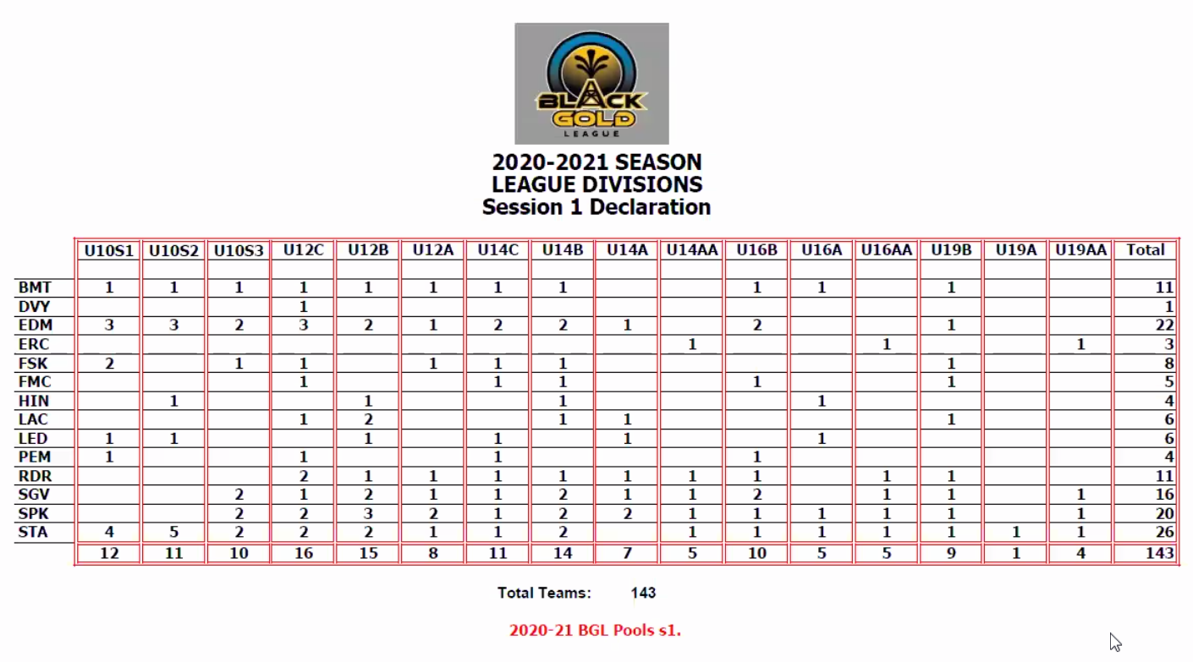
Cheques can be mailed to Krista Wood @ #2 Harvard Bay Spruce Grove T7X 4K9
Fee is $170/team (that includes $45 travel subsidy to FMC)
- Declaration of Overage Players, all are one year O/A
EDM – 2 on U14B-2, 2 on U12B-2
FSK – two U16 players playing on U14
FMC – one at U19B
HIN – 5 at U16A
LAC – 1 at U14A, 2 at U14B
LED – 3 @ U16A
RDR – 1 @ U14C
STA – 1 @ U19A goalie, 1 @ U14B-2, 1 @ U19B
- Review of draft cohorts by division
Drafts shared with membership, some discussion with adjusting cohorts and/or who needs to sit. Teams/scheduler to confirm.
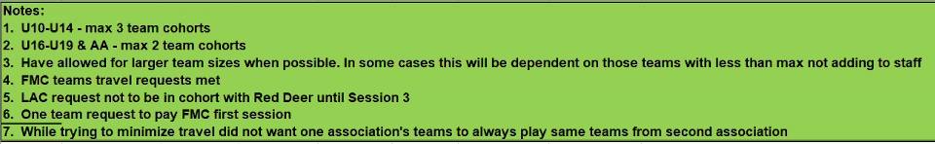
Double headers anticipated for HIN & FMC games. 4 away games and 2 home games in first session. Teams cohorting with HIN & FMC potentially could play a game or 2 less.
- Association Round Table
BMT – nothing
DVY – nothing
EDM – nothing
ERC – nothing
FSK – nothing
FMC – nothing
HIN – thanks for accommodating us this season
LAC – nothing
LED – nothing
PEM – looking for goalie at U16
RDR – nothing
SGV – would like spreadsheet sent out
SPK – nothing
STA – nothing
No exhibition games are allowed, even after schedule is released.
Deadline to change numbers on team sizes, since RAB changes is Sunday October 4th at 6pm.
- Motion for Adjournment @ 8:59pm: Wayne; 2nd Shannon, CARRIED
Next Planned Meeting: February TBD, no repooling meeting

