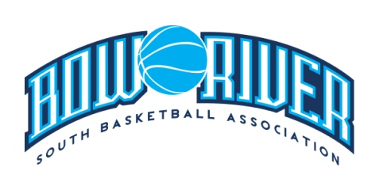
Bow River South Basketball Association
Agenda – Annual General Meeting, Thursday, May 2, 2019

- Attendance:

- Apologies Received:

- Establishment of Quorum (Bylaw 3.2.1)

- Approval of Agenda

- Board Member Voting (Secret Ballot - Bylaw 3..3.1, 3.3.2 and 4.2.1)

- Sr. Tykes
- Jr. Tykes
- Mini Girls
- Mini Boys
- Bantam Girls
- Bantam Boys
- Midget Girls
- Midget Boys
- Juv Boys and Girls
- Uniforms and Equipment
- Coaching Development

- Executive Member Voting (Secret Ballot)

- President
- Vice Presidents (Girls and Boys)
- Director of Facilities
- Registrar
- Treasurer
- Secretary/Casino

- Additional Directors (Bylaw 4.2.3)

- Additional Director of Facilities
- Webmaster

- Volunteer Positions (Bylaw 4.6)

- Appointment of Compensation Committee (Bylaw 7.2.2, 7.2.3 and 7.2.4)

- Financial Summary (Bylaw 5.3.2)

- Adjournment

