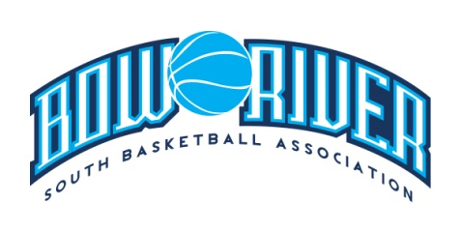
Bow River South Basketball Association
Agenda - Board Meeting, Thursday, May 2, 2019

- Attendance:

- Apologies Received

- Board Vacancies

- Reports/Business

- ABA Membership/AGLC Matters

- Registrar (2 minutes)

- Treasurer (5 minutes)

- Secretary/Casino (5 minutes)

- Review Critical Dates
- Advertising
- Registration
- Evaluations
- Coaches Meeting
- Next Board Meeting

- Facilities (10 minutes)

- VP/Coordinators (10 minutes)

- Uniforms/Equipment (10 minutes)

- Coaching Development (5 minutes)

- RAMP Interactive (5 minutes)

- Year in Review
- Surveys

- Other Business/Open Discussion (15 minutes)
- Any changes to consider for September?
- Learnings, Observations and Optimizations from the 2018/2019 Season

