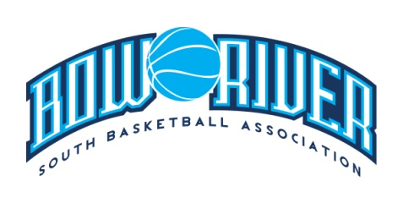
Bow River South Basketball Association
Meeting Minutes - Board Meeting, Thursday, May 2, 2019

Attendance: Clark Schow, Jeff Hudson, Anna Le, Rochelle Nickerson, Tim Nickerson, Sheri-Lynn Arishenkoff, Lindsay Anderson, Dan Magnan, Kelly Schow, Jennifer Schow, Dave Kearl, Danyelle Kaluski, Lara Jarvis, Natalie Olson, Kristen Schow, Colette MacArthur

Apologies Received: Shelley Fugal, Cindi Mitchell, Patrick Stein

Board Vacancies
- Midget Girls, Midget Boys, Juv Boys/Girls, Webmaster

ABA Membership/AGLC Matters
- Discussed if Bow River should be AMA members. It is $25 per player, coach and tykes.
- The con would be to lose our casino funds and then getting back into later may be issues.
- Motion to not be a member of AMA was denied, majority vote was to be members to keep the casino.
- Clark will discuss with AGLC to confirm our July casino is still available.

Registrar
- Registration will open June 1st and pricing will remain the same.
- Website during registration time should only have registrar and treasury contact info so that these inquiries can be filtered through one person.
- We will look at adding more players later on. For now, we will waitlist them once capacity is reached and go from there. It is dependent on uniforms and if available.

Secretary
- Signage to advertise will be the same locations and amount as last year. Signs will be up for two weeks mid-June and two weeks mid-July.

RAMP Interactive
- Colette discussed handout called Learnings, Observations and Optimizations from the 2018/2019 Season.
- Suggested and board agreed to no longer ask for cheques for uniform deposits. RAMP has ability to do this now where we can charge credit card on file for $3 fee at year end.
- Board members must provide an alias to be set up with their bow river email to ensure those emails are monitored per position.
- Board member first names will be added to each role on the website to make it personal.

Next Meeting Date – June 7th, 2019 location to be determined.

