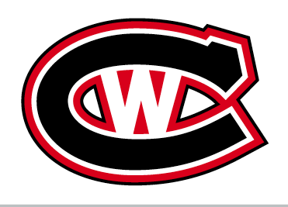

Canada West Elite Hockey

Hello,

You have been identified and selected as a potential player we are prepared to invite to Canada West Elite Hockey.

Canada West Elite Hockey is an Elite group of junior players from all over Canada, the U.S. and Europe that will compete in the JUNIOR CHOWDER CUP in Boston in July. This year the tournament is being held July 23rd to 28th
in Boston, Ma. The team will be competing against All Star teams from all over North American and Europe. This tournament is for players born 2003 and 2004 (2 separate tournaments but same times and rinks). We have been scouting players for the team all season and we feel very comfortable in offering you a spot in our program. We have won this event several times. Many NHL scouts as well as most college coaches and Junior A coaches come to this event.

The CHOWDER CUP will give you the opportunity to play against some of the top players in all of North America and Europe. Many teams from the US that enter this tournament have rigorous tryouts to even get onto a team going to the CHOWDER. The teams that attend this tournament are made of top end highly rated North American and European players. A smart player will value the knowledge of knowing that the competition is not only in Canada but in all of North America and Europe.

At your age many players have not decided yet if their path will take them to the CHL or the NCAA. In Western Canada our kids are very well exposed to the WHL. However we have very few Division 1 Universities or Colleges nearby. As in most things in life, knowledge is key. Therefore attending this tournament will give you a firsthand look at some of the top ranked Division 1 NCAA programs as well as visibility with NHL scouts. This would give you a chance to compare your talent to the players of your age group.

We have a long standing relationship with many of the scouts and coaches on the East Coast (Junior/College/NHL). Our coaches are experienced Junior, College and Pro coaches.

This tournament is scouted by not only NCAA schools but many of the different leagues in Canada (Major Junior or Junior A), the USA (USHL, NAHL, EJHL…) and NHL teams. One of our former players, Ryan Johansen was drafted 4th overall in the first round of the 2010 NHL Draft and is now playing for the Nashville Predators. Here are just some other alumni from our program:

- Alex Chiasson (Edmonton Oilers)
- William Karlsson (Vegas Golden Knights)
- Daniel Carr (Vegas) and Eli Lichtenwald (NCAA National Champs 2014 with Union College)
- Lucas Johansen Hershey Bears AHL/First round selection Washington Capitals
- Tage Thompson UCONN NCAA/Now playing with the Buffalo Sabres

And others (see our website)

***Lucas Johansen and Tage Thompson were both selected in the first round of the NHL 2016 Entry Draft by Washington and St-Louis respectively.

You should take a look at our ALUMNI on our program’s website at:

www.canadawestelitehockey.com

The CHOWDER CUP is operated by Pro Am hockey and is for players that could go in the NHL draft or possibly sign as free agents. Our program also competes in the NHL PRE DRAFT TOURNAMENT and the SENIOR CHOWDER CUP.

*** This tournament is reserved to invited teams only!
The website for the tournament is www.proamhockey.com.

We look forward to hearing from you about your possible participation to this event with Canada West Elite.

Lou Gravel
Canada West Elite Hockey
General Manager
(250) 702-2713

Director of Scouting
All Canada and Western USA
Aberdeen Wings NAHL
