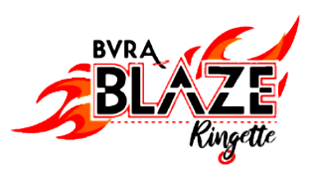

Annual Pre-Season Tournament

October 20th – 26th, 2025

* 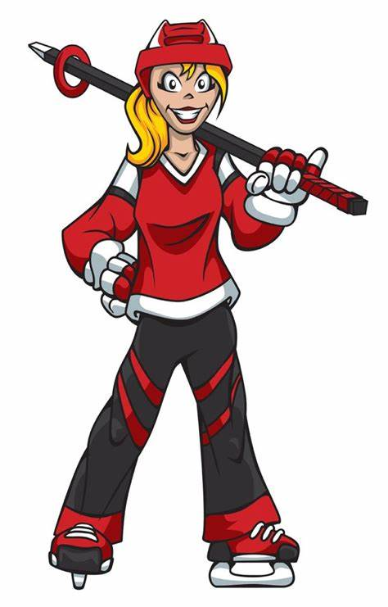3 Game Guarantee
* Gold & Bronze Medal games
* 50/50
* Silent Auction
* Off ice kids zone
* Banquet hall for team party
* AA Feature League Games
* ……and much more!

Held at:



***Registration & Information***

**Tournament Dates:** Monday, October 20 5:00 pm to 9:30 pm

Tuesday, October 21 5:00 pm to 9:30 pm

Wednesday, October 22 5:00 pm to 9:30 pm

Thursday, October 23 4:30 pm to 10:00 pm

Friday, October 24** 8:00 am to 10:00 pm

Saturday, October 25 8:00 am to 10:00 pm

Sunday, October 26 8:00 am to 8:00 pm

**Team should expect to play Friday during the day

|  |  |
| --- | --- |
| **Entry Deadline:** | **October 1st, 2025** |
| **Team Entry Fees:** | $900.00 U12 to U19 all levels,  $800 for U10 |
| **Loops:** | U10, U12-A, U12-B, U14-A, U14-B, U16-A, U16-B, U19-A, U19-B  3-Game Guarantee per Team, Gold and Bronze medal games |
| **To Register:** | Electronic Registration at [RAMP REGISTRATION](http://bonivitalringette.rampregistrations.com/)  Team Roster must be submitted by October 1st, 2025. Further instructions will follow. |
| **Payment Details:** | * Credit Card via RAMP * E-transfer treasurer@bvraringette.ca Please specify team name and loop * Cheque- email [president@bvraringette.ca](mailto:president@bvraringette.ca) for mailing address   Full payment required to hold your spot.  Rosters will be due Oct 8th. Further instructions will follow |
| **Refund:** | A 50% refund will be provided for any cancellations made prior to  October 1st, 2025. No refunds after this date unless the tournament is cancelled. |
| **Contact:** | Lev Kearney  204-471-8718  president@bvraringette.ca |
| **Accommodations:** | Special BVRA Tournament Pricing available. Offers Expire Sept 23rd   * Victoria Inn & Suites: [Click here](https://winnipeg.vicinn.com/). Use group code 355506 * Holiday Inn South : [Click here](https://www.ihg.com/redirect?path=rates&brandCode=HI&localeCode=en&regionCode=1&hotelCode=YWGSO&checkInDate=23&checkInMonthYear=092025&checkOutDate=26&checkOutMonthYear=092025&_PMID=99801505&GPC=BVR&cn=no&adjustMonth=false&showApp=true&monthIndex=00) |

**Out of Province Teams:** Will need to provide an official roster from your Provincial Ringette Association. Games will be scheduled Friday, Saturday, and Sunday only. Please be ready to play 8am Friday and as late as 5pm Sunday.



***BVRA RINGETTE TOURNAMENT – OCTOBER 20th – 26th, 2025***

**TOURNAMENT RULES**

1. The Official Rules of Ringette Canada will apply except for the Breaking of Ties in Games & Standings and as noted below. All participants must be registered with their Provincial Association.
2. U10 – U14, U16B - U19B Game length is two (2) 18-minute stop time periods. U16A – U19A Game length is two (2) 20-minute stop time periods. Running time may be used if behind schedule, at the discretion of the Tournament Committee.
3. Home team is the second team noted on the schedule.
4. Teams must be ready to go on the ice 15 minutes prior to game time. 2-minute penalty for every 3 minutes late. Tournament Committee may waive penalty if warranted.
5. In the case of conflict in jersey colour, the VISITING team is to change jerseys or wear pinnies. If one team has 2 sets of jerseys and the other does not, the team with two sets changes.
6. A seven (7) goal differential for/against shall be observed, including its use in any tie breaking formulas which are applied.
7. Point Structure – In round-robin play, teams receive five (5) points for a win, three (3) point for a tie, and zero (0) points for a loss. The team with the most points in each division will be declared the top team in that division. The second-place team is the team having the second highest number of points.
8. Breaking of Ties in Games & Standings – see attached.
9. Gold & Bronze Medal Games – Overtime period will be 5 minutes, stop time, sudden victory. Flip coin & winner chooses either ring possession or choice of end. If still tied – “Shoot Out”. See attached page.
10. U12-A, U14-A & -B, U16-A & -B, and U19-A & -B will use shot clocks for all games.
11. Any roster additions, from Provincial Team Registration form, must be declared by the entering team and approved in advance of the start of the tournament by Tournament Committee.
12. Match penalty may result in suspension from tournament.
13. No protest will be allowed.
14. Score sheets are to be picked up at the control desk of the arena. They are to be completed and signed by the coach at least fifteen (15) minutes before game time and returned to the control desk.
15. The Tournament Committee reserves the right to change/alter/adjust the tournament schedule and any/all game times at any time.

**Breaking of Ties in Games**

1. All Gold & Bronze Medal games will be played until a winner is declared.
2. If the score of a game is tied at the end of regulation time, there will be one 5-minute overtime period, stop time, which will be sudden victory (i.e., the first team to score will be declared the winner).
3. Possession to start the overtime period will be decided by the tossing of a coin by an on-ice official. The team winning the toss can either choose ring possession or choice of ends.
4. If the teams are tied after the overtime period, then the teams will proceed to a shoot-out to determine the winner. Please see the Shoot-Out Rules below.

**Breaking of Ties in Standings**

When two or more teams have an equal number of points after the completion of the round robin games, the highest of the tied teams will be determined in the following order.

1. The outcome of the game played between the two tied teams.
2. The winner of more game(s) ***between each other*** ***during the round robin*** will be declared the highest position.
3. If still tied, the team having the ***greatest positive difference between goals for and against in games between the tied teams in the round robin*** will be declared the highest position.
4. If still tied, the team having ***the least total goals against games between the tied teams during the round robin*** will be declared the highest position.
5. If still tied, the team having the ***greatest positive difference between goals for and against in all games during the round robin*** will be declared the highest position.
6. If still tied, the tied team with the ***least total goals against in all games during the round robin*** will be declared the highest position.
7. If still tied, ***a coin toss*** will be used to break the tie.

**Important Notes**

* This procedure shall be followed in sequence until the tie is broken (i.e., one team is eliminated from the tie). Once one team is eliminated from the tie, the procedure reverts back to (a) above.
* This procedure, in most cases, will declare the team in the HIGHEST position. However, in some cases, the procedure will declare the LOWEST position between tied teams, and that team shall be dropped from the tie breaking procedure (i.e., the top two teams remain tied). In these cases, the procedure shall also revert back to (a) above in order to break the tie between those teams which remain tied.

**Shoot Out Rules**

1. Each team selects 3 shooters, indicating on the game sheet shooter #1, 2 & 3.
2. Visiting team takes a penalty shot, starting from center ice.
   1. Shooter cannot enter crease with body or ring.
   2. No rebounds are allowed.
   3. Goalie starts in crease and, may leave crease after the shooter crosses the blue line.
3. Home team shoots next, and teams alternate until both teams have taken 3 shots. The team with the most goals wins.
4. If still tied after the first 3 shooters, each team selects **1 NEW** shooter. If a team's shooter scores and the other team's shooter does not, then the tie is broken.
5. If still tied, continue selecting **1 NEW** shooter from each team until the tie is broken.

