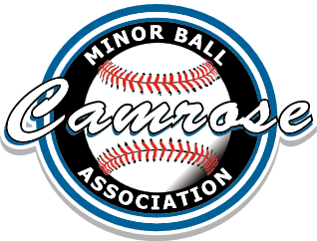
Wednesday, Jan 15th, 2020, 6:30pm
Board Meeting Minutes
Present: Ryan Foss, Jose Preza, Deb Soch, Ryan Popowich, Clint Mitchell, Stephen Koch, Stacey Winia, Jeff Badry, Gord Nadeau and Todd Lundstrom

- Call to Order at 6:30 pm
- Approval of today’s agenda. Motion ( Gord N ), second ( Jeff B ) and approved.
- Approval of Minutes of Last Meeting. Motion ( Clint M ), second ( Gord N ) and approved.
- Guest Speaker(s) – None
- Business Arising from Last Meeting
  - Review & update of items on Action Plan

- Correspondence
  - None

- Reports
  - Treasurer – none
  - Fundraising – none
  - Equipment – Gord had quotes for a few different projects. See attached. We will order netting, mats and L screens for the batting cage from Battle River Sports Excellence.
  - Registrations – 44 registered as of today
  - Association Programs, Policies, etc. – President currently working on Policies – What we have left to do (uniform/equipment – complaint/discipline/conflict resolution – website/social media/email – appeal policy – tryout/evaluation/forms – expense reimbursement). Diamond usage/designated diamonds (working with CSA/City)

- New business
  - Clint M motioned to order an inflatable batting cage at approx. $15,000 Cdn including all costs. Jeff B seconded. 7 approved 2 opposed.
  - Stacey W motioned to accept Coach Selection/Ratification Process policy. Deb S seconded. Approved.
  - Coaching Applications closing today.
  - Coach selection committee has been selected. Lance Zimmer to be Committee Chair
  - Ryan F will look at ordering new jerseys
  - Registration in house dates have been set for Jan 29 and Feb 19 from 6-8 pm.

Motion for meeting to be adjourned @ 8:55 pm by ( Jose P ) , second ( Gord N ) and approved.
Next meeting date: Feb 12 at 6:30 pm

