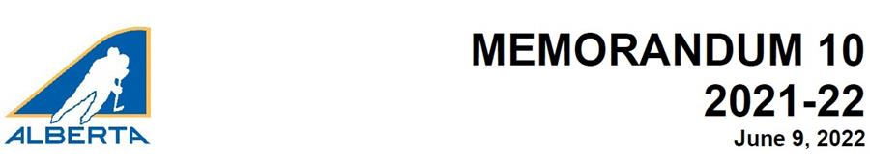

Additional information on the removal of the NTO form
On May 31, Hockey Alberta announced the decision to end the use of the Notification of Tryout (NTO) Form in AA and AAA Male and Female hockey, effective for the 2022-23 season. This Memo provides some additional resources and background on the new process.
The original purpose of the NTO procedure was to ensure a player’s resident Minor Hockey Association was aware which players are pursuing AA and AAA hockey. Based on feedback from families and associations, Hockey Alberta realized that the NTO procedure created unnecessary work to obtain MHA approval, which could not be refused unless a player was not in good standing. Removing the NTO streamlines the tryout process for players, while also not creating additional burden for MHAs.
In lieu of the NTO form, host AA and AAA Female and Male Associations will now collect the names of players who register for AA/AAA Female and Male tryouts. Hockey Alberta has created a form that includes all the information to be collected. The form can be found HERE under the Elite/AA tab. A minimum of one week prior to the start of tryouts, the host AA/AAA Female and Male Association will distribute the tryout list to all associations who have players registered.
Hockey Alberta also understands that the NTO Form served to provide AA/AAA Female and Male Associations with the following information about a player:
• DOB
• Address
• Parent Email
• Resident MHA & President Email
• RIS Certificate Number & Expiry Date
• Position
It is Hockey Alberta’s recommendation that AA/AAA Male and Female Host Associations add fields to their registration process in absence of the NTO form to collect all relevant information in one place.
If a resident MHA determines that a player not in good standing (ie: player has outstanding fees) is registered for a tryout, the resident MHA will inform the MHA hosting the tryout, and contact the player to try and resolve the issue. The resident MHA will also notify the tryout-hosting association when the player is in good standing.
For players who need to be added to Tryout Rosters for AAA Male Hockey, registrars can request a ‘Shared Transfer’ for a player with the expiry date of September 30 and add a comment indicating the purpose of the transfer.
For players who successfully make AAA and AA teams, a permanent transfer must be requested and approved by the resident MHA. A comment stating the purpose of the transfer is all that is required.
For AA and AAA Male and Female Host Associations hosting Skill/ Development Camps to develop players outside of the traditional hockey season (to prepare players for tryouts via a camp where no evaluations or team selections occur), players no longer will be required to submit a Letter of Permission to attend these camps. They simply register for the camp with the host association.
Again, this decision is intended to streamline the registration process for players. Associations hosting Skill/ Development camps must apply through Hockey Alberta’s Centre Ice Portal to have their camp sanctioned using the Special Event Sanction. All conditions of the Special Event Sanction must be met, including that a list of all participants (name, address, date of birth) must be submitted to Hockey Alberta within 48 hours of the conclusion of the event. All regulations surrounding Player Movement for Elite Male Hockey, AA/ AAA Male and Female Hockey remain unchanged and in effect.

