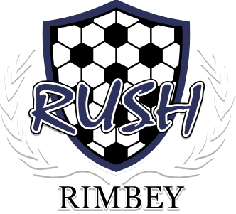
RIMBEY SPRING RUSH TOURNAMENT

TIER 4, AGE GROUPS: U11 BOYS & U11 GIRLS

WHEN: May 25 - May 26, 2024

WHERE: Rimbey, Alberta (Rimbey Lions Soccer Fields)

COST: $450/team

REGISTRATION: Opens April 1 - May 6, 2024
Accepting up to (6) boys/co-ed & (6) girls teams.

REGISTRATION FORM: please fill out the following form. https://forms.gle/HZLz14JMmaubkJAV9
- Spot will be secured when payment is received.

PAYMENT: by E-transfer only to: rimbeyminorsoccertreasurer@gmail.com

GAME FORMAT: 8v8
2 X 30 minute halves with 5 minute halftime (8V8)
U11 Field - Width 42- 55 Meters by Length 60-75 Meters Net - Height 6 ft x Width 18 ft

PLAYER GIFTS: MVP Award, Gold, Silver and Bronze Medals to the winners!

TOURNAMENT CONTACT: rimbeyminorsoccercompetitive@gmail.com

AMENITIES: Concession available at the soccer field.
Local restaurants, bowling alley, outdoor swimming pool, museum, playgrounds and parks.

ACCOMODATIONS:
Lions Campground (Walk to your games!): 403-704-6997
Canalta Hotel: 403-843-3808
Quality Inn Hotel: 403-843-2999

