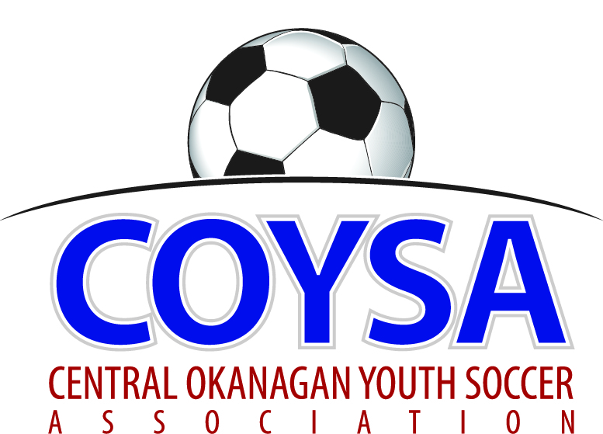
CENTRAL OKANAGAN YOUTH SOCCER ASSOCIATION
District Board Meeting: Thursday, April 11, 2019 7:00pm
COYSA Boardroom, Kelowna, BC

MINUTES
APPROVED (as is/as amended): May 09, 2019 Motion #1052
CALL TO ORDER: Roll Call
Jenn Bernier, COYSA Chair, called the meeting to order at 7:02pm
Present: Curtis Morcom (Treasurer), Sheryl Turner (Administrator)
Voting Members Present:
April Steed
Carrie Smith
Jason Scott
Jon McClenaghan
Marcy Dabiri
Niki Siddall
Nolan Belanger (for Dan Rae)
Scott Percival
Shane Green
Shauna Whitney
Stephanie Gudbranson
Total Votes = 11
Regrets: Dan Rae, Winston Morgan, Bruce Clark (Discipline), Dan Tauber (Past Chair), Al Ryder (Referees)

PRESENTATION OF AGENDA

APPROVAL of MINUTES of the March 14, 2019 regular board meeting
April 11, 2019 Motion #1049 It was moved and seconded to accept the minutes of the March 14, 2019 regular board meeting as presented. Carried unanimously.

CHAIR REPORT – written report
TREASURER REPORT – written report. Full budget.
REFEREE REPORT – written report
DISCIPLINE REPORT – written report
ADMINISTRATOR REPORT – written report

CLUB REPORTS:
KUFC – TOYSL started last weekend, an academy will start next week, bubbles are coming down soon.
KYSA – written report
LCYSA – written report. New coach shirts aren’t black.
OMYSA - written report. Equipment goes out this weekend. KU’s doing U6/7, not doing pictures.
Scott arrived at 7:23pm
RYSA –Accepting registrations for Canada Day Tournament.
WYSA – written report

COMMITTEE REPORTS
Facility (Jenn) – Some hiccups with fencing. Before first booking, had to clean up the field, including broken glass. Have spoken to neighbors directly behind and the lighting will be okay.
Indoor (Jon) – 98% of coaches have provided rankings for next year.
Promotional (April) – Going to have a table at the Easter Parkinson event. Please share it from COYSA’s FaceBook. Trade cleats, bring cleats, free cleats. Registered for May Days parade, want teams so coach comes too. Will be at Healthy Kids Day May 05 with RYSA and COYSA together and also the Westside parade. Great to have everyone together.
Seasonal (Jenn) – Committee met today. Meeting again beginning of May to ensure by next COYSA meeting there is something to go back to Clubs. OMYSA needs someone on the Committee.
Tiering (Jon) – Just educating everyone on how it’s supposed to work. Will meet in May.

CORRESPONDENCE – nothing received

BUSINESS: CARRIED FORWARD / NEW BUSINESS
Game Rescheduling (Jon) – Would like to make a motion to form a policy about reschedules. Very difficult to do with not enough fields, refs and a time that works for everyone.
April 11, 2019 Motion #1050 It was moved and seconded that U14-18 games will not be rescheduled for any reason and the score will be recorded as 0-0 tie. Carried unanimously.
International Children’s Games (ICG) (Jenn) – 7 kids from COYSA are going to the ICG in Russia in July. We have said we would support fundraising efforts via social media. Would like to propose we pay the fee for the BCSA travel permit.
April 11, 2019 Motion #1051 It was moved and seconded to pay $183.50 for the ICG team’s Application to Travel Permit. Carried Unanimously.
CORE’s Clubhouse Plan (April) – Went to a meeting last week. Central Okanagan Rugby Enthusiasts. 2700 players over seven different groups. City is on Board and are going to make sure we have our allotted time. Planning to light R1 with hopefully enough money for R3.
BCSA form (Jenn) – Have been sent an opportunity for comments about BCSA Associate members. Okanagan FC (Soccaskool) is applying for renewal. It says it’s not an avenue to submit complaints. No comments.

BCSA sent out a document today and they are looking at how it is all structured. Soccer Canada wants this.

KMSL has said they will pay for one third the cost of the referee course venues and asked for an invoice. KWSL have already paid one third.

ADJOURNMENT 8:11pm

NEXT MEETING: Thursday, May 9, 2019 @ 7:00pm

