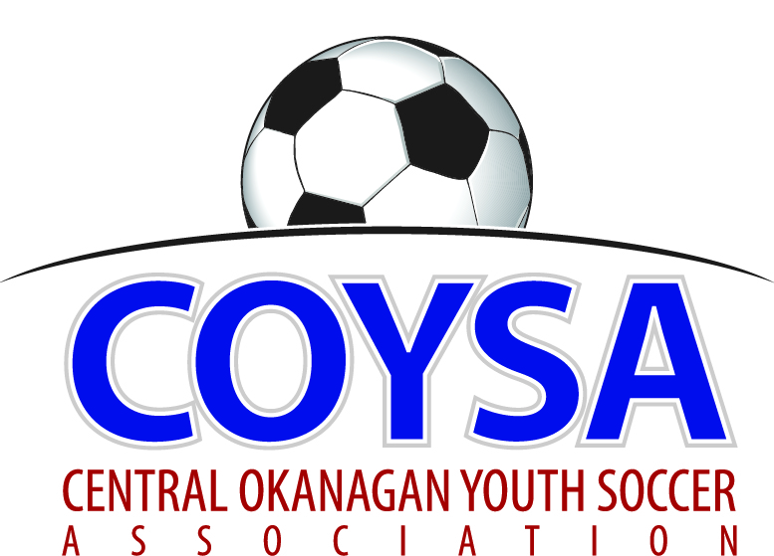
CENTRAL OKANAGAN YOUTH SOCCER ASSOCIATION
District Board Meeting: Thursday, March 14, 2019 7:00pm
COYSA Boardroom, Kelowna, BC

MINUTES
APPROVED (as is/as amended): April 11, 2019 Motion #1049
CALL TO ORDER: Roll Call
Jenn Bernier, COYSA Chair, called the meeting to order at 7:01pm
Present: Al Ryder (Referees), Sheryl Turner (Administrator)
Voting Members Present:
April Steed
Carrie Smith
Jason Scott
Jon McClenaghan
Marcy Dabiri
Niki Siddall
Scott Percival
Shane Green
Shauna Whitney
Stephanie Gudbranson
Winston Morgan
Total Votes = 11
Regrets: Dan Rae, Bruce Clark (Discipline), Dan Tauber (Past Chair), Curtis Morcom (Treasurer)

PRESENTATION OF AGENDA

APPROVAL of MINUTES of the February 13, 2019 regular board meeting
March 14, 2019 Motion #1047 It was moved and seconded to accept the minutes of the February 13, 2019 regular Board meeting minutes as presented. Carried unanimously.

CHAIR REPORT – written report.
TREASURER REPORT – written report. Please ensure your Club has paid their assessment fees.
REFEREE REPORT – written report. Smaller numbers means not necessarily a full compliment of officials. Long term with mentoring and developing we will be good but could be a couple of tough years. Tiering Committee can get 11/12 game results from Al.
Al left at 7:15pm
DISCIPLINE REPORT – written report.
ADMINISTRATOR REPORT – written report.

CLUB REPORTS:
LCYSA– written report. 69 teams in tournament.
KUFC – written report. Needs to be clear communication between Clubs about player movement. Need to ensure players are playing at the level that is right for them. We are not doing any favors by holding players in and not giving them the option of more competitive play.
KYSA – Working on White Caps contract; up over last year for numbers; need two more coaches.
OMYSA – written report.
RYSA – Putting teams together, lost the sponsor person. May Days parade – What if RYSA hosts it but have kids from all Clubs? Large soccer presence. Westside Days too. All COYSA participating.
WYSA – written report.

COMMITTEE REPORTS
Facility (Jenn). Contract for Urban Rec has been signed. Washrooms and garbage have been arranged. Still need a Committee to evaluate and make decisions. Would be nice to have someone from each Club.
Indoor (Jon). Sent out a google doc for coaching rank. 95% back. Need to help the coaches on how the game gets played. Shift length, etc.
Promotional (April) – Meeting this week. For Indoor, McDonald’s will do U10 and U12 and TimBits will do U6 and U8. McDonalds would be happy to participate in tournaments or events.
Seasonal (Winston) – Will meet before next COYSA meeting.
Tiering (Jon) – Overall understanding of tiering is confusing; can’t seem to get the message across. 3 tiers: strongest / moderate / next. Clubs should structure teams that way. Appropriate competition. There’s a notion that Div A is a superstar house group and some are paying more money so if a Div A team gets relegated, could be a problem. At Declaration every Club made a concession for forming divisions.

CORRESPONDENCE
BCSA’s presentation from Tuesday’s meeting. It has gone to Club Admins and will send to this Board.

BUSINESS: CARRIED FORWARD / NEW BUSINESS
KWSL / GU18 (Sheryl) – KWSL would like to go to games, introducing the option of playing KWSL after COYSA.
Risk Management (Sheryl/Jenn – in handout) – BC Soccer’s Criminal Record Check Policy: must have at least one CRC’d person always present and have a CRC’d adult the same gender as the team present. Highly recommend Clubs have a specific Risk Management Officer (RMO). KYSA’s RMO would be willing to help any Club set it up.
Ball Sizes U7/8 (in handout) - Small Sided rules say size 3 or 4. Been asked for consistency across the District.
March 14, 2019 Motion #1048 It was moved and seconded to use Size 3 for all U7/8 starting with the 2020 outdoor season. Carried unanimously.

ADJOURNMENT at 8:28pm

NEXT MEETING: Thursday, April 11, 2019 @ 7:00pm

