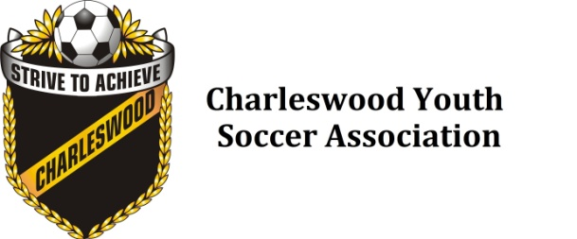

Registration Policy

The purpose of this policy is to outline the standard policies and procedures regarding fees and registrations for all youth players.

1. Registration

1. Player registration deadlines will be established annually prior to the opening of soccer registration for the outdoor and indoor seasons of play.
2. No registration will be accepted after posted deadlines, unless permission has been obtained by the relevant convenor.
3. Registration will be accepted for any male or female player who qualifies to play in the U3 to U18 age divisions.
4. No registrations will be accepted for U19 and above (WYSA rule)
5. The program and division a player is eligible to register for will be determined by the players date of birth.
6. Proof of age is required for all new players. Acceptable forms of identification in order to verify a players date of birth are:
7. Birth certificate, original, photocopy, or digital image
8. Manitoba medical card, original, photocopy, or digital image
9. Passport, original, photocopy, or digital image
10. Only a legal parent/guardian may register a player.
11. The order in which players are considered registered will be determined by the date on which full payment is received or the date on which payment arrangements, including subsidies if any, are determined.
12. Registration, payment and verification of a players’ date of birth,must be approved by the CYSA registrar before a player is considered registered.
13. Registration will not be accepted if any outstanding fees are owed to Charleswood Youth Soccer Association (CYSA)

2. Payments

1. Payment can be made by:
2. Credit Card (online registration only)
3. Cheque sent by mail
4. Cheque, or cash dropped off at a location as determined by the CYSA registrar.
5. CYSA believes every child should have the opportunity to play, if alternative payment arrangements or subsidy requests are required please contact either the CYSA registrar or another member of the executive for assistance
6. Payment is the responsibility of the legal parent/guardian
7. NSF cheques will be charged a $15 fee. Cash only accepted to clear NSF cheques

3. Refunds

1. CYSA will consider a refund only when a request in writing, which clearly states the reason for the request, is made to the registrar within two weeks of the player becoming ineligible to play.
2. Refunds will only be considered in the case of:
3. A season ending injury which prevents further participation
4. A relocation to an area outside the city of Winnipeg

All other requests one month or less prior to the season scheduled start and/or once the season of play (season of play start is designated as date released by Winnipeg Youth Soccer Association) has commenced will be considered on a case by case basis in extenuating circumstances only

1. Any requests made based upon a player becoming ineligible to play due to disciplinary action by the governing bodies of soccer will not be considered
2. Supporting documentation may be requested
3. Charleswood Youth Soccer Association shall have sole discretion on whether a refund request is approved or denied
4. All decisions are final
5. Once a refund has been issued a player will be considered ineligible for the remainder of the season for which the refund has been issued
6. Rate of refund:

One month prior to season start:

1. a full refund will be issued upon receipt of a written request minus any applicable credit card fees

One month or less prior to the scheduled season start and/or once the season of play has commenced rate of refund will be determined by whichever is less:

1. 75 percent of the players full registration fee
2. The players registration fee divided by the number of matches scheduled for the regular season of play multiplied by the number of matches for which the player will be considered ineligible.

Reviewed and enacted February 2024