Whimsical Creations

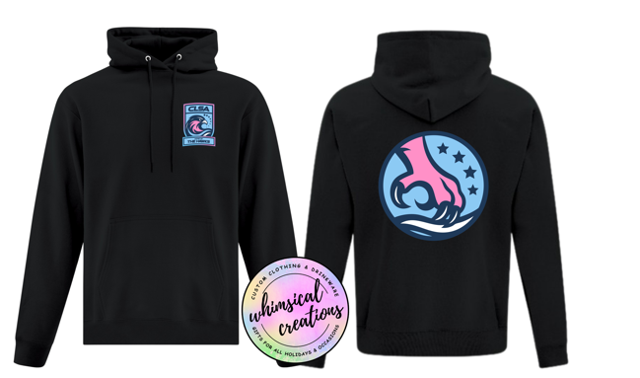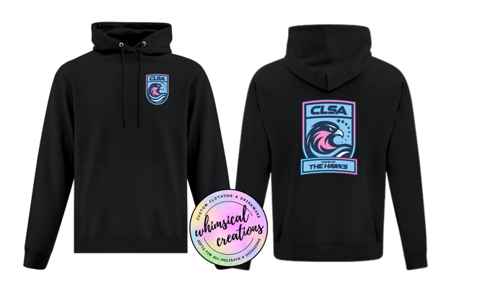

The following prices are for 2 printed and pressed designs per hoodie. Each additional design is $5.00 per design per hoodie. (Example name on sleeve)
All orders are subject GST
Youth Hoodies $33.75
Adult hoodies $45.00
To place orders please message Tina @ 780-201-0132 (this is her busy season so please allow 24hours for a response)
Adult Hoodies
