RAMP Team App

Creating Account / Log In
After downloading the app, an account will need to be created. The Team App does not have an account created automatically if someone has used the registration process from the kgha.ca website. It is a separate application.
1. Select Create Account
2. Complete information on Create Account setting
a. If you want to automatically get your player(s)’ teams, use the same email address as you did for the registration process.
b. The email address can be updated later.
Log in to app using the created account and select Login
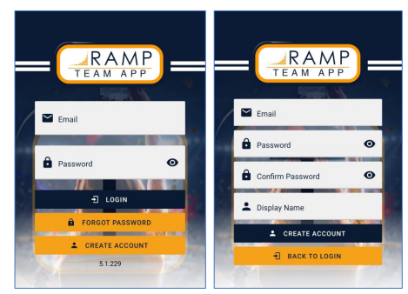

Schedules
Initial screen will give you a combined schedule of all players’ in your family.
If you are a staff member of the team as well, a separate calendar entry will appear as staff as well as one for the player.
An RSVP box will be beside each team event. Select the RSVP and select No, Maybe, Yes

If someone selects the actual event, details of the event are expanded on.
If an event is canceled, the event will stay in the calendar but a reason, if provided, and a crossed-out symbol appears.

Map / Directions to Event Location
Within the map, a car icon can be found. Selecting the car will open your default map app and input the address into the event.

Adding Availability Note, Spectator and Carpooling Information
Within the details screen of the event
1. User should scroll up to below the Health Check box
2. Select the field they need to update
3. Enter in detail
4. The field will automatically save when moving to another location or off the screen

Availability
Selecting Availability tab allows users to see the RSVP status of everyone on the team (players and staff) and any spectators also staying for the event associated to that player.
Depending on the user access, the view within the availability will differ.
Someone with App Managers will see the status of the “Health Check” as well as the RSVP status.

Calendar Subscription
Selecting the calendar icon in the upper right corner will bring a new screen up that will send a URL link to your email address to subscribe to the calendar. Selecting the Google Calendar or Email URL link, new events will automatically be added to your calendar (about a 24-hour refresh period).

Teams
This screen will allow the user to select the specific team they would like to be interacting with.

Schedule
This will show the specific team schedule. Functionality is the same as the schedule items above.

Roster
Shows all players names and details (numbers, position) in one view, as well as team staff. Each person can be selected and provide contact information of the individual. Depending on access (App manager vs Team member), there is a view only capability (team member) or an “edit team member” capability (app manager) to add additional information or capabilities for the app, as well as uploading a picture

Chat
Allows all members to chat and share messages directly with all users of the team. Chats are instantly shared with through the app.
There is a “Fan Access” also available for people outside of the family, Fans also have access to the chats.
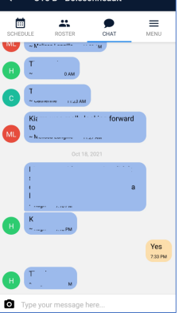

Menu
Depending on level of access there is several different selections from here:
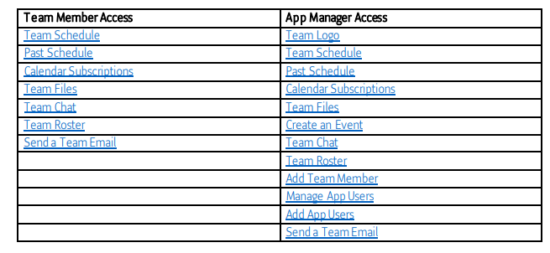

Past Schedule
Allows users to see previous events. All details and access level are carried over to this function as well

Team Files
Allows users to download documents uploaded to the Team Files folder.
If user has App Manager access, they can also upload a file as well as download a file.
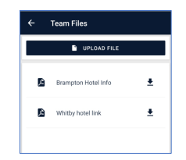

Send a Team Email
Allows user to send a team email and select who should be receiving the email and if they should be BCCd or not.
When “Compose Email” is selected, the users default email will open with the email addresses prepopulated.
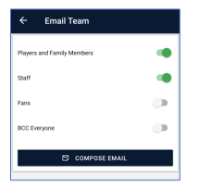

Team Logo
Allows user to upload a team logo of your choice. The logo will show up on the team selection page. Contact the executive for a copy of the logo.

Create an Event
Allows user to create an event directly through the app instead of logging in through the desktop.
Selection of Team Event, Practice, or Game will be reflecting in the Health Check download.
Selecting the map find symbol next to the location field allows the user to find an arena or location for the map functionality to take the person to. Most Ontario arenas are already within the search function, so if playing an away tournament, entering in the arena name should produce a result.
All practices, games, and team events can be added through the desktop functionality as well. 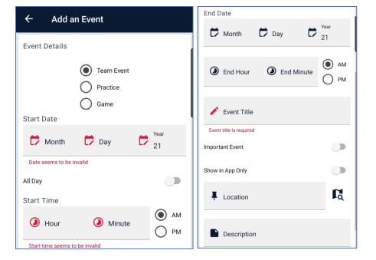

Add Team Member
This allows a new team member to be added. This can allow Affiliate Players to be added or new Staff Members. An email invitation to the app can be sent if selected.
By adding an affiliate player, they will be able to be included in the health check when arriving at the event.
Affiliate players can be deleted by using the desktop website only.
When a roster is approved, all players and staff are automatically added to the app without any manual process.
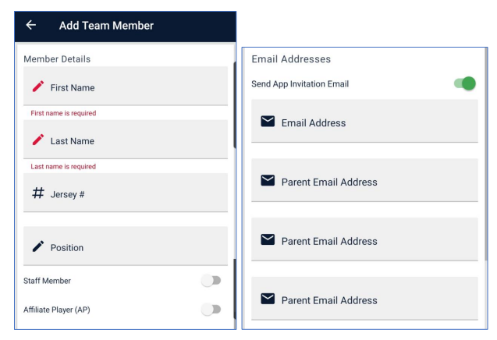

Manage App Users
From this screen, an app user can manage the level of access for everyone on the team app. If a current app user has Team Member access, they can be updated to App Manager user and vice versa, or anyone can be updated to “limited fan access”.
App users can have their email address update through this function or through their own settings.
All rostered team staff are automatically given App Manager access
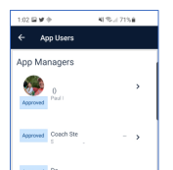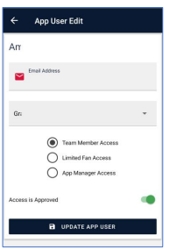
Add App Users
An invitation can be sent to anyone not currently using the app. The App Manager user can enter an email, select a rostered member (required) and the level of access they need to have and then send the invitation.
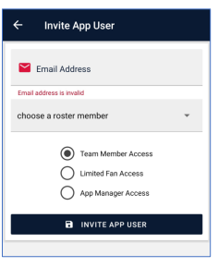

Chat
Brings user to the main page, if more than one team is affiliated with the account, to select the team they wish to chat with. This only occurs if selecting Chat at the bottom right of the page selection is made and not if selecting chat after selecting the specific team first and then selecting chat at the top of the team page.
Separate Chats cannot be created with a specific individual or smaller group. These will be shared with everyone, including players, if they have access.

Settings
From the schedule, teams or chats main screens, there is a sprocket in the upper right corner that will bring the user to settings.

Account Settings
Allows the user to upload/change a picture of user. The display name of the user can be updated, and additional optional information can be added here. Any notifications can be set from here. If someone has fan access and does not want to receive chat or event notifications, they can do it from this screen.
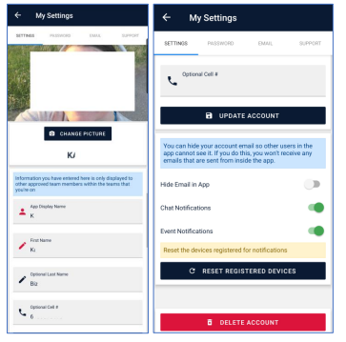

My Team Members
Shows all players associated with the user’s account. A parent could update their own and each of their player’s info directly from this screen. If you add a photo of your player here, when viewing the schedule for all family members, their photo will appear here in the background.

Change Password
Update password for the user.
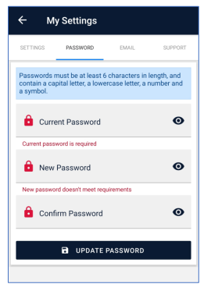
Change Account Email
Enter current password and update email address for account
