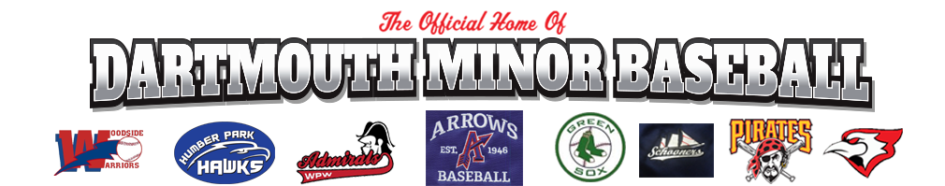

Coaches Code of Conduct

In addition to Code of Conduct (PAGE 1), coaches have additional responsibilities. The coach-athlete relationship is a privileged one and plays a critical role in the personal, sport, and athletic development of the athlete. Coaches must understand and respect the inherent power imbalance that exists in this relationship and must be extremely careful not to abuse it, consciously or unconsciously. Coaches will:

- Meet the highest standards of credentials, integrity and suitability, including but not limited to such considerations established by DDMBA Screening Policy, so that the community is satisfied it has minimized the risk of an unsafe environment;

- Report any ongoing criminal investigation, conviction or existing bail conditions, including those for violence; child pornography; or possession, use or sale of any illegal substance;

- Under no circumstances provide, promote or condone the use of drugs (other than properly prescribed medications) or performance-enhancing substances and, in the case of minors, alcoholic beverages and/or tobacco;

- Respect all other teams and athletes from other teams and, in dealings with them, not encroach upon topics or actions which are deemed to be within the realm of coaching', unless first receiving approval from the coach who is responsible for the team or athlete(s) involved;

- Not engage in a sexual relationship with an athlete of under the age of 18 years, or an intimate or sexual relation with an athlete over the age of 18 if the coach is in a position of power, trust or authority over such athlete;

- Recognize the power inherent in the position of coach and respect and promote the rights of all participants in sport. This is accomplished by establishing and following procedures for confidentiality (right to privacy), informed participation, and fair and reasonable treatment. Coaches have a special responsibility to respect and promote the rights of participants who are in a vulnerable or dependent position and less able to protect their own rights;

- Dress professionally, neatly and inoffensively;

- Use inoffensive language, taking into account the audience being addressed.

