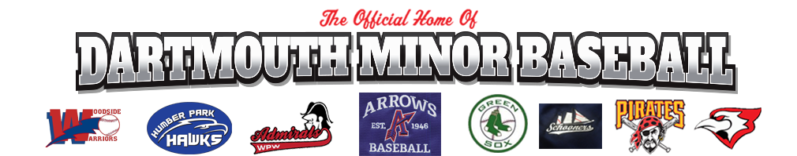

Players Code of Conduct

In addition to Code of Conduct (page #1), athletes will have additional responsibilities to:

- Report any medical problems in a timely fashion, where such problems may limit the athlete’s ability to travel, train or compete;

- Participate and appear on time, well nourished and prepared to participate to one’s best abilities in all competitions, practices, training sessions, events, activities, or projects;

- Properly represent one self and not attempt to enter a competition for which one is not eligible, by reason of age, classification, or other reason;

- Adhere to DDMBA rules and requirements regarding clothing and equipment;

- Never ridicule a participant for a poor performance or practice;

- Act in a sportsmanlike manner and not display appearances of violence, foul language, or gestures to other players, officials, coaches, or spectators;

- Dress in a manner representative of DDMBA with focus being on neatness, cleanliness, and discretion. Designated official clothing, if applicable, must be worn when traveling and competing;

- Act in accordance with DDMBA’s policies and procedures and, when applicable, additional rules as outlined by coaches or chaperones.

