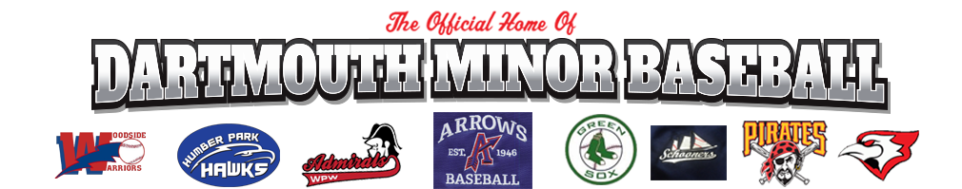

DDMBA Code of Conduct

All Individuals have a responsibility to:

- Maintain and enhance the dignity and self-esteem of DDMBA members and other individuals by:

- Demonstrating respect to individuals regardless of body type, physical characteristics, athletic ability, gender, ancestry, colour, ethnic or racial origin, nationality, national origin, sexual orientation, age, marital status, religion, religious belief, political belief, disability or economic status;

- Focusing comments or criticism appropriately and avoiding public criticism of athletes, coaches, officials, organizers, volunteers, employees and members;

- Consistently demonstrating the spirit of sportsmanship, sport leadership and ethical conduct;

- Acting, when appropriate, to prevent or correct practices that are unjustly discriminatory;

- Consistently treating individuals fairly and reasonably;

- Ensuring adherence to the rules of Baseball and the spirit of those rules.

- Refrain from any behavior that constitutes harassment, where harassment is defined as comment or conduct directed towards an individual or group, which is offensive, abusive, racist, sexist, degrading, or malicious. Types of behavior that constitute harassment include, but are not limited to:

- Written or verbal abuse, threats or outbursts;

- The display of visual material which is offensive or which one ought to know is offensive in the circumstances;

- Unwelcome remarks, jokes, comments, innuendo or taunts;

- Leering or other suggestive or obscene gestures;

- Condescending or patronizing behavior which is intended to undermine self-esteem, diminish performance or adversely affect working conditions;

- Practical jokes which cause awkwardness or embarrassment, endanger a person’s safety, or negatively affect performance;

- Any form of hazing where hazing is defined as “Any potentially humiliating, degrading, abusive, or dangerous activity expected of a junior-ranking athlete by a more senior team-mate, which does not contribute to either athlete’s positive development, but is required to be accepted as part of a team, regardless of the junior-ranking athlete’s willingness to participate. This includes, but is not limited to, any activity, no matter how traditional or seemingly benign, that sets apart or alienates any team-mate based on class, number of years on the team, or athletic ability.”;

- Unwanted physical contact including, but not limited to, touching, petting, pinching, or kissing;

- Unwelcome sexual flirtations, advances, requests, or invitations;

- Physical or sexual assault;

- Behaviors such as those described above that are not directed towards a specific individual or group but have the same effect of creating a negative or hostile environment;

- Retaliation or threats of retaliation against an individual who reports harassment to DDMBA Board.

- Refrain from any behavior that constitutes sexual harassment, where sexual harassment is defined as unwelcome sexual comments and sexual advances, requests for sexual favors, or conduct of a sexual nature. Types of behavior that constitute sexual harassment include, but are not limited to:

- Sexist jokes;

- Display of sexually offensive material;

- Sexually degrading words used to describe a person;

- Inquiries or comments about a person’s sex life;

- Unwelcome sexual flirtations, advances or propositions;

- Persistent unwanted contact.

- Abstain from the non-medical use of drugs or the use of performance-enhancing drugs or methods. More specifically, DDMBA adopts and adheres to the Canadian Anti- Doping Program. Any infraction under this Program shall be considered an infraction of this Code and shall be subject to disciplinary action, and possible sanction, pursuant to DDMBA Discipline and Complaints Policy. DDMBA will respect any penalty enacted pursuant to a breach of the Canadian Anti-Doping Program, whether imposed by DDMBA or any other sport organization

- Refrain from associating with any person for the purpose of coaching, training, competition, instruction, administration, management, athletic development or supervision of the sport of competitive Baseball, who has incurred an anti-doping rule violation and is serving a sanction involving a period of ineligibility imposed pursuant to the Canadian Anti-Doping Program and/or the World Anti-Doping Code and recognized by the Canadian Centre for Ethics in Sport (CCES)

- Refrain from the use of power or authority in an attempt to coerce another person to engage in inappropriate activities

- In the case of adults, avoid consuming alcohol in situations where minors are present, and take reasonable steps to manage the responsible consumption of alcoholic beverages in adult-oriented social situations associated with DDMBA events

- Respect the property of others and not willfully cause damage

- Promote Baseball in the most constructive and positive manner possible

- Adhere to all federal, provincial, municipal laws

- Comply at all times with the bylaws, policies, procedures, rules and regulations of DDMBA, as adopted and amended from time to time.

