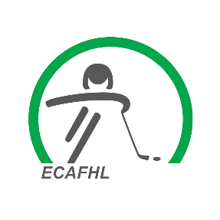
ECAFHL Bonds and Fees

Bonds:
Each association must pay the ECAFHL a bond in the amount of $1000.00. This bond will be held by the ECAFHL and will be refunded to the association if it is no longer an active member of the ECAFHL or if the membership is revoked.
Bonds are used to deduct any unpaid fines or association fees that are outstanding. The association will have 10 days to replenish the bond.

Team Fees:
All teams participating in the ECAFHL will be charged a team fee. This fee will be determined after all the associations have declared the amount of teams participating within the ECAFHL. The team fee is due on or before the annual ECAFHL Scheduling Meeting.
Late fees: Late fees will be applied to the association if the team fees are not paid on time as indicated above. A late feed of $250.00 will be applied.

