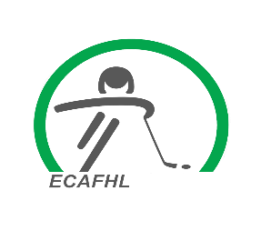
Letter of Agreement

As team staff we are serving as positive role models for players on and off the ice, with respect, a winning attitude, hard work and determination to do our best by our players. Please enjoy the 2023/2024 hockey season!
This is to certify that we as team staff have read the Alberta One Regulations, Policies & Procedures written by Hockey Alberta, along with the appendices written by the ECAFHL.
We agree to abide by these regulations and appendices.
Signed: Printed:
__manager(s)___________________________________________________________________________________________________________________________________________________coach(s)_____________________________________________________________________________________________________________________________________________________asst.coach(s)_______________________________________________________________________________________________________________________________________________________________________________________________________________________________trainer(s)____________________________________________________________________

Please return this to your governor with your FOIP paperwork and before your first regular season game.

