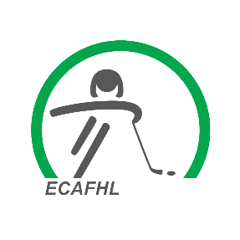
ECAFHL Communication Protocol:
Attention:
MHA Presidents
MHA Directors
MHA Managers and Coaches

Please follow the ECAFHL Communication Protocol, if you have any questions regarding the ECAFHL, ECAFHL games, and AB1 regulations.

- If Coaches and Managers have any questions first contact your MHA League Representative/President and if necessary your League Governor.
If they cannot answer your question those individuals can contact the ECAFHL executive.
- This protocol is in place to ensure that the Minor Hockey Association is aware of concerns or problems their teams are experiencing withing the ECAFHL, and to minimize calls to the ECAFHL Executive.
- All contact to the ECAFHL Executive will be done via the League Representative or the MHA President. (No Coaches, Managers or Parents are to contact the League Executive).

