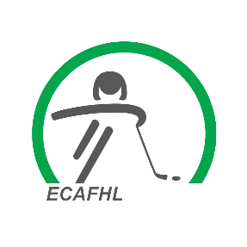
ECAFHL Fines

The following is an outline of all the ECAFHL fines as per the Alberta One Regulations, Policies & Procedure Handbook:
- $200.00 fine for non-representation at a regional league meeting (pg 7)
- $2500.00 fine for team failing to present itself (pg 12)
- $200.00 fine for not uploading a game sheet in the allotted time (pg 16)
- $200.00 fine for failing to provide a complete and legible game sheet (pg 16)
- $1000.00 fine for an association whose team fails to fulfill its commitments to participate in ECAFHL playoffs, unless requests made (pg 19)
- $200.00 fine for late HCR reporting to your league governor

