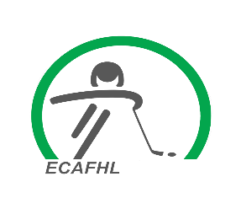
ECAFHL Supplemental Discipline
The following will be used once a player hits a threshold of penalty minutes during an ECAFHL hockey season which includes tiering, league and playoff games. If threshold isn’t hit during regular season the minutes quit counting towards playoffs.
U18 Division:
Threshold: Suspension Length:
100 minutes 1 game
120 minutes 2 games
140 minutes 4 games
160 minutes 8 games
U15 Division:
Threshold: Suspension Length
75 minutes 1 game
90 minutes 2 games
110 minutes 4 games
130 minutes 8 games
U13 Division:
Threshold: Suspension Length:
60 minutes 1 game
80 minutes 2 games
100 minutes 4 games
120 minutes 8 games
U11 Division:
Threshold: Suspension Length:
50 minutes 1 game
65 minutes 2 games
80 minutes 4 games
95 minutes 8 games

