**10U FINA Figures 2018-2022**

**Compulsory:**

302 BLOSSOM  1.4 From a **Back Layout** position the trunk is lowered as the hips are bent to assume a **Submerged Ballet Leg Double**Position. The feet separate along the surface as the hips rise and the body assumes a **Split Position**. The legs join to assume a **Vertical Position** at ankle level. A *Vertical Descent* is executed.



101 Ballet Leg Single 2.4: TO ASSUME A **BALLET LEG** Begin in a Back Layout Position. One leg remains at the surface throughout. The foot of the other leg is drawn along the inside of the extended leg to assume a **Bent Knee Back Layout** Position. The knee is straightened, without movement of the thigh, to assume **a Ballet Leg Position.** 2 TO LOWER A BALLET LEG From a Ballet Leg Position the ballet leg is bent, without movement of the thigh, to a **Bent Knee Back Layout Position**. The toe moves along the inside of the extended leg until a Back Layout Position is assumed.



**Group 1:**

316 **KIPNUS** 1.4 From a Back Layout Position, a partial Somersault Back Tuck is executed until the shins are perpendicular to the surface. The trunk unrolls as the legs assume a Bent Knee Vertical Position midway between the former vertical line through the hips and the former vertical line through the head and the shins. **A Vertical Descent is executed in a Bent Knee Vertical Position**.



360 **WALKOVER FRONT** 1.9 From a Front Layout Position (From a Front Layout Position with face in the water as the trunk moves downward to assume a Front Pike Position, the buttocks, legs and feet travel along the surface until the hips occupy the position of the head at the beginning of this action), a Front Pike Position is assumed. One leg is lifted in a 180° arc over the surface to a Split Position. The Front leg is lifted in a 180° arc over the surface to meet the opposite leg in a Surface Arch Position and with continuous movement, an Arch to Back Layout Finish Action is executed. From a Surface Arch Position, the hips, chest and face surface sequentially at the same point, with foot first movement to a Back Layout Position, until the head occupies the position of the hips at the beginning of this action.



**Group 2:**

310 **SOMERSAULT BACK TUCK** 1.1 From a Back Layout Position, the knees and toes are drawn along the surface to assume a Tuck Position. With continuous motion, the tuck becomes more compact as the body somersaults backward around a lateral axis for one complete revolution. A Back Layout Position is resumed.

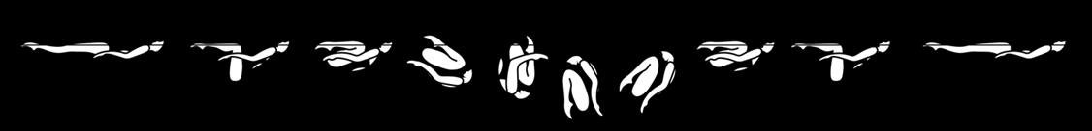

344 **NEPTUNUS** 1.7 From a Front Layout Position (From a Front Layout Position with face in the water as the trunk moves downward to assume a Front Pike Position, the buttocks, legs and feet travel along the surface until the hips occupy the position of the head at the beginning of this action), a Front Pike Position is assumed. One leg is lifted to a **Fishtail Position**. The horizontal leg is bent to assume a **Bent Knee Vertical Position**. A Vertical Descent is executed as the bent knee is extended to meet the vertical leg as the ankles submerge.



**Group 3:**

324 **SOMERSUB** 1.9 From a Front Layout Position with face in the water as the trunk moves downward to assume a Front Pike Position, the buttocks, legs and feet travel along the surface until the hips occupy the position of the head at the beginning of this action. From a Front Pike Position, maintaining this position, the body somersaults forward around a lateral axis so that the hips replace the head at the one quarter point to assume a **Submerged Ballet Leg Double Position**. The buttocks, legs and feet travel (move) downward until the hips occupy the position of the head at the beginning of this action. One leg is lowered to a Submerged Ballet Leg Position. Maintaining this position, the body rises vertically to a Surface Ballet Leg Position. The Ballet Leg is lowered.



362 **SURFACE PRAWN** 1.3 From a Front Layout Position, a Front Pike Position is assumed. One foot is moved in horizontal arc of 180° at the surface to a Split Position. The legs are joined to assume a Vertical Position at the ankles. A Vertical Descent is executed.

