11-12 Compulsory Figures
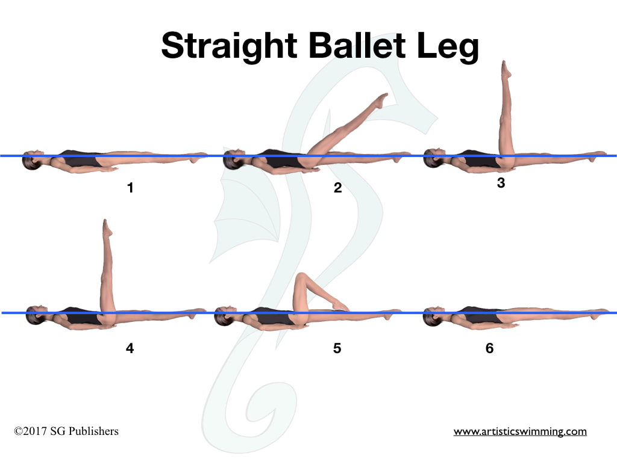
DD 1.6
From a Back Layout Position, one leg is raised straight to a Ballet Leg Position. The Ballet Leg is lowered. TO LOWER A BALLET LEG From a Ballet Leg Position the ballet leg is bent, without movement of the thigh, to a Bent Knee Back Layout Position. The toe moves along the inside of the extended leg until a Back Layout Position is assumed.

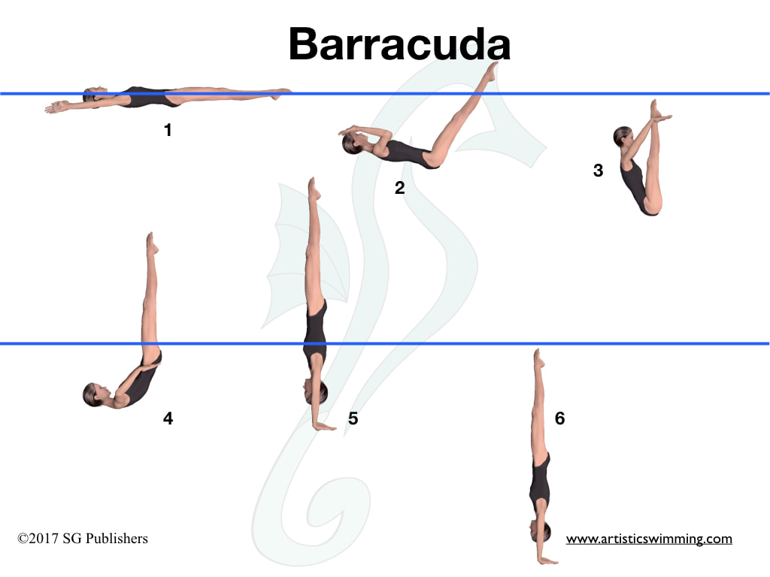
DD 1.9
From a Back Layout Position, the legs are raised to vertical as the body is submerged to a Back Pike Position with the toes just under the surface. A Thrust is executed to Vertical Position. A Vertical Descent is executed at the same tempo as the Thrust.
Thrust: From a Submerged Back Pike Position, with the legs perpendicular to the surface, a vertical upward movement of the legs and hips is rapidly executed as the body unrolls to assume a Vertical Position. Maximum height is desirable.

11-12 Group 1
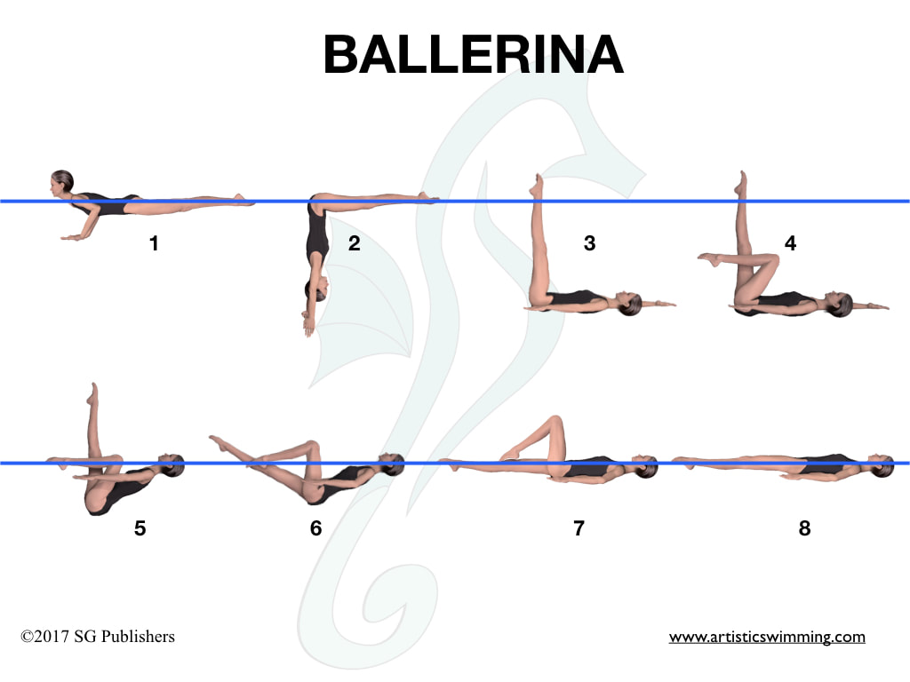
DD 1.8
From a Front Layout Position a Somersault Front Pike is executed to a Submerged Ballet Leg Double Position (From a Front Pike Position, maintaining this position, the body somersaults forward around a lateral axis so that the hips replace the head at the one quarter point to assume a Submerged Ballet Leg Double Position. The buttocks, legs and feet travel (move) downward until the hips occupy the position of the head at the beginning of this action.) One knee is bent to assume a Submerged Flamingo Position. Maintaining this position, the body rises to a Surface Flamingo Position. The ballet leg is lowered in a 90° arc to the surface as the other leg moves to assume a Bent Knee Position. The toe moves along the inside of the extended leg until a Back Layout Position is assumed.

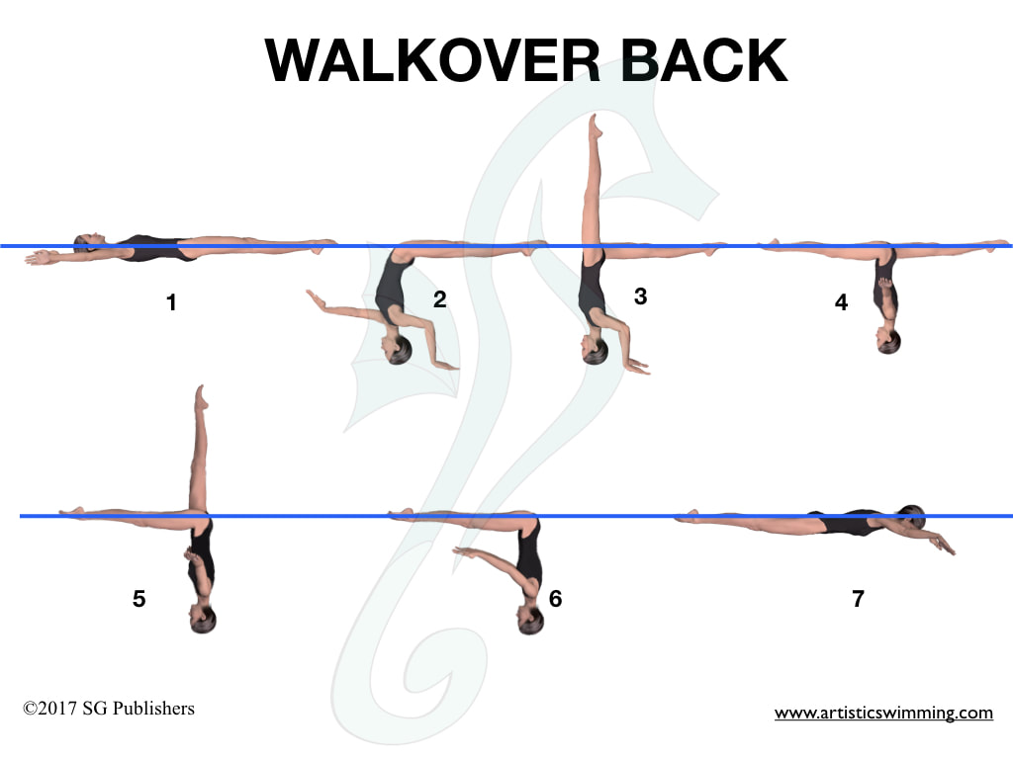
DD 1.9
With the head leading a Dolphin is initiated. The hips, legs and feet continue to move along the surface as the back is arched more to assume a Surface Arch Position. One leg is lifted in a 180° arc over the surface to a Split Position. A Walkout Back is executed.
Walkout Back: The back leg is lifted in a 180° arc over the surface to meet the opposite leg in a Front Pike Position and with continuous movement, the body straightens to a Front Layout Position. The head surfaces at the position occupied by the hips at the beginning of this action.

11-12 Group 2
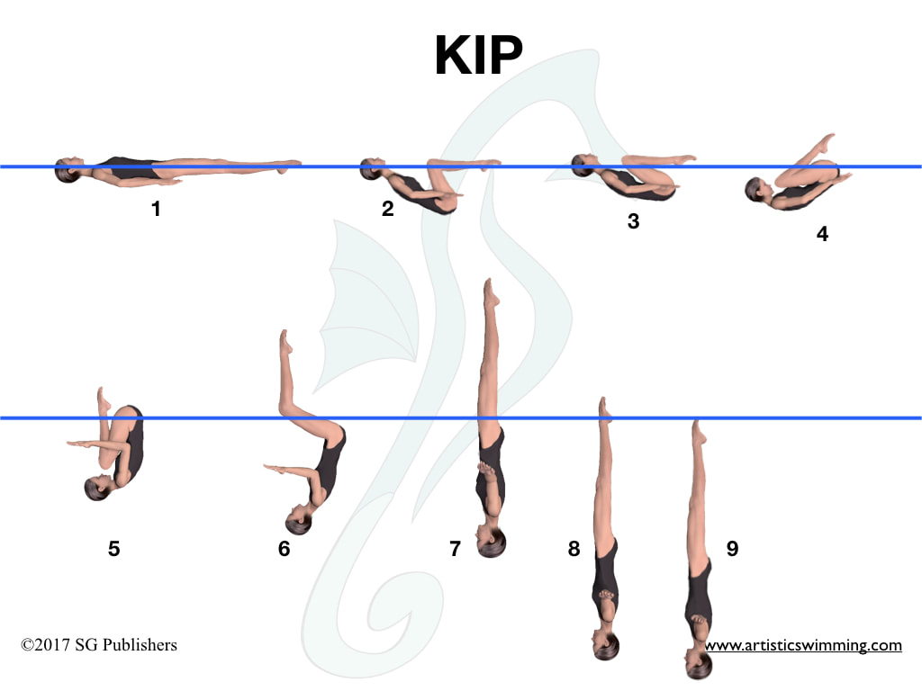
DD 1.6
From a Back Layout Position, a partial Somersault Back Tuck is executed From a Back Layout Position, the knees and toes are drawn along the surface to assume a Tuck Position. With continuous motion, the tuck becomes more compact as the body somersaults backward around a lateral axis until the shins are perpendicular to the surface. The trunk unrolls as the legs are straightened to assume a Vertical Position midway between the former vertical line through the hips and the former vertical line through the head and the shins. A Vertical Descent is executed.
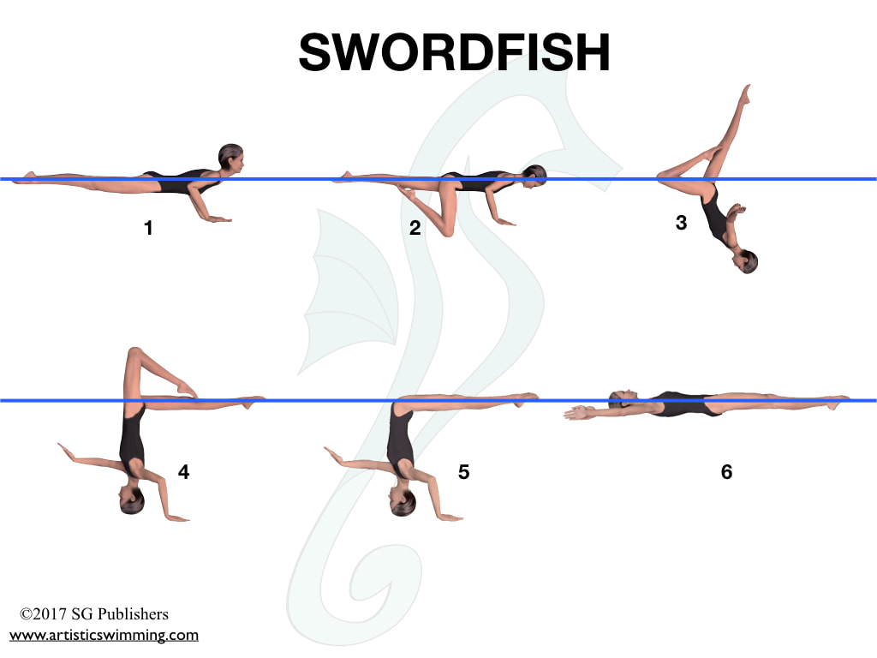
DD 2.0
From a Front Layout Position, a Bent Knee Position is assumed. The back arches more as the extended leg is lifted in a 180° arc over the surface to assume a Bent Knee Surface Arch Position. The bent knee is straightened to assume a Surface Arch Position, and with continuous motion, an Arch to Back Layout Finish Action is executed.
ARCH TO BACK LAYOUT FINISH ACTION
From a Surface Arch Position, the hips, chest and face surface sequentially at the same point, with foot first movement to a Back Layout Position, until the head occupies the position of the hips at the beginning of this action.

11-12 Group 3
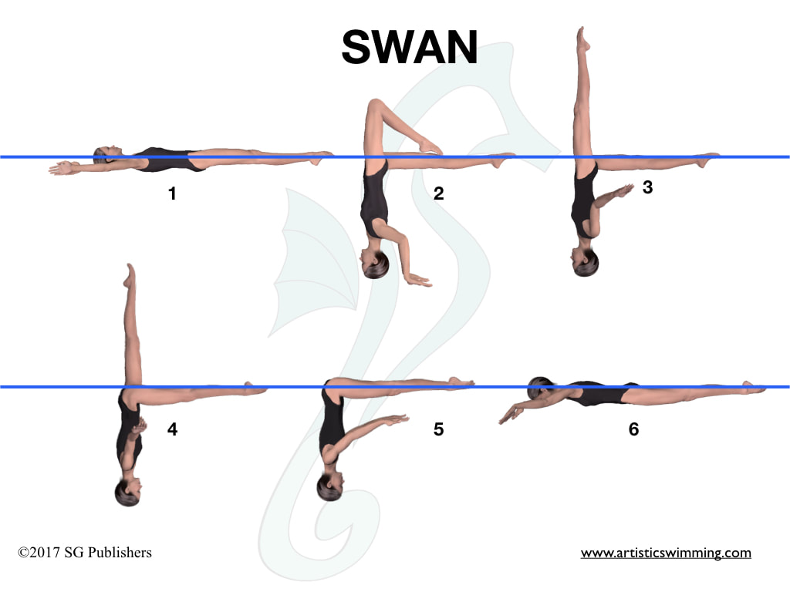
DD 2.1
A Nova is executed to the Bent Knee Surface Arch Position. The bent leg straightens to assume a Knight Position. The body rotates 180° to assume a Fishtail Position. The vertical leg is lowered to the surface to meet the opposite leg in a Front Pike Position and with continuous movement the body straightens to a Front Layout Position. The head surfaces at the point occupied by the hips at the beginning of this action.
NOVA
With the head leading a Dolphin is initiated until the hips are about to submerge. The hips, legs and feet continue to move along the surface as the back is arched more as one knee is bent to assume a Bent Knee Surface Arch Position.

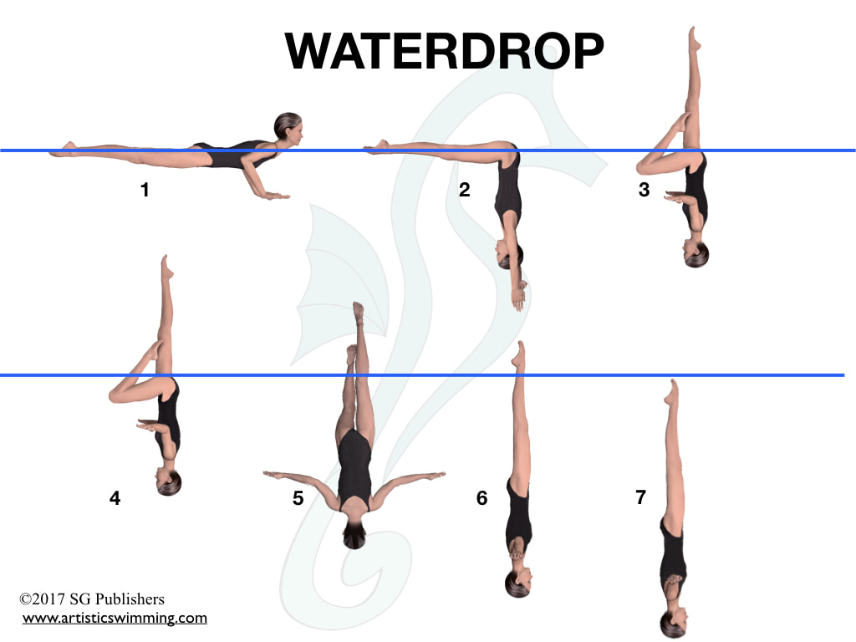
DD 1.5
From a Front Layout Position, a Front Pike Position is assumed. The legs are lifted simultaneously to a Bent Knee Vertical Position. A 180o Spin is executed as the bent knee is extended to a Vertical Position before the ankles reach the surface of the water.

