Registration News
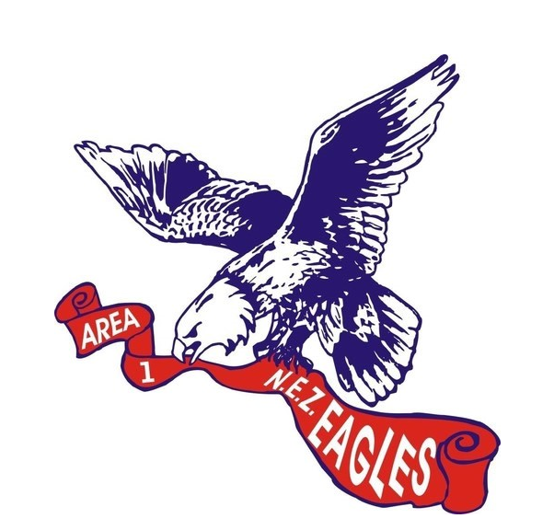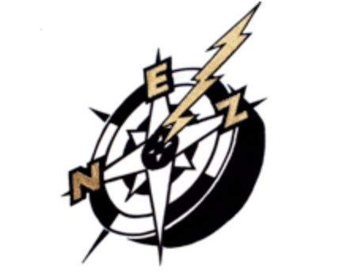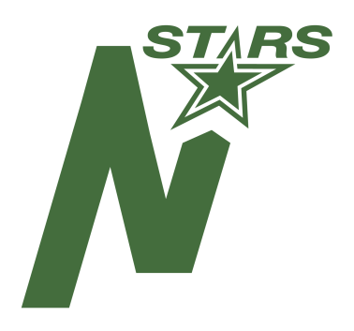

We have very exciting news for the upcoming 2019/2020 Hockey Season.
Within the North East Zone (NEZ); the Eagles and Northstars have agreed to work collaboratively to improve the competitive balance of our teams.

Starting in Peewee; the NEZ, Eagles, and Northstars will host our evaluations starting with the Zone Peewee AA team formation, then continue to form all our teams jointly. We are currently finalizing the details in Novice and Atom and will update as we progress.

All players from the Eagles and Northstars will continue to register with their home club and then will be combined for joint NEZ team formation. The Eagles and Northstars will continue on as sponsor organizations. Further details on the evaluation process will follow.

This is a very exciting initiative allowing the potential for greater development, increased involvement and more competitive balance on our teams within the North East Zone.
If you have any questions or concerns, please contact:

Eagles Dylan Thomas: Dylan.Thomas@gov.ab.ca
NEZ Carlos Vieira: nezbantamdirector@gmail.com
Northstars Marvin Heise: mkheise94@gmail.com

