COACHING APPLICATION FOR THE 2019-2020 SEASON
SECTION 1: CONTACT INFORMATION
Name of Applicant:
Home Phone: Cell Phone:
Work Phone: Birth Date:
(Emergencies Only) (yyyy/mm/dd)
Email Address:
Home Address:
City: Postal Code:

SECTION 2: Division Information
I wish to apply for the following Division:
Do you have a son / daughter at this age? Yes No
Head Coach Minor Novice Assistant Coach Minor Novice
Major Novice Major Novice
Atom Atom
Peewee Peewee

Head Coach (List below any people you are considering for part of your coaching staff)
Name | Position

SECTION 3: EXPERIENCE/QUALIFICATIONS
Please provide details of prior coaching positions held:
Year: Association/ Team: Position:
Year: Association / Team: Position:
Year: Association / Team: Position:

2019 / 2020 Coaching Requirements
NOTE: ALL COACHES AND STAFF MUST COMPLETE ANY OUTSTANDING CERTIFICATIONS BY
OCTOBER 31, 2019 PLEASE DO NOT DELAY IN SIGNING UP FOR A COURSE AS THEY FILL UP EARLY!
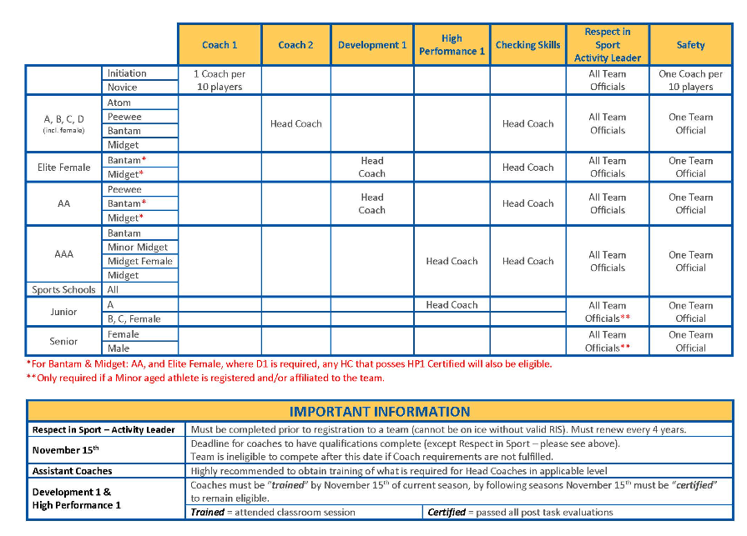
Please provide details of Coach / Trainer Certifications (Please fill out all certificates that you currently hold that are valid (not expired).
Certification Course Name | Completion Date / Course Date

Highest Level Played | Team Name

Explain in general terms your Coaching philosophy / style:

Why are you volunteering to be a coach / assistant coach:

What is your philosophy on ice time (for example – shortening the bench or benching as s form of discipline?)

What is your attitude towards winning and losing?

What are your strengths?

Briefly summarize your proposed seasonal plan:

SECTION 4: REFERENCES
Coaching:
Name: Phone:
Non-Coaching:
Name: Phone:
I acknowledge and agree to the above named references being contacted. I am aware that other persons and organizations may also be contacted. I give permission to these persons/organizations to provide information about myself to the Northstars Athletic Club (NSTARS) for purposes of this application.
If accepted to a coaching position with NSTARS, I agree to uphold and abide by any rules and regulations as set forth by the Association, and the goals and philosophies of the Association.
I AGREE to terms and conditions.

Name: Signature: Acknowledgement of Signature

Please return completed application at enac@nstars.com
Thank you for taking time be a volunteer coach with Edmonton Northstars Hockey!

