EFCLRA Evaluations Handbook

2021-2022 Season

Table of Contents
1 INTRODUCTION AND PHILOSOPHY 4
1.1 Committee Members and Roles 4
2 Oversight Committee 4
3 EFCLRA Evaluation Sessions 5
3.1 Evaluators 5
3.2 Preparation Skates (non-evaluative) 5
3.3 Grading Session(s) 5
3.3.1 Universal Athlete Assessment (UAA) Session (U10-U14) 6
3.3.2 Individual athlete placement 6
3.3.3 Scrimmage Evaluation Session(s) – U12-U19 6
3.3.4 Player movement between Skate Groups 7
3.3.6 Goalies 7
4 Team Formation 8
4.1 U10 8
4.2 U12-U19 9
5 Team Draft Process U12-U19 9
5.1 Eligible players – See Appendix D for more information 9
5.1 Goalies 10
5.3 Draft Order 10
5.4 Draft Oversights 11
5.5 Responsibilities of the Draft members 11
6 Miscellaneous 11
6.1 Missed Session policy 11
6.2 Injured / Sick Player missing all evaluations 11
6.3 Age Division Movement 12
6.3.1 General 12
6.3.5 Association Needs 13
6.4 Draft Details 13
6.4.1 Coaches / Assistant coaches Daughters 13
6.4.2 Other Issues 13
6.5 Import Players 14
6.5.1 Import Player Process - See Appendix D – Team formation 14
APPENDIX A: UAA Skills Session Drills (U10, U12 & U14 ONLY) 15
APPENDIX B: Evaluation forms 16
APPENDIX C: Flowcharts 27
APPENDIX D: Team Formation 31

1 INTRODUCTION AND PHILOSOPHY
The Evaluation Committee of the Edmonton Federation Community League Ringette Association (“EFCLRA”) has compiled this document to outline the general principles behind this year’s evaluation process. Ideally, the evaluation committee wants each player to play at the level consistent with their skill, desire and commitment.

This document was created to provide information regarding the process, ensure clarity and the greatest possible degree of fairness. The committee will strive to make the process as transparent as possible.

Evaluations require significant planning and execution, based on player numbers which often fluctuate week to week, day to day. As such, changes to the process may be required which may not be presented fully on our website, or in this document. Final authority for what process occurs rests with the Evaluation Director/Oversight Committee.

The Evaluation Committee will meet after the evaluations to go over the process with a mind to improve where possible. This handbook, then, is intended to be a living document, as the EFCLRA strives for continually better evaluations.

It is the philosophy of EFCLRA that every athlete be placed at an appropriate level, based on the athlete’s current skill level, ringette experience and physical maturity. Evaluations then are not tryouts but rather opportunities for athletes to showcase themselves. For this to happen, EFCLRA will:
- create appropriate evaluation drills and measurements
- communicate the process to parents/guardians and athletes
- provide a minimum of one non-evaluative preparation session
- provide a minimum of two evaluation sessions
- provide feedback, when requested, to each athlete as to the decisions on their placement. This feedback will be limited to the player’s ratings only and no discussion will be entertained regarding placement of other athletes.

1.1 Committee Members and Roles
The Evaluation Committee may be made up of the following positions who all play a key role in the process:
- President – responsible for supporting other committee members and providing guidance as needed
- Evaluations Director – responsible for laying out the process, coordinating the evaluations, liaising with all committee members, and communicating with evaluators.
- Division directors – responsible for organizing player skate groups and volunteers to facilitate scrimmages as well as tabulating results (along with at least one other member of the EC). The Division Directors are responsible for communication with players and parents.
- Internal Director – responsible for providing administrative support including, but not limited to, data entry and keeping, tabulating results, and scheduling EC meetings and drafts.
- Coaching Director and Coach Selection Committee – will be responsible for selecting and placing the coaches
- Ice Allocator – will be working with the Evaluation Director to establish the schedule of the evaluations

2 Oversight Committee
Throughout EFCLRA evaluation processes, independent evaluators, representatives from the Evaluation Committee, Coaches and Assistant Coaches are asked to provide feedback. Once the evaluation-based recommendations (ratings, team selections and Coach/Ass’t Coach selection, etc.) are made, a final review will be made by the Oversight Committee.
The objective of this committee is to provide one final level of review, and subsequent approval, of important recommendations prior to implementation of these decisions. The Oversight Committee is the final authority. Should a recommendation be rejected by the Oversight Committee, it falls to them to implement a solution.
Members of the Oversight Committee are selected by the President. They will comprise, at a minimum, of the Evaluation Director, the Vice President and/or the President, plus one Board member without a child in the division.

3 EFCLRA Evaluation Sessions
Evaluation schedules will be created by the Evaluations Director, in conjunction with the Ice Allocator. The approximate timeframe will be from the first week of September through the third week of September, with the intent of forming the teams as early as possible while still maintaining a fair and open process. Athletes will all get the opportunity for one or more non-evaluative/conditioning skates prior to evaluations.

3.1 Evaluators
Evaluators will be selected by the Lead Evaluator and the Evaluation Director. It may include knowledgeable former players, current and former coaches, Executive members and potentially paid independent evaluators. Many evaluators are highly qualified ringette people, some with national and international experience.
Evaluators will be directed by a Lead Evaluator who will work with the entire evaluation team to establish age-appropriate standards for the grading system. That is, the Lead Evaluator will evaluate a skill with evaluation team. They will agree on what is the appropriate score for that athlete’s skill level. This will then be applied to all athletes. Periodic re-assessment will also be conducted, requiring conversations among the evaluators as needed. Evaluation scores will be on a comparison basis between players on the same sheet of ice.
Evaluators will:
- be assigned to a particular age group in order to maintain consistency and fairness where possible
- be assigned to evaluate players positionally, where applicable (i.e., U16/U19)
- work with the Lead Evaluator of each session
- give a rating in every category for any athlete assigned to them as well as a tiering number (overall rating compared to the group)
- give these results to the Division Director for compilation of results
- Provide written comments where possible to provide context for numerical scores
It should be noted that it is expected that evaluators WILL sit together for discussion throughout the course of the session.

3.2 Preparation Skates (non-evaluative)
The first session for all athletes will be an open skate. Drills and scrimmages will be performed to prepare the athletes. The intent of these sessions is to provide athletes with a chance to play in a non-evaluative setting so that they are hopefully more relaxed in the later evaluative sessions

3.3 Grading Session(s)
For U12-U19, players will be tiered. Each grading session will consist of drills and scrimmages. The evaluators will provide clear and unbiased feedback in both areas to the Division Director. Evaluators will use forms in Appendix B.
For U10, a similar approach will be followed with respect to grading of drills and scrimmages. **However, the grading session scores will be one of several factors used to determine what U10 Step each player is best suited to. Age, previous experience (what level played last season, physical maturity, former coach input where necessary, as well as team size are factors that will also be used when placing players. **
For U10-U14, EFCLRA will use the UAA assessment as created by Ringette Alberta as the primary assessment tool for skating skill. Additional drills will be established by the Evaluations Director, who will determine what skills will be tested and how. These drills will align with the evaluation sheets.
Following the UAA session (if applicable), warmup drills followed by scrimmages will be run for the remaining grading sessions. Coaches from previous years may be asked to run these sessions, and will be provided with a pre-set practice plan. They will have no input nor effect on the evaluations, nor does their presence on the ice mean they have been selected to coach a particular team.
There will be volunteer coaches on each bench ensuring proper organization of shifts and balance of positional play. This will be achieved by the use of numbered pinnies. Players will be placed on a bench and will take the ice in numerical order. It is the opinion of the EFCLRA that direct coaching is not appropriate but encouragement can be given to the athletes. Parents must be on opposite benches from their child to avoid any appearance of favoritism.
For U16 and U19 players will be allowed to play their preferred positions during scrimmages whenever possible.
The overall intent of the scrimmage evaluations is to determine the rank of the athletes based on their ability to play Ringette. Every effort will be made to ensure the scrimmage teams are balanced.
The underlying intent of the evaluation sessions is to provide Head Coaches data concerning the various players and their strengths and weaknesses.
TABLE #1 WEIGHTING OF GRADING SCORES BY AGE DIVISION (** See above)
EVALUATION PROCESS | U10 | U12 | U14 | U16 | U19
UAA SKILLS | Primary** | 40% | 30% | N/A | N/A
DRILL / SCRIMMAGE | Secondary** | 60% | 70% | 100% | 100%
For the game sessions, the UAA skill session will be used to create balanced teams and initial skate groups.

3.3.1 Universal Athlete Assessment (UAA) Session (U10-U14)
Developed by Ringette Alberta, these are repeatable, timed skill measurements which do not require Evaluators. The four timed drills used last year are used this season. Each skill session is designed to test a particular skating or ring handling skill specific to Ringette. Each drill will be explained (and demonstrated if needed) to the group before proceeding. See Appendix A
In keeping with the Long-Term Athlete Development (LTAD), each U10 athlete’s height may be assessed as a measure of physical maturity. This information may be made available to coaches. Height/size does NOT form a part of the evaluation ranking process. It may only come into play should a coach use this information when making a “coach pick”, when distributing players between teams at the same U10 Step, and when determining placement for bubble players when all other factors are equal.

3.3.2 Individual athlete placement
After the completion of the Preparation skates and the UAA assessment, athletes will be assigned to an initial scrimmage group based on UAA scores.

3.3.3 Scrimmage Evaluation Session(s) – U12-U19
Full scrimmage sessions will be a part of each evaluation. At the beginning of each session there will be a drill session followed by a Scrimmage. 3v3 scrimmages may be used at skate #1, a with 5v5 scrimmages for successive skates.
The purpose of the scrimmage sessions is to allow athletes to showcase their skills, positional and team play as well as spatial awareness. These are all to be done in a competitive situation. Free ring and goalie ring distributions may be used to simulate real game situations.
The line changes shall start with a free ring or goalie ring selected randomly by the ice facilitator and will be:
- every 90 seconds for U10/U12 (assuming 15 seconds for the line change, this allows approximately 75 second skating shifts), and
- 75 seconds for U14, U16, U19 (leaving approx. 60 second skating shifts).
On the sound of the buzzer or whistle the players shall abandon the ring and leave the ice. The next line can enter the ice but play will only resume on a whistle.
Players in U10, U12 and U14 will be rotated through all positions, while players in U16-U19 will be permitted to play their preferred position wherever possible.
To prevent the same players playing together or against each other for the entire game, while maintaining equal ice time, efforts will be made to shift rotations wherever possible.

3.3.4 Player movement between Skate Groups
In divisions with enough players to require multiple skating groups, some players may be shifted between skate groups to provide a comparison of the relative competitiveness of each group, and to provide a better evaluation of those players in the middle of the spectrum. The change in scores of these players when playing in the different skate groups will help define the “adjustment factor”, which will be awarded to those players playing in the stronger group. (I.e. if on average, players score an additional 4 points when playing in skate group 2 vs skate group 1, all players in skate group 1 will be awarded an additional 4 points for each skate evaluated in group 1.)
3.3.5 Final Skate Evaluations
Final skates are by invitation only and will be based on the cumulative scores achieved in the previous two evaluations. The number will be based on the number of teams and expected team size. However, this number can be altered by the evaluations committee in the interests of creating a fair evaluation environment. The Evaluation Committee will have the right to remove from final skates:
- any protected players (players by virtue of their initial scores place them within the mandatory selection of the team), plus
- any players at the other end of the spectrum mathematically eliminated from making the next level.
- Coaches’ daughters (if applicable)
Final skates are therefore used to aid evaluators by comparing an athlete against athletes of comparable experience and skill. Removing the players at either end of the spectrum at the final stages makes this comparison easier.

3.3.6 Goalies
It is the policy of EFCLRA that part time and primary goalies be evaluated appropriately, in order to encourage all athletes who, wish to be a goalie, whether on occasion or as her primary role within the team. In keeping with the goals of LTAD, goalie specialization is not encouraged until U14, thus there are goalie play limits in place at U10 and U12.
U10 players will only evaluate as skaters. Interest in the position will be recorded on registration forms and used when placing athletes.
All athletes in U12 must participate as skaters in the Preparation Skate, the UAA and Scrimmage Skate #1. If they wish, players with an interest in goal may dress as goalies in the remaining skates. A separate goalie session will be offered to assess only goaltender skills where possible.
Where possible, goalies in U14 will be afforded a separate session for their evaluation which can be used to replace the UAA session. They will then participate in scrimmage sessions as goalies. Players who wish to be evaluated as a skater and as a goalie will be encouraged to participate in both sessions, where possible.

4 Team Formation

4.1 U10
U10 is unique among the age divisions. Due to the large size, the three-year age span and the diversity of experience present, U10 teams will be formed using several factors, in addition to evaluation results.
- Players who will be nine (9) in the current playing year will be eligible to play Step 2 and 3
- Players who will be eight (8) in the current playing year will be eligible to play Steps 1, 2 and 3
- Players who will be seven (7) in the current playing year will be eligible to play Steps 1 and 2.
- Goalie play does not play a role in evaluations, as no player shall play the position full time
- Physical maturity will be a minor factor when determining where a “bubble” player will be suited to develop best. It will also be used to distribute players between teams of the same Step
- First year U10 (7 and 8 years old) have little game play experience, and as such, evaluations may be limited to skating ability (UAA) only. Game play evaluations for these players have been shown to be of limited additional value.
- Returning Step 2 and 3 players will be evaluated in game play situations.

4.1.1 Process
U10 Players will be initially organized into skating groups according to birth year and level played last season.
Following UAA scoring, players’ rankings will be initially set, within the birth year limits. Skate groups may be adjusted.
At this point, most Step 1 and beginner players will be completed evaluations. There may be an additional skate if ice availability permits.
Remaining players will participate in one or two further skates with players rankings and groups adjusted as needed. Cross ice 3v3 games may be used to better assess basic skills rather than knowledge of the game.
Based on the distribution of players according to age, experience and skill level, team number per Step and team size will be determined by the OC.
Once a final ranking of players has been completed, Step 3 teams will be formed first. The coach selection committee will select head coaches who have players falling within the team size window. These coaches will help form teams as necessary, via draft., overseen by the OC and division director. Particular attention will be paid to the players at the cut line between S2 and S3, with input from coaches. Affiliates will be chosen at the same time – typically those bubble players who do not get placed in Step 3.
Step 2 teams will be formed next. The coach selection committee will select head coaches who have players falling within the team size window. These coaches will help form teams as necessary, via draft, overseen by the OC and division director. Particular attention will be paid to the players at the cut line between S2 and S1, with input from coaches. Affiliates will be chosen at the same time – typically those bubble players who do not get placed in Step 2.
Step 1 teams will be formed next. The coach selection committee will select head coaches who have players in the remaining group. Teams will be formed by the Division director and the OC, with coaches being able to adjust teams as necessary to accommodate friend requests and assistant coach needs. Step 1 should have the most players per team. Because S1 draws on other S1 teams for affiliates, larger team sizes will enable affiliation to only be necessary on the rare occasion.

4.2 U12-U19
The number of teams at each level (A/B/C) will be determined following Ringette Alberta guidelines (RAB policy 4.4.5), once team size has been determined by the Oversight Committee Team size will be determined by dividing total number of players by the total number of teams, to arrive at approximate team sizes. C and B level teams will usually be afforded one or two additional players to help provide stability of numbers while providing opportunities for affiliation up.
- A team selection
  - A team head coaches will be present at all skates and will be required to form a team immediately following the tabulation of the final skate numbers.
  - The draft, if necessary, will follow the process as per Article 5.
  - The coach may inform players of their placement only once all teams within the division are formed, and the Division Director approves notification.
- B team selection
  - B team formation will take place after A team formation. If necessary, there will be a final skate for the remaining players to aid in formation.
  - B team head coaches will be present at these skates and will be required to form immediately following the tabulation of the final skate numbers.
  - The draft, if necessary, will follow the process as per Article 5.
  - The coach may inform players of their placement only once all teams within the division are formed, and the Division Director approves notification
- C team selection (U12 and U14)
  - C team formation will take place following the B team formation. The final tabulation will be made available at this time to the C team coaches.
  - C team head coaches, if determined, will be present at the evaluation skates
  - The draft will follow the process as per Article 5.
  - The coach may inform players of their placement only once all teams within the division are formed, and the Division Director approves notification

5 Team Draft Process U12-U19

5.1 Eligible players – See Appendix D for more information
EFCLRA has determined that there will be a number of protected players (‘Mandatory Picks’) in each age group equal to *75% of the total team size. These players are the players with the top rankings from the Evaluation Process, based on their cumulative scores. They must be picked in the draft and consequently will be noted at the beginning of the draft.
*Notwithstanding the above, the OC may adjust the protected player number and coach pick window if necessary. Reasons to do so include, but are not limited to: closely bunched rankings and natural breaks in rankings.
Coaches may select their remaining players (25% of team size) from those whose rankings are equal to 125% of total team size, or double the number of players to be picked (i.e., 2 players to be picked from the next 4, 3 players to be picked from the next 6, etc.)
An exception to the above applies in U16/U19, where players have declared their primary positions. Evaluators will assess positions separately in order to better assess skills and positional play. This will allow separate rankings by position to be created, from which coaches may select players to best fit their team.
All athletes are eligible to be drafted. The purpose for this is to allow the Head Coach some flexibility in choosing the team based on several factors including positional balance. However, any player not ranked within the coach pick window will be subject to approval by the Oversight Committee. Each coach is allowed one pick in this manner and approval from the OC will only be given when the coach has justified it. Possible justifications include injury or a missed session, which would both affect an athlete’s ranking.

5.2 Goalies
EFCLRA supports the guidelines as laid out by LTAD and Ringette Alberta regarding the specialization of positions and goalies in particular. See the Edmonton Ringette website under resources/rules and procedures. Every effort possible will be made to place goalies on teams wherein the best development for the athlete lies. In other words, goalies in U10 and U12 should play multiple positions, even if their primary position is goalie. The growth of the whole player must be considered when placing them.
Final say for this will lie with the Oversight Committee who will weigh goalie ratings and skater ratings for these individuals for placement and consider what is best for the general player population as well.

5.3 Draft Order
- One Team
  - The Head coach will select the appropriate number of players for that team. This will be set out by the Division Director and the OC. Protected/Mandatory players must be picked.
- Two Teams
  - The two Head Coaches will select the appropriate number of players as determined by the Division Director and the OC. Protected players must be selected before the end of the draft. The Division Director or the Evaluation Director will be present and will have the appropriate list of eligible players
  - First selection in the draft will be determined by a flip of a coin. OR the first selection will be based on the lower of the combined score of the Head and Assistant Coaches’ daughter’s evaluation scores.
  - Coaches must select their daughter (or assistant coaches’ daughter) when that athlete is the highest remaining ranked athlete.
  - Goalies can be selected at any time.
  - The order will follow a snake as below:
Coach 1 | Coach 2
1 | 2
4 | 3
5 | 6
8 | 7
9 | 10
12 | 11
13 | 14
16 | 15
17 | 18
20 | 19
21 | 22
24 | 23
25 | 26

5.4 Draft Oversights
The Oversight Committee will review all the Evaluation ratings and will make recommendations regarding individuals. Further, the OC will review all teams to ensure that fairness and equity has been achieved to the highest possible standards.
The Oversight Committee (under the direction of the EFCLRA board policy on goalie placement) will ensure that a balance of part time and primary goalies is considered. The placement of primary goalies and part time goalies will be done considering the best development situation for the athletes. Developing the whole player will be considered as well as team formation. The Oversight Committee has the final say on the matter.

5.5 Responsibilities of the Draft members
The Division Director and/or a member of the OC will ensure the draft process is followed and sign off on teams as they become finalized. The director is then to inform all involved of the teams as formed.
The Oversight Committee will aid the Division Director where needed and will make decisions regarding the balance of teams. The OC will either accept the teams as drafted or deal with concerns from the coaches. The OC is entitled to make final decisions regarding the matters.
Coaches will follow the process and sign off on the final team drafts.

6 Miscellaneous

6.1 Missed Session policy
In our attempt to create fair evaluations and treat athletes equitably, it is our policy that all athletes should attend all evaluations (barring 6.2 below). Any athlete missing a session will be not be given a score, and the remaining sessions averaged. For those athletes missing more than one session, and when those averaged scores place an athlete within the protected mandatory pick zone, the athlete will be positioned one spot outside the mandatory zone, yet within the coach pick zone.
The rationale for this is not to punish the athlete, but to ensure that every athlete be evaluated fairly. For this to happen, they must be evaluated on different occasions. The more times an athlete is viewed the more accurate the rating.
Missed UAA sessions may be replaced by the OC with a score from the previous season.
In a continued effort to evaluate in the fairest manner, however, an asterisk may be placed beside their name and the Evaluation committee, and the Oversight Committee will determine any adjustment to the ranking of the players who have missed a session.

6.2 Injured / Sick Player missing all evaluations
There may be circumstances which prevent an athlete from participating in evaluations. The Evaluation Committee must be made aware of this before the first skate, and a health practitioner note (see website, resources/return from concussion-injury/complete form) confirming the injury must be provided.
The Oversight Committee will determine the approximate ranking of the player who has missed the session, and an asterisk will be placed beside their name. This will be done using past evaluations, coach assessments, etc. The coach may select this player as an additional coach pick beyond the pre-determined team size.
In instances where team sizes do not allow an additional player to be taken (i.e., small teams), the OC shall approve the pick as a regular selection, if it is determined that is where the player best fits.

6.3 Age Division Movement

6.3.1 General
Playing Up means playing in a division higher than defined for the Player’s age. Normally, Levels within Divisions provide sufficient separation of skill levels.
Playing Down means playing in a division lower than defined for the Player’s age.
One of our principal goals for first year Players is to ensure that they have a positive playing experience. Considering the birth date, size, maturity and skill level together with the overall complexion of Association Teams in a given year, it may be better for a Player to play down.
As one of the goals of Ringette is the development of positive self-esteem and a proper sense of self-worth, it is important that Players remain with their peer group. Leadership can be a bigger challenge than skill improvement. It is sometimes a harder task to become a Team leader on and off the ice than it is to score goals. It is possible that the rewards in life could be greater if this Leadership skill is mastered.
Some studies have shown that the youngest in an age group may struggle, while the oldest tend to be more successful. In all cases of Player movement, the needs of the Player (not the parents, not the Association, not the Teams, and not of others) must be paramount.
6.3.2 Policy Scope:
This policy applies to all player movement (up or down) for all divisions/levels within Edmonton Ringette. Player movement is typically initiated by players or parents but in some circumstances such moves can be requested by the association as outlined in this document.
6.3.3 Philosophy & Intent:
This policy is intended to deter player movement between levels outside of the Ringette Alberta divisional rules. Exceptions will be considered in rare cases and must meet the criteria outlined in this policy.
    - Criteria for Player Requests to move up/stay down a division
      - Players may only be one year removed from the requested playing division.
  - i.e.: an 11-year-old could request to play in the U14 Division, however a 10-year-old could not, etc.
      - Players may move up a maximum of two levels only.
  - (I.e., if a player is U10 age, they may play at U12B, assuming there is a U12C; if a player is U12 age, they may play at U14A, assuming there is NOT a U14C
      - All requests will only be considered if it does not impede the ability of the affected playing age divisions to field competitive teams and does not adversely affect the team sizes for all involved.
      - Should the previous criteria be met, the Board will then ensure that at least one approved independent evaluator & one designated board member (i.e.: Director of Player Development, executive member etc.) are present to evaluate the player’s ability to play at the requested level.
      - Players will be evaluated in their designated playing division first and must meet the following criteria: underage players must rate in the top 5% of their designated playing division, and overage players must rate in the bottom 5% of their designated playing division.
      - If scheduling does not permit evaluations in both divisions to be completed in this manner, previous year results (if available) may be used.
      - If the designated playing division criteria is met, the player will be evaluated in the requested playing division second and must meet the following minimum criteria: Overage players must rate in the bottom 1/2 of the requested playing division. Underage players must evaluate within the team size window or be a mandatory pick for the requested team/division. i.e. they cannot “make the team” by solely being a coach’s pick. This means, that the player cannot be chosen by coach pick, if it requires the coach to “jump” players to make the selection – in this instance, the player would displace a player from the team who evaluated higher than them; this is not permitted.
      - Physical size & maturity level of the evaluated player as well as the players in the requested division should be considered.
      - The Director (s) will work with the Player Development Director, Executive member, evaluator(s) to determine if the players request is approved based on the above criteria.
      - Exceptions to the above must be approved by the President
      - The Director of the approved division will inform the player/parents of the final decision.

6.3.5. Association Needs
In exceptional years, it may be necessary for the Association to move players in order to balance divisions or to form viable Teams.

6.4 Draft Details
- Draft location
  - Time, date, and location will be determined each year by those involved
- People present at the draft
  - Head coaches (or designate such as an Assistant Coach)
  - Division Director
  - The Oversight Committee
- Other people who may also attend
  - The President (if he/she is not already a member of the Oversight Committee)
  - The Internal Director

6.4.1 Coaches / Assistant coaches Daughters
Daughters of assigned coaches are automatically selected to their team as per the notes on team selection. (sec 5.2)
One assistant coach may be selected in advance. His/her daughter automatically makes the team as per the selection process (sec 5.2)

6.4.2 Other Issues
Any issues involved in the drafting/selection of individual players must be brought forward in advance of evaluations. These can then be dealt with on a case by case basis, as they will only come into play if that particular situation arises. The Head Coaches will try to arrive at a reasonable solution. If they are unable to do so, the issue will be dealt with by the OC.
Other issues will be examined as they arise and will fall under the jurisdiction of the EFCLRA President and executive.

6.5 Import Players
From time to time players not residing in Edmonton may request to evaluate for an Edmonton team. If required by Ringette Alberta, these players may require a release to play. As the overall goal should be to encourage ALL players to participate, Edmonton Ringette will try to accommodate import players who request to play without handicapping Edmonton players.

6.5.1 Import Player Process - See Appendix D – Team formation

APPENDIX A: UAA Skills Session Drills (U10, U12 & U14 ONLY)
(U10, U12 & U14 ONLY; However, U10 does not complete the Butterfly Drill)

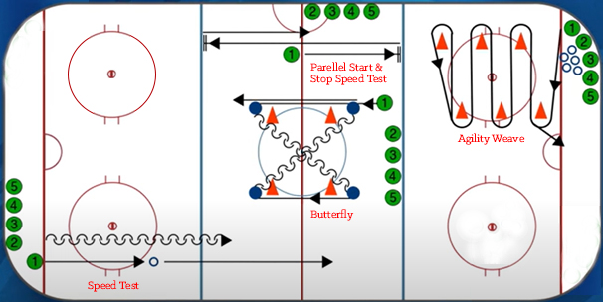

APPENDIX B: Evaluation forms
U10 Division Skater Form
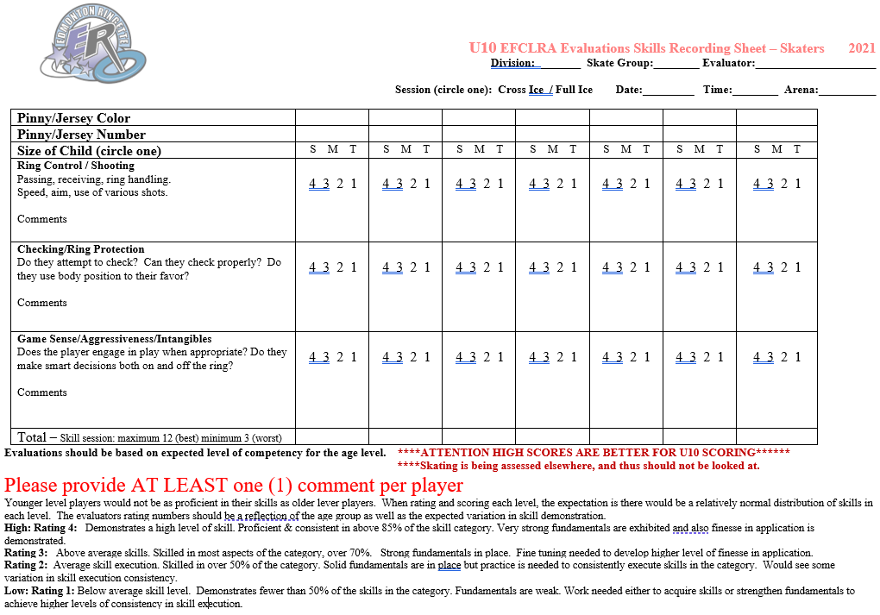

U10 Division Tiering Form

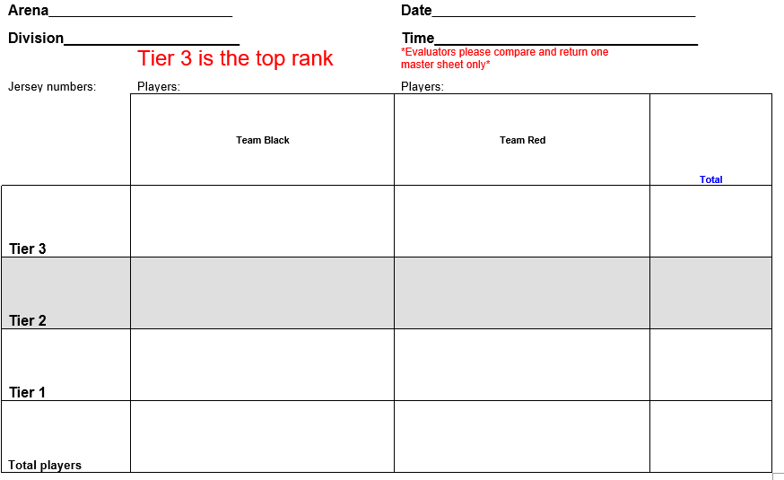

U12 Division Skater Form
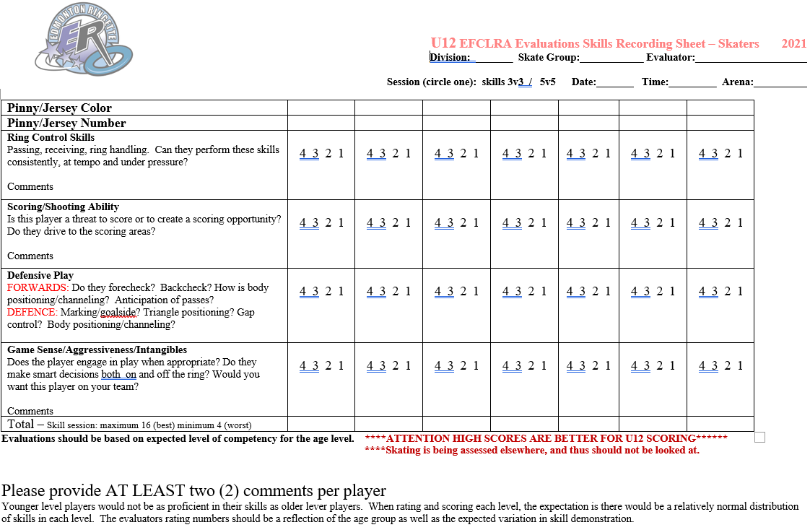

U12 Division Goalie Form
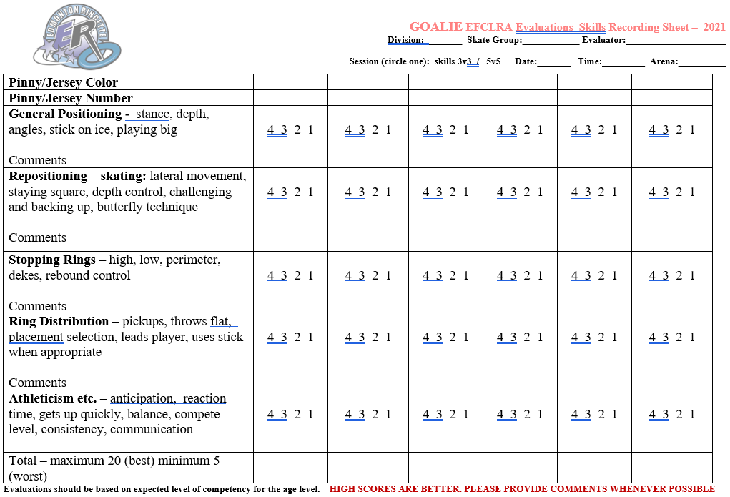

U12 Division Tiering Form
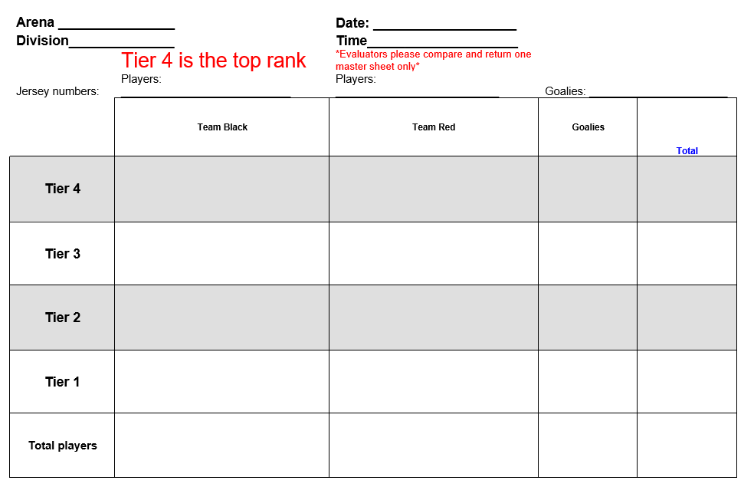

U14 Division Skater Form
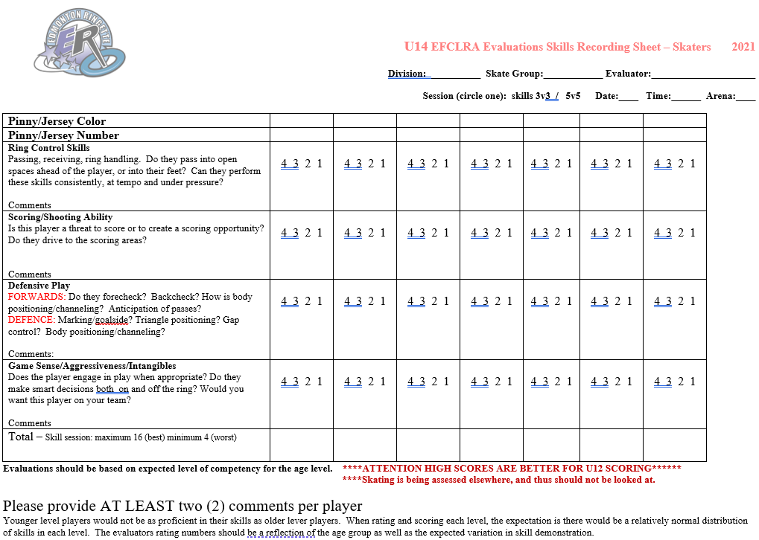

U14 Division Goalie Form
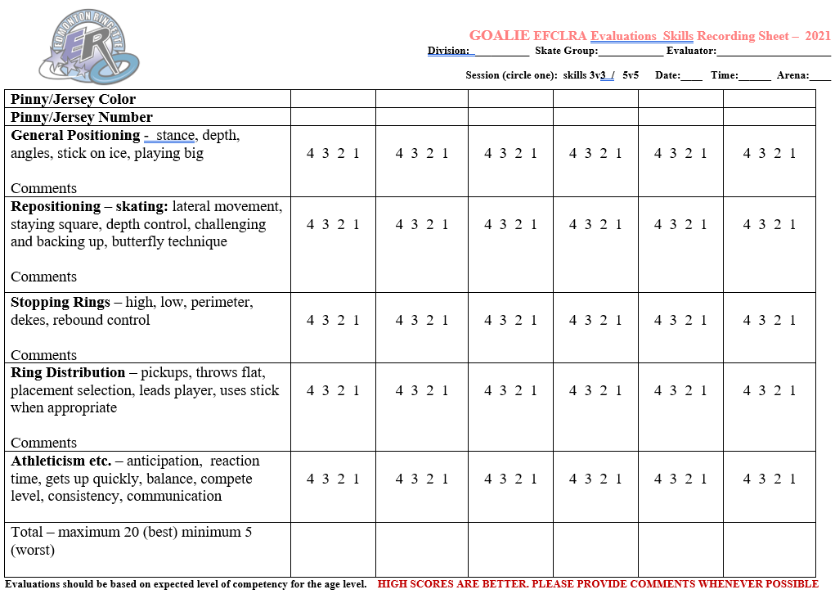

U14 Division Tiering Form
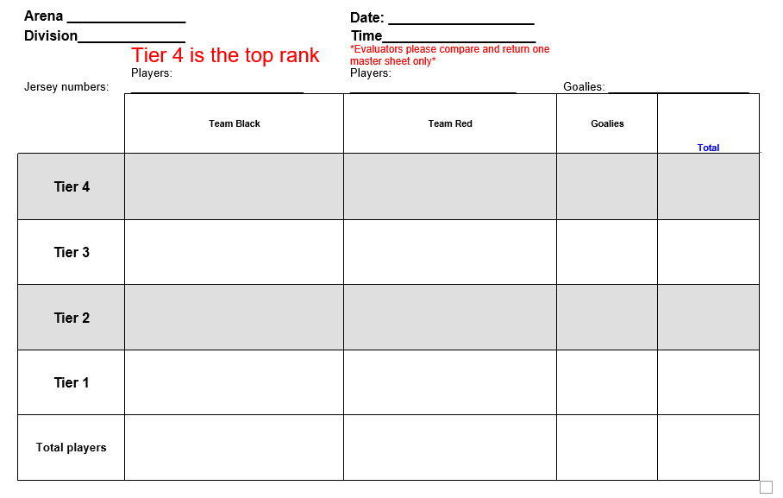

U16/U19 Division Skater Form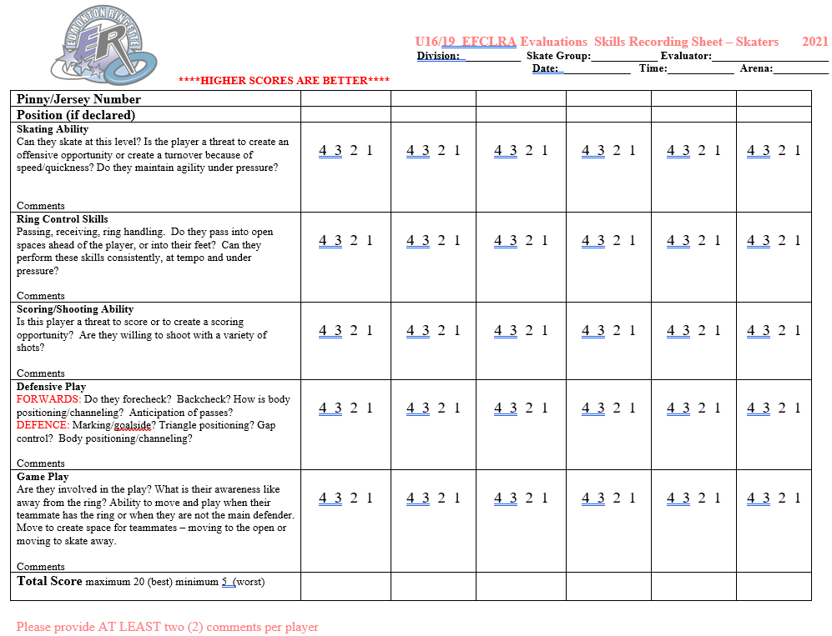

U16/U19 Division Goalie Form
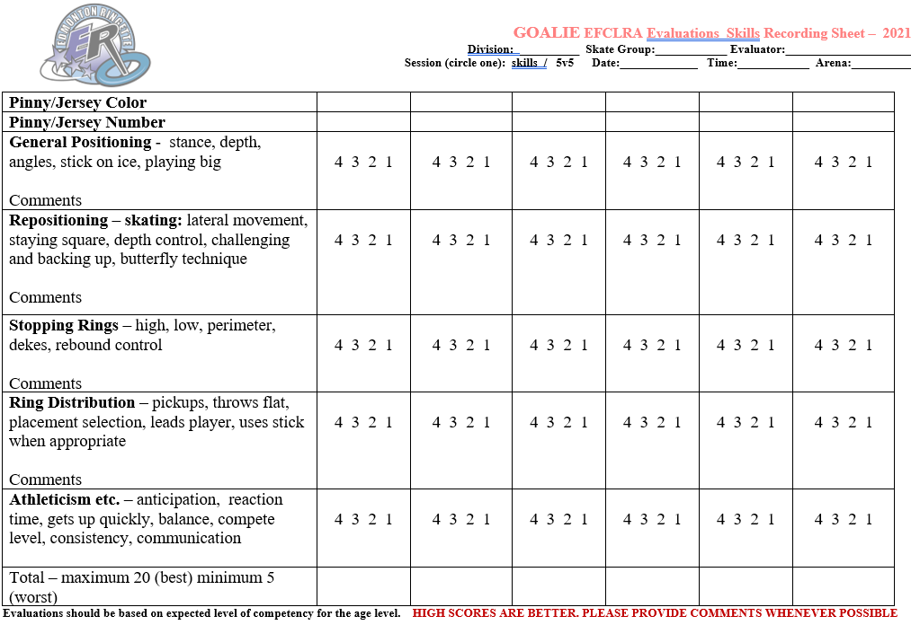

U16/U19 Division Tiering Form
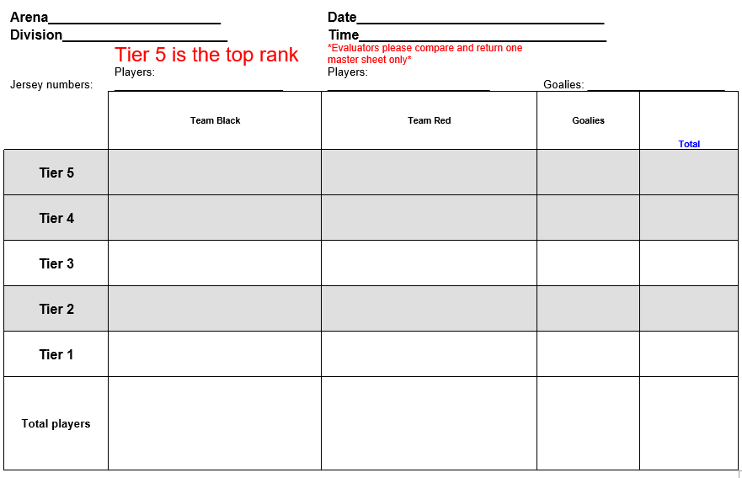

Appendix C: Flowcharts

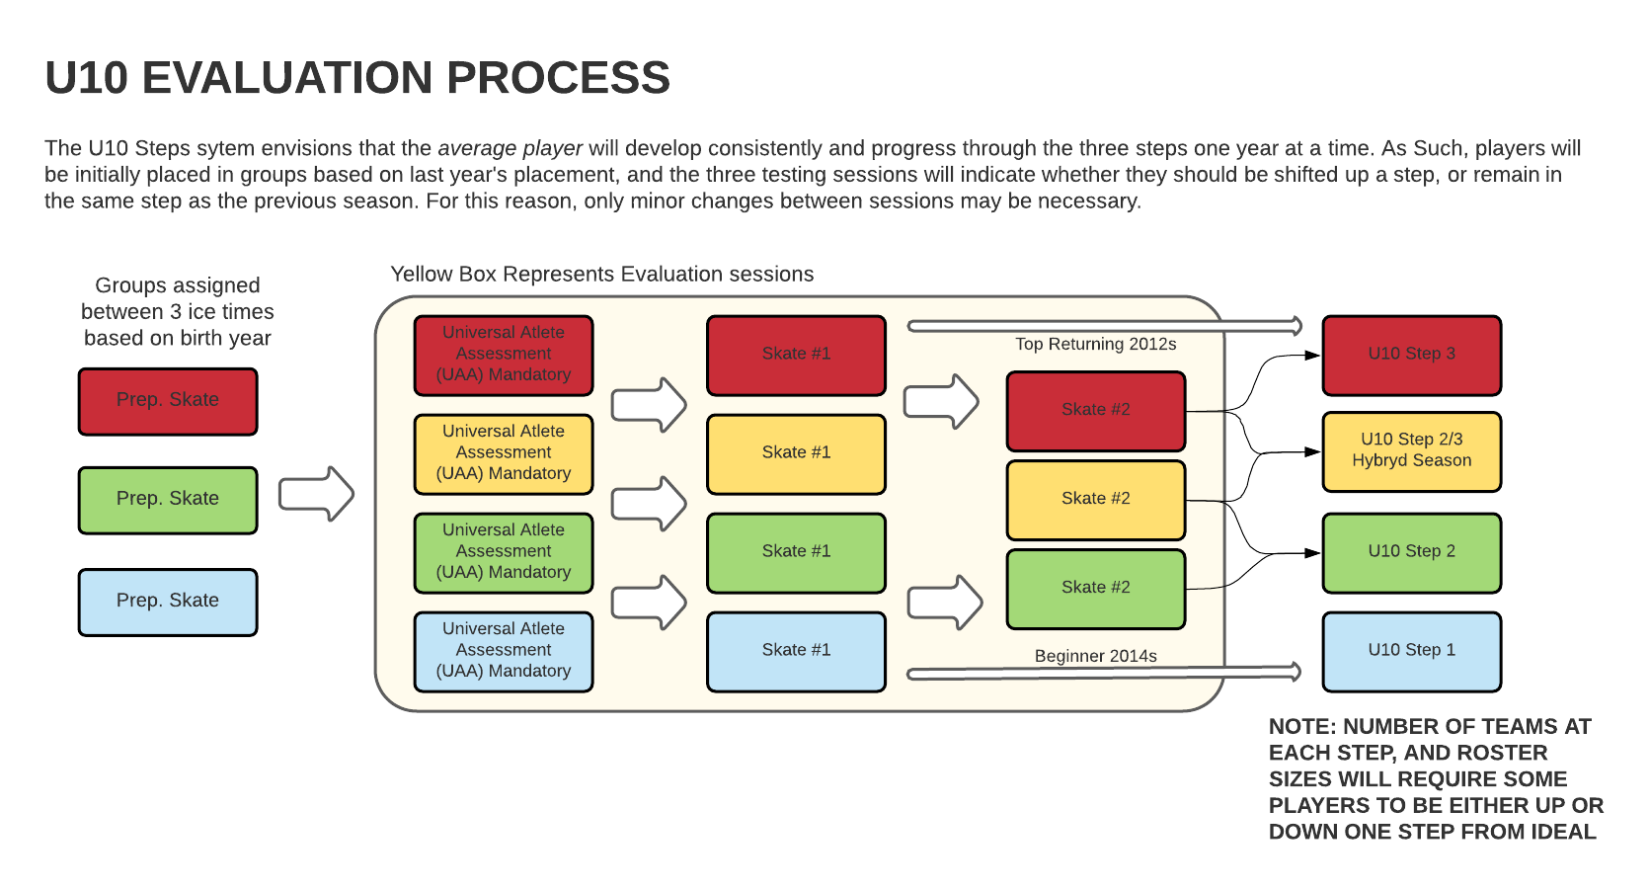

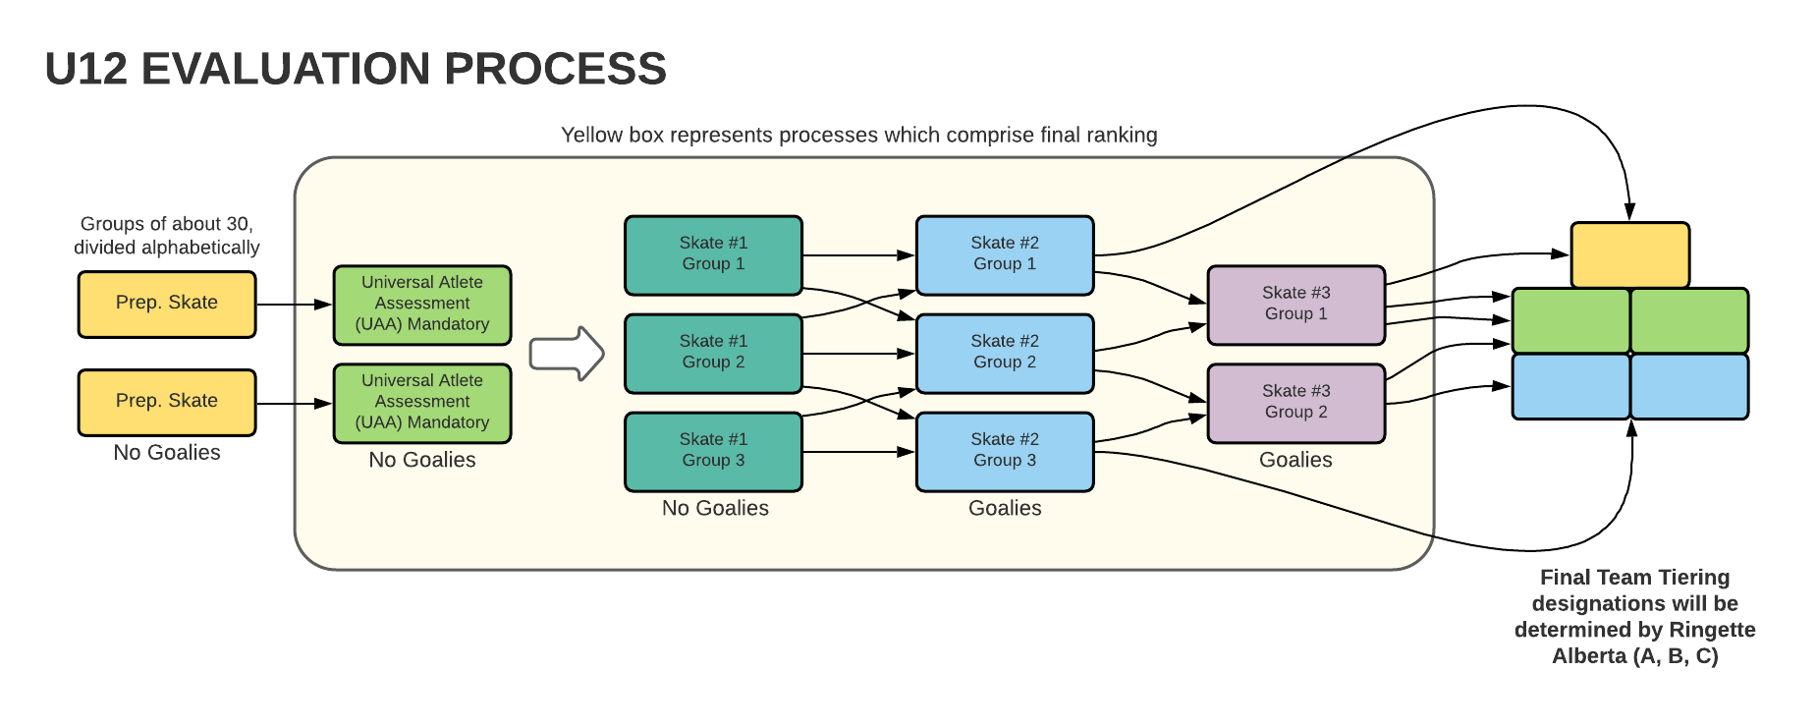

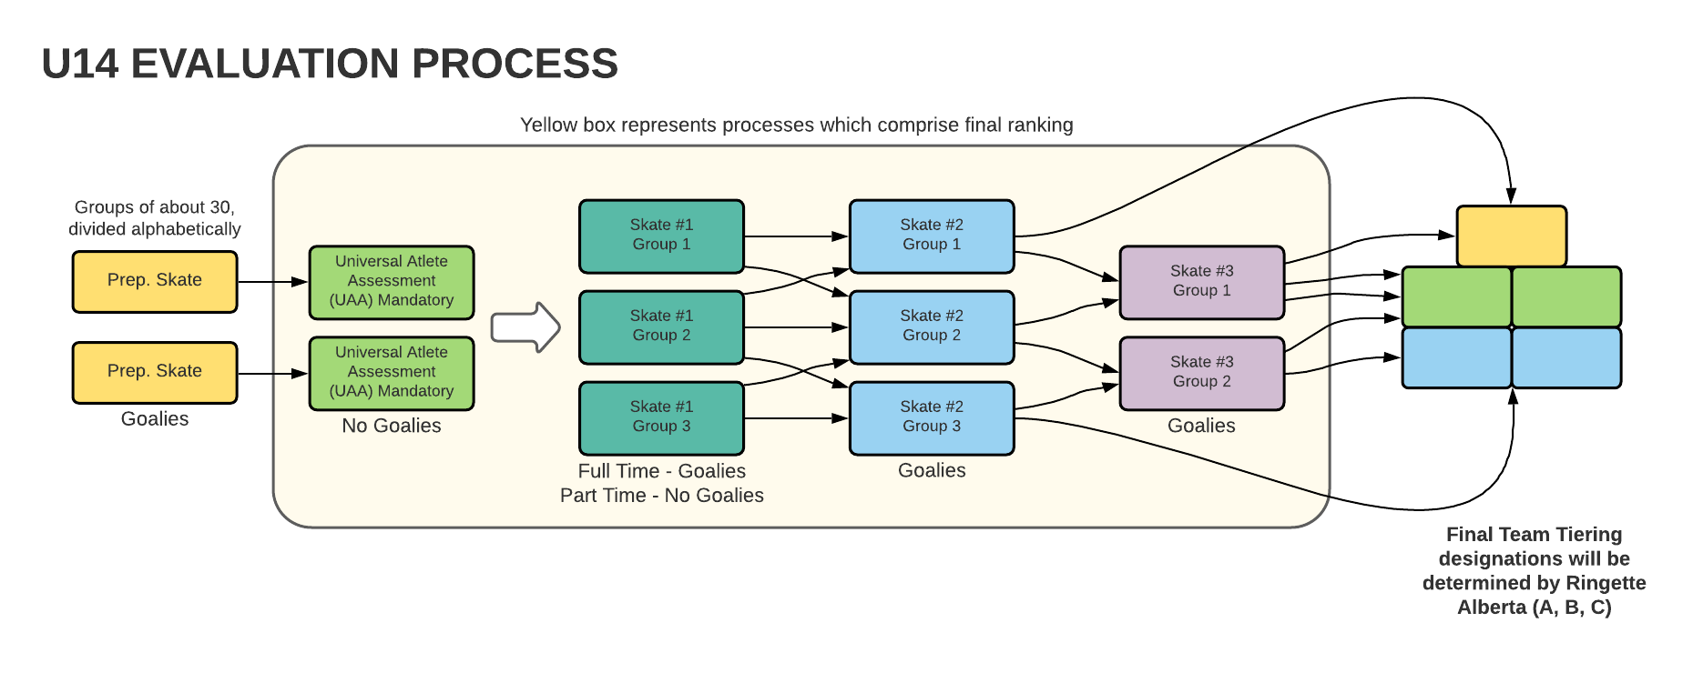

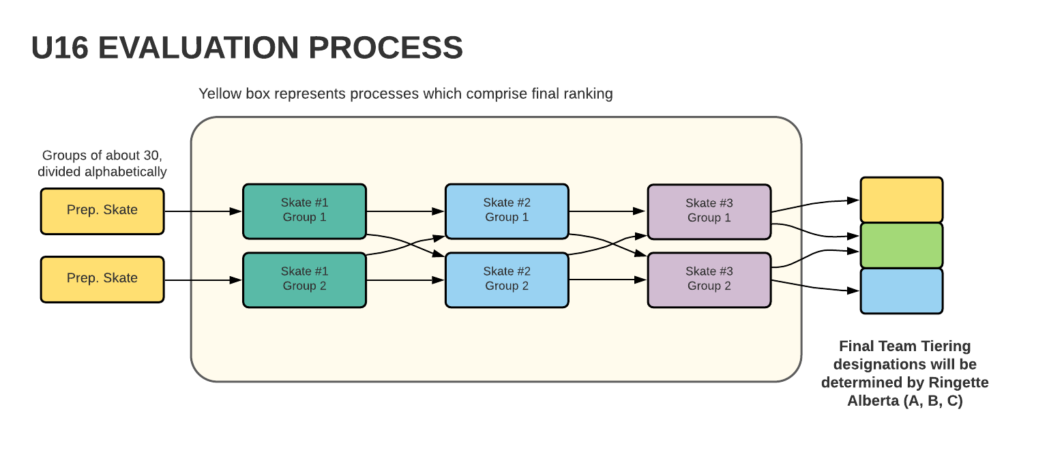

APPENDIX D: Team Formation
TEAM FORMATION: Mandatory vs Coach Pick

U10-U14
# Skaters | Pick Type | 75% - 25% | Coach Pick Window
10 | Mandatory | 8 | 4
 | Coach | 2
11 | Mandatory | 8 | 5
 | Coach | 3
12 | Mandatory | 9 | 5
 | Coach | 3
13 | Mandatory | 10 | 5
 | Coach | 3
14 | Mandatory | 11 | 5
 | Coach | 3
15 | Mandatory | 11 | 6
 | Coach | 4
16 | Mandatory | 12 | 6
 | Coach | 4

U16-U19
# Skaters | Pick Type | 66% - 33% | Coach Pick Window
10 | Mandatory | 7 | 5
 | Coach | 3
11 | Mandatory | 7 | 6
 | Coach | 4
12 | Mandatory | 8 | 6
 | Coach | 4
13 | Mandatory | 9 | 6
 | Coach | 4
14 | Mandatory | 9 | 8
 | Coach | 5
15 | Mandatory | 10 | 8
 | Coach | 5
16 | Mandatory | 11 | 8
 | Coach | 5

- Players tied in the ranking for the last mandatory spot will be included in the mandatory zone and number of coaches’ picks reduced accordingly
- In the highly unlikely event that the mandatory pick zone has been expanded due to players being tied and the zone exceeds the determined team size, the mandatory pick zone will be reduced by one
- Where possible, U16 and U19 Coaches will be supplied rankings based on preferred position, in addition to overall ranking to aid in selecting a positionally balanced team. If final team selections do not agree with either set of rankings, the coach must justify the selections, and the OC will have final approval.

COACH PICK: How far down can I select? 1.5X the coach pick number
- 1.5X the number of players to be picked beyond the last mandatory pick are eligible to be a coach’s pick.
- Players tied in the ranking at the final coach pick position will be included in the pick zone
- For two team draft, coach pick zone doubles.
- If evaluation score difference between a non- picked player and the lowest ranked picked player is six (6) points or greater, the selection is subject to OC approval.
- Where a significant drop in score between players occurs, the OC may reduce the coach pick window.
- Coaches are permitted ONE pick below the coach pick window, subject to OC approval.

TEAM FORMATION: Mandatory vs Coach Pick (Cont...)
IMPORT PLAYER POLICY
- The Edmonton Teams will be formed completely first, without consideration to any import players who may try out. This negates any effect on Edmonton player placement.
- Once the evaluation sessions are completed, per 4.2, the OC, will determine the A and B team sizes, based on Edmonton player registration numbers only. The B team will be afforded more players than the A team, to provide stability of numbers (for attendance) while providing opportunities for affiliation up. This may be done in consultation with the A team Head Coach.
- The A team will be formed, consisting only of Edmonton players, per the process in 4.2. The B team will consist of those players not selected for the A team.
- Import players will be added to the established A team roster, when the following conditions are met:
  - Per 5.1.1, any import player will be required to evaluate, when compared against Edmonton players, within in the top 50% of team size, as determined in 1).
  - Any import player(s) must have attended the minimum number of evaluation sessions to be considered a normal pick, per 6.1: a player may miss no more than one evaluation session.
- Import players not having a home association team to play on, and not selected to the A team roster, may be added to the B team roster provided there is room to accommodate them. Subject to OC approval.
- The Coach MAY refuse any import player.
- In years where Edmonton player numbers are small, and/or players from outside Edmonton do not have a home association team to play for, the Board of Directors may choose to accept such players for registration. These players will be treated as Edmonton players, NOT subject to the above policy, but WILL be subject to the withdrawal/refund policy.
Injured player policy
- Parent must present a medical note prior to evaluation start showing participation not allowed
- Parent must make application to Oversight Committee
- OC will decide player placing based on, but not limited to past years performance and review of previous year coach evaluation & coach opinions
- Team accepts player as an ‘extra’, where team sizes permit. Subject to OC approval
- Mandatory pick increases by 1, coach pick decreases by 1.

