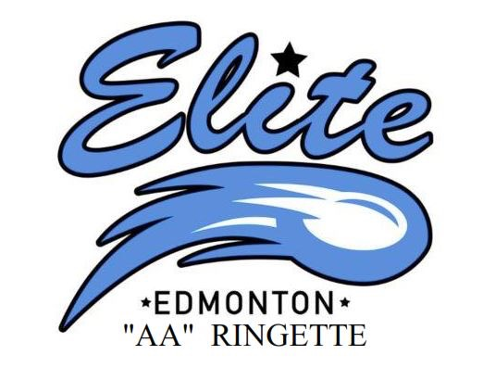

ERC Head Coach & Assistant Coach Application
2020-2021

Name: ___________________________________________________________

Address: ___________________________________________________________

Home Phone: _______________________ Cell: ________________________

Email: ____________________________________________

Applying for position of HC (Head Coach) AC (Assistant Coach) MGR (Manager) TR (Trainer)
U14 U16 U19 WAM!
___ HC ___ HC ___ HC ___ HC
___ AC ___ AC ___ AC ___ AC
___ MGR ___ MGR ___ MGR ___ MGR
___ TR ___ TR ___ TR ___ TR

Would you consider taking on a Head Coach position if you have applied only for the Assistant Coach position?
___Yes ___ No N/A

Would you consider taking on an Assistant Coach position if you have applied only for the Head Coach position?
___Yes ___ No N/A

Would you consider a coach position in a division other than that for which you applied?

___Yes ___ No

Please list below your coaching history: Please list ringette positions first.

Year Sport Age Div. Position Held Organization

NG CERTIFICATION
To coach at the AA level all coaches and assistant coaches are required to comply with Ringette Alberta coaching certification guidelines and must be willing to comply with all policies and guidelines as set out by the Edmonton Ringette Club.
Check off below which levels you currently have Old Program
[ ] CSI [ ] Full Level 1
[ ] CI Trained [ ] Full Level 2
[ ] CI Certified [ ] Full Level 3
[ ] Making Ethical Decisions

If you do not have the certification required for the division in which you have applied for, are you prepared to complete the deficiencies by December 15th, 2020? ____ Yes ____ No

Prior evaluations, particularly ERC evaluations, will be considered.Do you consent to the EFCLRA or other past association releasing your complete coaching evaluation history?

____ Yes ____ No
If No please explain:

____________________________________________________________________________

____________________________________________________________________________

Have you played Ringette in the past? _____ Yes ____ years ______ No
Up to what Level of Ringette? ____ Level

Attach a brief outline description on what you would like to put in place and accomplish next season in the role for which you are applying. Objectives and player development goals should be identified. Have you attached a brief outline?
____ Yes _____ No

If applying for the Head Coach Position, have you identified your potential assistant coaches? If you answered yes please name them.

____ Yes _____ No

1. | 2.
3. | 4.

Do you acknowledge that team selection is subject to ERC Executive Approval and that there should be no communication with players and parents prior to that approval?
____ Yes _____ No

Have you had any disciplinary Action by Ringette Alberta or any other Ringette or sport associations?

____ Yes _____ No
If yes, please explain:
____________________________________________________________________________

____________________________________________________________________________

ERC Policy, Tournaments, CRCs and Westerns

Please note that all head coaches, assistant coaches, and managers are expected to know, adhere to, and apply the ERC team selection policy, travel policy, and evaluations policy. All head coaches are expected to attend all tournaments of the team. If you require a copy of any policy, please email Christine Kearney at 31chrisk2@gmail.com. These policies touch on a number of ERC team activities, including tournaments and travel.

Do you agree to the ERC team selection policy, travel policy, and evaluations policy and that all head coaches are expected to attend all team tournaments.

____ Yes _____ No
If No please explain:
____________________________________________________________________________

____________________________________________________________________________

In particular, the ERC philosophy is that teams will attend, if the team qualifies to attend, the Canadian Ringette Championships (U16, U19, WAM!) and Western Canadian Championships (U14). In some seasons, this will mean that all teams in Alberta attend, regardless of their final position at provincials. This policy was in place and communicated to all head coaches in the summer of 2013. The ERC will continue to commit all teams to attend these championships. Attendance is not optional. For example, in 2016, all 12 Alberta teams (6 at each level, U16AA and U19AA) as well as all 3 Alberta NRL teams committed to attend or qualified and did attend CRCs. In 2016, 4 Alberta U14AA attended Westerns.

This is important to the ERC for long term athlete development and important to Ringette Alberta in that teams and clubs must honor their commitments as part of its commitment to Ringette Canada.

Will you actively promote the developmental benefits and experience of CRCs/Westerns?
____ Yes _____ No
If No please explain:
____________________________________________________________________________

____________________________________________________________________________

Will you confirm the team will attend at CRCs or Westerns regardless of the position in which the team qualifies?
____ Yes _____ No
If No please explain:
____________________________________________________________________________

____________________________________________________________________________

Will you follow the ERC disciplinary policy with regards to the removal and or additions of players on the ERC Teams? This Policy can be read on line.

____ Yes _____ No
If No please explain:
____________________________________________________________________________

____________________________________________________________________________

Will you confirm before team selection both with each player and with the ERC Executive Members (c/o 31chrisk2@gmail.com) that every player trying out will attend CRCs or Westerns, as the case may be?
____ Yes _____ No
If No please explain:
____________________________________________________________________________

____________________________________________________________________________

Do you acknowledge that any player who does not commit during tryouts to attend CRCs or Westerns will not be selected for a position on the team and will you communicate this before team selection to each family?
____ Yes _____ No
If No please explain:
____________________________________________________________________________

____________________________________________________________________________

Please submit your applications to the Technical Directors (Kelly Keylor & Kevin Harrison) kelly.Keylor@pcisupply.com and harris21@telus.net , copy to 31chrisk2@gmail.com. Deadline for Applications is June 1, 2020.

If necessary, interviews will be arranged. Coach selections will need to be ratified by the Board. We hope to have coach selections finalized by late June/early July or sooner.

