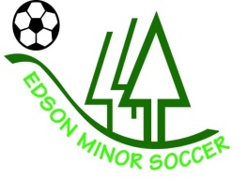
Diversity and Inclusion Policy

PURPOSE
The Edson Minor Soccer Association (EMSA) is committed to developing and fostering an inclusive and diverse environment for coaches, players, parents, and volunteers. EMSA recognizes the value of a diverse team of athletes and coaches. Differences in race, age, gender, sexuality, education, abilities and background are celebrated and recognized for the unique qualities that enhance our learning and experience while playing soccer. Any form of discrimination or bullying by those participating in Edson Minor Soccer will not be tolerated.
APPLICABILTY
This policy applies to all participants, volunteers and employees of EMSA.
GUIDING PRINCIPLES
EMSA is committed to providing an environment that promotes diversity and inclusion. Participants and coaches should be judge purely on their skills and character as a person and nothing else. EMSA has ZERO tolerance for any racist or discriminatory behaviours exhibited by members.
It is part of the EMSA mission statement that our soccer association provides an equal playing opportunity and an environment that is safe, inclusive and welcoming.
The EMSA Executive Board is focused on cultivating the diversity of our teams including encouraging more female athletes to join the sport.
EMSA coaches and volunteers will continue to educate themselves for the best practices in communication about diversity and inclusion.
EMSA will work to develop more programs for all abilities. The EMSA Board Executive works with families to ensure participants with special needs are accommodated and provided with an enjoyable and enriching soccer experience.
Partnerships
EMSA currently uses Jumpstart and KidSport to help with fees for participants from low-income families to have the ability to play.
Reporting
All reports of discrimination, bullying, racism or harassment will be taken seriously and investigated thoroughly. The EMSA Board Executive will issue sanctions as required if allegations are founded.

