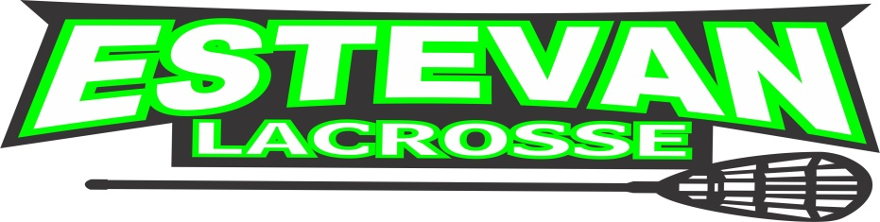
COACH/TRAINER APPLICATION

Name: |  | Date:

Address:

Phone: |  | Email:

Division Applying For:
(Mini-Tyke, Tyke, Novice, Peewee, Bantam, Midget, Junior, Senior)
Position Applying For:
(Head Coach, Assistant Coach, Trainer)
Coaching Certification Level:
(Community Development, Competitive Introduction, Competitive Certified)

Respect in Sport Certification #:
(Online Module required by Sask. Sport Inc.)

NCCP #:

CHILDREN REGISTERED IN VOLTZ LACROSSE

Name | Division

Estevan Voltz Lacrosse Association

