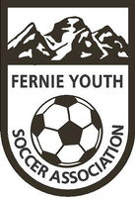
Fernie Youth Soccer Association PO Box 2751, 897 Mt. Wasshburn St., Fernie, BC V0B 1M0

Fernie Youth Soccer Association (FYSA)
Box 2751
Fernie, BC, V0B 1M4

Hello,
As a FYSA a volunteer (Coach, Co-Coach, Manager, etc.) you are required to have a criminal record check every 3 years.
If you have not done so or are not sure if your criminal record check is due, you can now apply online using the link and private access code below:
Online link: https://justice.gov.bc.ca/criminalrecordcheck

Access Code: QRHEJG7PJZ
Please select the "share the result of a completed criminal record check".
The result of the criminal record check will be sent directly to us.
If you have already completed the criminal record check in person, please email your result to us.
Kind Regards,
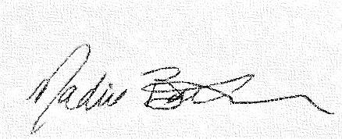
Nadine Baker
FYSA Operations Manager/Admin
403-850-0510
www.ferniesoccer.com

