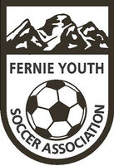
Fernie Youth Soccer Association PO Box 2751, 897 Mt. Wasshburn St., Fernie, BC V0B 1M0

Fernie Youth Soccer Association (FYSA)
Box 2751
Fernie, BC, V0B 1M4
Date: Nov.1, 2023 to onward
Attn: Fernie RCMP
RE: Police Information Check for _____________________________
We, FYSA, are requesting all our volunteer members complete Police Information Checks with all associated searches through RCMP. We are a non-profit organization and run purely on volunteers. Our volunteers work with the vulnerable sector.
Kind Regards,
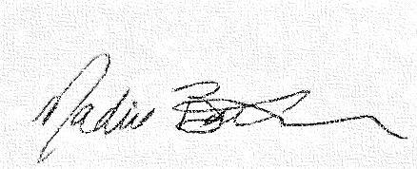
Nadine Baker
FYSA Operations Manager/Admin
403-850-0510
www.ferniesoccer.com

