FOREST XTREME RINGETTE PROGRAM

FUN1
FUN2

Updated May 2022
Forest, ON N0N 1J0
www.forestringette.com

What is Ringette?

Ringette is a Canadian invention that has become one of the fastest team sports on ice. Sam Jacks, a recreation director and sports enthusiast from North Bay, Ontario, invented the sport in 1963 when he saw the need for a winter team sport for girls.
Ringette, like hockey, is played on ice with skates and stick with six players per team on the ice at once. The objective is to score goals by shooting the object of play into the opposing team’s net at either end of the rink during stop-time periods of play. But this is where the comparisons between ringette and hockey really end. The stick is straight. The object being pursued by the players is a rubber ring, not a puck. There is no intentional body contact. The rules of ringette make it a wide-open and dynamic sport.
The emphasis is on play-making and skating skills. Players cannot carry the ring across the blue lines on the ice. Only three players from each team, plus the defending goalie, are allowed in the end zones at the same time, which keeps the play open, puts a premium on sharp offensive moves, and requires defending players to skate close to their opponents. These features of the game demand the development of keen skating skills that give ringette players fantastic skating and agility.

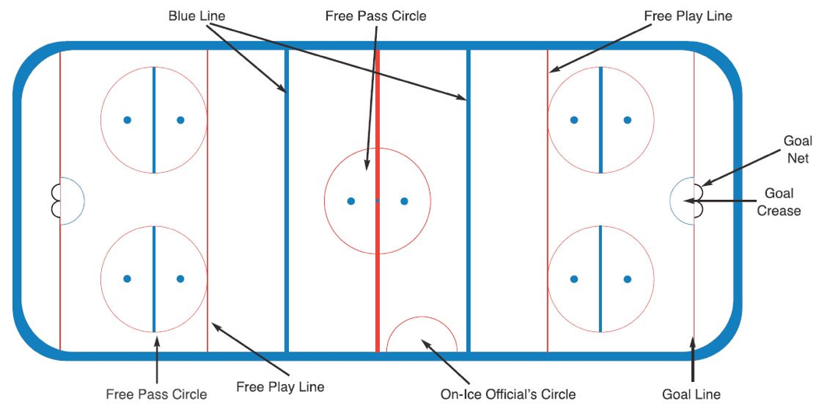

Levels of Play

Division | Grade | Age
FUN1 | JK & SK | 5 years & under
FUN2 | Gr. 1 & 2 | 7 years & under
FUN3 | Gr. 3 & 4 | 9 years & under
U12 | Gr. 5 & 6 | 11 years & under
U14 | Gr. 7 & 8 | 13 years & under
U16 | Gr. 9 & 10 | 15 years & under
U19 | Gr. 11, 12 & 13 | 18 years & under

Equipment

Players are required to wear regulation equipment when they are on the ice.

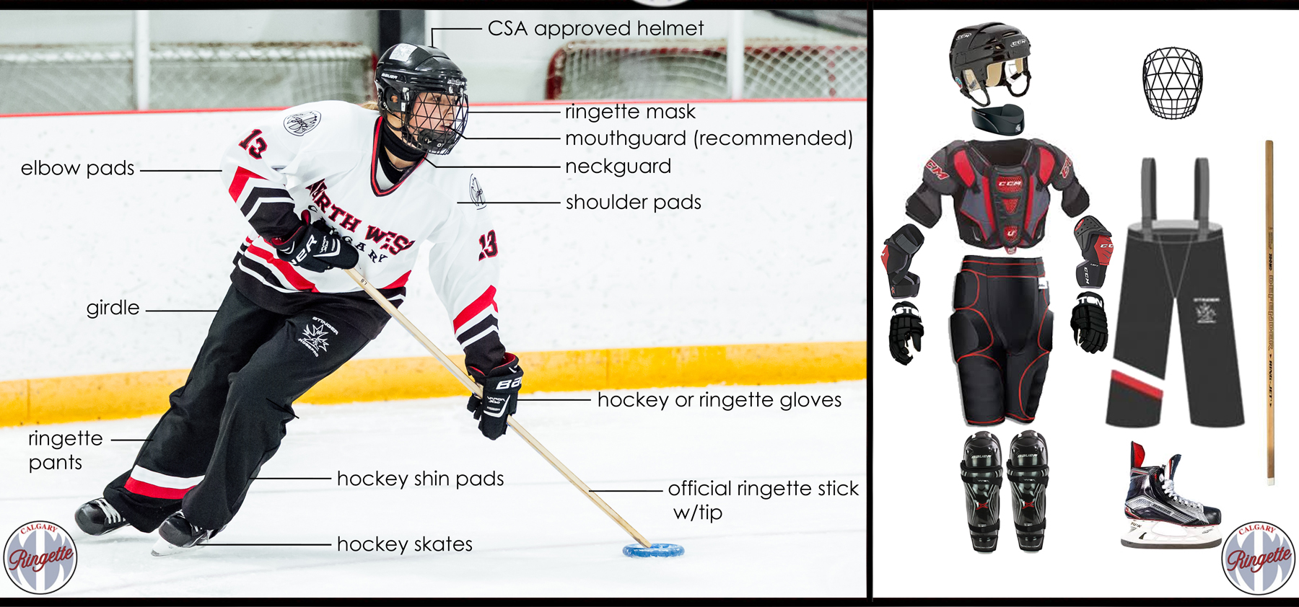

Note: Ringette pants and girdle are required for players, FUN3 and up. Hockey pants, hockey socks and jill are adequate for FUN1and FUN2.

DIAMOND MASKS ARE MANDATORY!

Jerseys and socks are provided to players and are expected to be returned at the end of the season.

How are the players organized?

FUN1

- Players in JK & SK
- Players will practice/skate at one end of the rink
- Typically at the Shores Recreation Centre Wednesdays at 4pm and Saturdays at 8am

FUN2

- Players in Grade 1 & 2
- These players play approximately 6-8 games per regular season
- These players play in 1-3 tournaments, at the discretion of the coach
- Players will practice/skate at one end of the rink
- Typically at the Shores Recreation Centre Wednesdays at 4pm and Saturdays at 8am

Players may enter the ice surface once a certified coach is on the ice and the Zamboni doors are closed.

My role as a parent

Parents are their childs biggest cheerleader and fan! Along with bringing your player to the rink for practices and games, parents:

- are a positive role model of sportsmanship
- remain at the arena while your child is on the ice
- run the score clock for games (not included in volunteer hours)
- complete game sheet on game sheet app (instructions provided on website)
- complete 4 volunteer hours in addition to the above items
- ask the coach/parent rep if you have any questions

The Ringette Season

Forest Xtreme Ringette’s season starts the first week after Labour Day and usually runs until the last weekend in March.

Players in the FUN1 and FUN2 program typically skate 2 hours per week. (Wednesdays at 4pm and Saturdays at 8am at the Shores Recreation Centre.)

Tournaments

FUN1
- Bunnyfest (Tuesday of March Break, 2 games, crafts, lunch) in Hensall

FUN2
- Whitby (one day, usually Saturday, 2 games) first weekend in January
- Bunnyfest (Tuesday of March Break, 2 games, crafts, lunch) in Hensall
- Regionals (one day, usually Saturday, 2 games) April 15 in Kitchener
- Coaches may choose to register in other tournaments

Raffle Fundraising

Forest Xtreme Ringette organizes fundraising per family, not per player. During registration, families pay $100 for raffle tickets. Tickets are distributed to families in December, when they will have an opportunity to sell their tickets. The money is withdrawn from your account on December 1st.

Banquet
Forest Xtreme Ringette celebrates the season by having a year end banquet for players and their parents. Players and parents are required to buy tickets for the banquet event.

Volunteer
Opportunities

All families within the Forest Xtreme Association are required to complete 4 volunteer hours. Failure to complete these hours will result in cashing of your $500 volunteer cheque. Some examples of volunteer opportunities are:

- Steam Threshers (August)
- Forest Fall Fair (September)
- Picture Nights (1-2)
- Equipment pickup and return nights
- Game pant pick up and return nights
- 3 on 3 tournaments (PD day in November, Family Day)
- Regionals (April 14-16)
- Banquet (set up, clean up)
- Any bench staff position
  - Head Coach
  - Assistant Coach
  - Trainer
  - On Ice Assistant
- Parent Rep
- Any Forest Ringette board position
  - President
  - Past President
  - Vice President
  - Secretary
  - Treasurer
  - Registrar
  - Ice Scheduler
  - Volunteer Director
  - Sponsorship Director
  - Communications Director
  - Equipment Director
  - Coaching Director
  - Events and Fundraising Director
  - Referee Director
  - General Director

