FOREST XTREME RINGETTE PROGRAM

FUN1

FUN2



Updated August, 2024

Forest, ON N0N 1J0

[www.forestringette.com](http://www.forestringette.com)

**What is Ringette?**

Ringette is a Canadian invention that has become one of the fastest team sports on ice. Ringette, like hockey, is played on ice with skates and sticks with six players per team on the ice at once. The objective is to score goals by shooting the object of play into the opposing team’s net at either end of the rink during stop-time periods of play. But this is where the comparisons between ringette and hockey really end. The stick is straight. The object being pursued by the players is a rubber ring, not a puck. There is no intentional body contact. The rules of ringette make it a wide-open and dynamic sport.

The emphasis is on playmaking and skating skills. Players cannot carry the ring across the blue lines on the ice. Only three players from each team, plus the defending goalie, are allowed in the end zones at the same time, which keeps the play open, puts a premium on sharp offensive moves, and requires defending players to skate close to their opponents. These features of the game demand the development of keen skating skills that give ringette players fantastic skating and agility.

**Levels of Play**

|  |  |  |
| --- | --- | --- |
| Division | Grade | Age |
| FUN1 | JK & SK | 5 years & under |
| FUN2 | Gr. 1 & 2 | 7 years & under |
| FUN3 | Gr. 3 & 4 | 9 years & under |
| U12 | Gr. 5 & 6 | 11 years & under |
| U14 | Gr. 7 & 8 | 13 years & under |
| U16 | Gr. 9 & 10 | 15 years & under |
| U19 | Gr. 11, 12 & 13 | 18 years & under |

**Objectives of the FUN1 & FUN2 Program**

* To ensure that all players have fun and look forward to coming to ringette each week, and want to return to play the following season, and also to create friendships that last a lifetime.
* To ensure parents and coaches provide a supportive environment for the players to build confidence and self-esteem.
* To develop the skating skills and confidence of each player, to provide a strong basis for continued skill development.
* To develop the auxiliary ringette skills of the players (passing, stabbing).
* To provide opportunities for game play to allow players an opportunity to be introduced to the rules and strategies of the game and to learn how to play as part of a team.

**The Ringette Season**

Forest Xtreme Ringette’s season starts the first week after Labour Day and usually runs until the last weekend in March.

**What does a typical season look like for my player?**

**FUN1**

* Players in JK & SK
* Typically at the Shores Recreation Centre Wednesdays at 4pm and Saturdays at 8am
* All ice times at this age group are designated as practices.
* Learning to skate is a primary focus for this age group (after having fun!), with the introduction of ringette skills (through drills and play) as the season progresses.
* There are opportunities for 1-2 “tournaments” during the season (see tournament section below for more details).

**FUN2**

* Players in Grade 1 & 2
* Typically at the Shores Recreation Centre Wednesdays at 4pm and Saturdays at 9am
* Wednesday ice times are typically practices, while Saturdays and/or other scheduled ice times may be for games.
* Skill development is a primary focus for this age group (after having fun!).
* All FUN2 players will play league games over the course of the season. There are typically 16 league games (8 home, 8 away).
* All players will have the opportunity to play in tournaments (typically 1-3), at the discretion of the coach. See more information regarding tournaments below.

**Additional Program Info:**

* The FUN1 and FUN2 programs are divided by their age groups, but there is collaboration between the programs and amongst the coaches and on-ice helpers. By November 1st of each season, the coaches will complete evaluations of the players, and will discuss the possibility of moving players up or down from FUN1 or FUN2 as recommended. (Note: **no** movement between levels will occur without discussion and permission from the players’ guardians).
* A note on games: The option to “opt out” of some games is available for families that are not prepared to travel for games. If you wish to do this, it is asked that you give *ample notice* to your player’s coach so that he or she can provide opportunities for FUN1 players or FUN2 players from another team to substitute.

**Safety:**

* Players may only enter the ice surface once a certified coach is on the ice and the Zamboni doors are closed.
* When FUN1 and FUN2 have shared ice time, they will be separated on their own half of the ice.

**Equipment**

Players are required to wear all regulation equipment when they are on the ice.

DIAMOND MASKS AND RINGETTE STICKS ARE MANDATORY. Cut-off hockey sticks are not permitted.

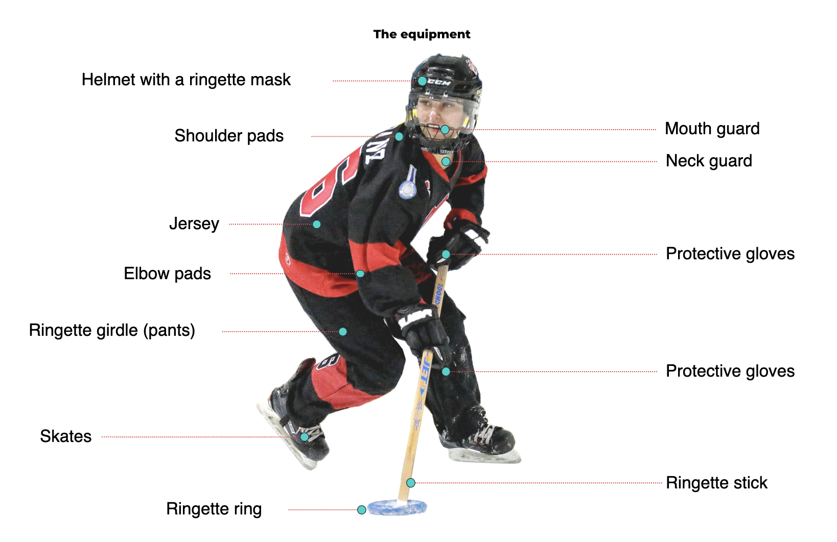

Note: Hockey pants, hockey socks and jill are adequate for FUN1and FUN2. Ringette pants and girdle are required for players, FUN3 and up. Mouth guards are optional.

Jerseys and socks are provided to players and are expected to be returned at the end of the season.

**My Role as a Parent**

Parents are their child's biggest cheerleader and fan! Along with bringing your player to the rink for practices and games, parents:

* Are a positive role model of sportsmanship.
* Remain at the arena while your player is on the ice.
* Complete 4 volunteer hours in addition to the above items (see a list of opportunities below).
* Demonstrate commitment to the team by ensuring their player is attending practices and games.
* Consistently check the RAMP app for scheduled ice times and changes, and RSVP to all games and practices.
* Give ample notice to the coach when your player will be absent from a game so that he or she has adequate time to fill the spot and to offer the opportunity to other players who are keen to attend.
* Run the score clock for games when assigned by the coach or parent rep to do so, along with completing the game sheet on the game sheet app (instructions are provided on the FRA website). Please ask the coach or parent rep if you have any questions about this. (Also note that this is not included in volunteer hours).

**On-Ice Support:**

* Having parents assist the coach on the ice at the FUN1 level is crucial in supporting the development of these skaters. If interested (and have the availability to be committed), please reach out to the FRA Coaching Director and/or your player’s coach.
* Make sure you register as an on-ice helper on the FRA website before you step on the ice. Contact the Coaching Director if you have any questions.

**Raffle Fundraising**

Forest Xtreme Ringette organizes fundraising per family, not per player. During registration, families pay $100 for raffle tickets. Tickets are distributed to families in November, when they will have an opportunity to sell their tickets. The money is withdrawn from your account on November 1st.

**Tournaments**

**FUN1**

* Jamboree in Watford (Family Day, 1 game, lunch and activities)
* Bunny Fest (Tuesday of March Break, 2 games, crafts and lunch)

**FUN2**

* Whitby - First weekend in January (one day, 2 games, usually on the Saturday)
  + Note: it is recognized within the organization that this is far to travel for one day/2 games. If families do not wish to attend, please inform your coaches as soon as possible.
* Jamboree in Watford (Family Day, 1 game, lunch and activities)
* Bunny Fest (Tuesday of March Break, 2 games, crafts and lunch)
* Regionals (location varies) - end of the season, typically in March (one day, 2 games, usually the Saturday)
* Coaches may choose to register in other tournaments.

**Year End Banquet**

Forest Xtreme Ringette celebrates the season by having a year-end banquet for players and their parents. The FUN1/FUN2 Banquet is typically held in the afternoon.

**Volunteer Opportunities**

All families within the Forest Xtreme Association are required to complete 4 volunteer hours. Failure to complete these hours will result in cashing of your $500 volunteer cheque. Opportunities are always shared via an email from the FRA and are also posted on social media. Some examples of volunteer opportunities are:

* Steam Threshers (August)
* Forest Fall Fair (September)
* Picture Nights (October)
* Equipment pickup and return nights (beginning and end of season)
* Game pant pick up and return nights (beginning and end of season)
* 3-on-3 tournaments (PD Day in November, Family Day)
* Regionals (year-end tournament)
* Banquet
* Any bench staff position
  + Head Coach
  + Assistant Coach
  + Trainer
  + On Ice Assistant
  + Parent Rep
* Any Forest Ringette board position
  + President
  + Past President
  + Vice President
  + Secretary
  + Treasurer
  + Registrar
  + Ice Scheduler
  + Volunteer Director
  + Sponsorship Director
  + Communications Director
  + Equipment Director
  + Coaching Director
  + Events Director
  + Fundraising Director
  + Referee Director
  + General Director