At the Forest Ringette Association, we know it takes teamwork to make great things happen! We’ve teamed up with Thuss’s Greenhouse! They have made available these beautiful 11inch pots for $25. Just in time for Mother’s Day!
Orders Due April 24th @ 5pm
Flower Pick up May 8th
Contact Jesse MacDonald @(226)886-3179 with any questions

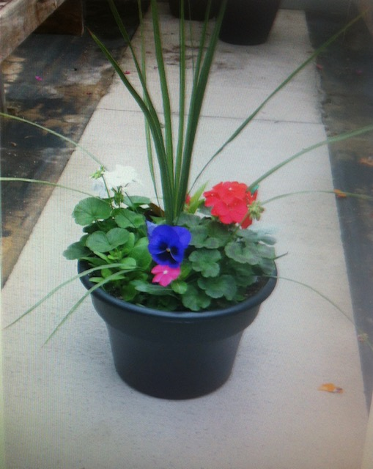

Person Selling:

Contact Number:

Name | Contact Information | # of Flower Pots | Total Paid
All orders must be received by April 24th @ 5pm.
Payment is to be made by e-transfer to : forestringettetreasure@gmail.com
In the memo section of the transfer PLEASE put Name of Person picking the order up, contact number and total amount ordered.
Pick up of flower pots will be done @71 King St East in Forest and will be following Social Distancing Guidelines

