Ringette BC
FUNdamentals 2 Practice Plan Template
Orange Phase – Part 1 (Week 5-7)

Day of the Week | Month, Day, Year | 60 Minutes | Location
Coaches/Helpers: | 3
Important Notes: | Skating development (stopping, forward strides, balance, agility)

Orange Part 1 Phase Emphasis
Skating Development | Technical Dev. | TGfU
Skating Development 32 minutes 65%
Technical Development 9 minutes 17%
Teaching Games for Understanding 9 minutes 17%

0:00XM - 0:00XM | 3 Minutes | Free Play

WARM-UP - BANANA TAG
0:00XM - 0:00XM |  | 5 Minutes
Coaches |  | 1-2
Equipment |  | None
Description |  | - Have all players put their sticks along the boards somewhere outside of the playing area (if you are using the full ice, put all sticks on the benches). The coach must define a boundary based on the amount of players in the game then identify 2- 3 players to be “Monkeys”. The “monkeys” will each be holding a ring in their hands.  - On the whistle the players will skate within the boundaries. The monkeys try to tag as many players as they can by touching them with their ring.  - When a player is touched they must stand with their hands up in the air above their heads together as if they are a banana. In order to get back in the game another player must stop next to the frozen player and peel their arms apart (as if they were peeling a banana).
Key Teaching Points |  | Forward skating strides, acceleration, crossovers/changing direction, balance, agility, awareness and stopping.
Adaptations | Easier | Expand the boundaries.
 | Harder | Shrink the boundaries.

STATIONS
0:00XM - 0:00XM | 30 Minutes (including water and transitions)

STATION 1: NIGHT AT THE MUSEUM
0:00XM - 0:00XM |  | 10 Minutes
Coaches |  | 1
Equipment |  | None
Description |  | - The coach chooses 1 player as the museum guard. The museum guard is a reasonable distance away from the other players, facing away from them. All the other players will be objects (fossils or relics) found within the Museum. They will come to life when the Museum Guard is not looking. To start, have them line up by the boards.  - Players will start to skate when the Museum Guard shouts “lights out!” Players skate towards the museum guard. When the guard turns around to face the objects, the objects must freeze in position (full stop).  - If an object is caught moving or falling by the museum guard, they must return to the start. The first player to the guard’s side is the winner.
Key Teaching Points |  | Forward skating strides, acceleration (V starts or crossover starts), stopping (snowplow or sideways), and backwards c-cuts.
Adaptations | Easier | Do snowplow stops instead of sideways stops.
 | Harder | Choose a direction that they must face when they stop (so they are doing a sideways stop) and have them do crossover starts. You can also make them skate backwards to the start if they are caught.

STATION 2: HALF-ICE PHILLY
0:00XM - 0:00XM |  | 10 Minutes | Category
Coaches |  | 1
Equipment |  | Rings
Description |  | 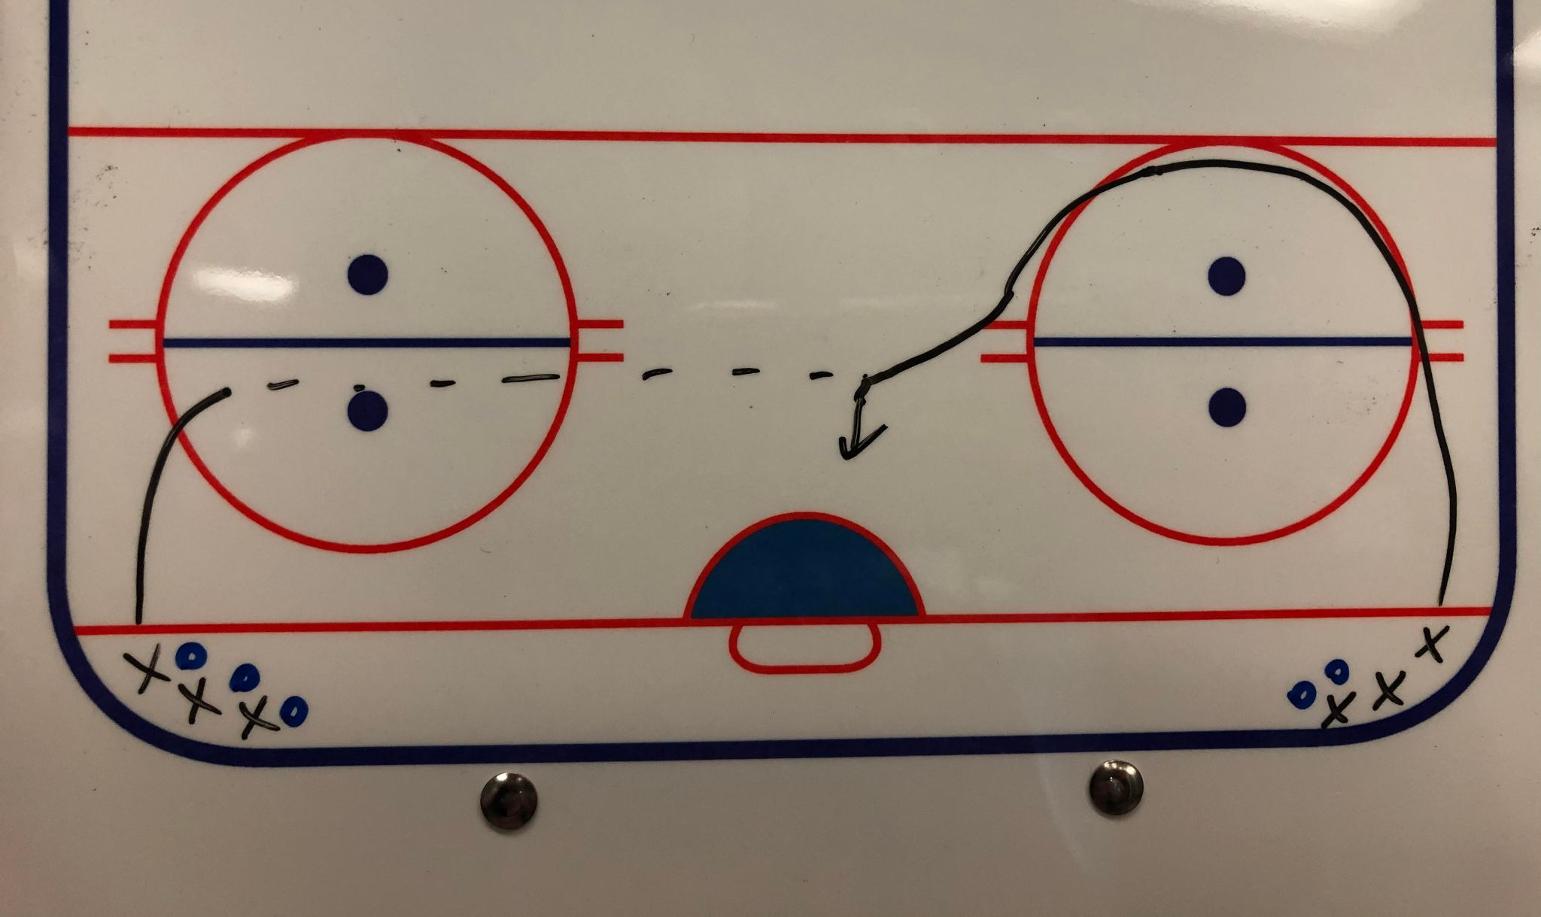 | - Separate the players into 2 lines with rings.  - The first player starts without a ring and skates around the top of the circle to the middle of the ice.  - The player in the other line skates up and provides a horizontal pass to the other player.  - The player with the ring shoots on the net and goes to the back of the opposite line from where they started from.  - Repeat steps 2-4 with the player who just passed the ring.
Key Teaching Points |  | Forehand/backhand passes, forehand/backhand shots

STATION 3: RING RACES
0:00XM - 0:00XM |  | 10 Minutes | Category
Coaches |  | 1
Equipment |  | Rings, 1 net
Description |  |  | - Players are divided into 2 lines with the coach in the middle. The coach has a ring.  - The coach tosses the ring ahead and, on their whistle, the first players in each line race for the ring.  - The person who gets the ring first is an offence and goes to shoot on the net, the other player acts as defence.
Key Teaching Points |  | Checking, defensive positioning, awareness, forehand/backhand shots,
Adaptations | Harder | The first people in each line start on their knees to practice quickly getting up.

GROUP GAME - DOCTOR DODGE-RING
0:00XM - 0:00XM |  | 15 Minutes | Category
Coaches |  | 1-2
Equipment |  | Rings, cones if needed to indicate boundaries
Description |  |  | - Divide the players into 2 teams and place each team on one half of the ice (divided by the red line). Then select 1-2 players on each team to be the doctors. An equal amount of rings are spread out on each ringette line.  - The players shoot and pass the rings across the ice and try to hit the skates of players on the other team (keeping the rings on the ice). If you get hit with a ring, you are now ‘injured” and must sit on both knees.  - The doctor can save injured teammates by holding their stick and pulling them behind the ringette line on their side. Once they’ve crossed the goal line, the player who was hit can stand up and keep playing.  - The game ends when one team has had all of their players (including doctors) hit by rings.
Key Teaching Points |  | Forward skating strides, shooting/passing (with power and accuracy), and awareness.
Adaptations | Easier | Play cross ice with players having to stay in the end zone

0:00XM - 0:00XM | 3 Minutes | Wrap-Up and Team Cheer

