Goalie Warmup Drills –

**Team Canada – Full Ice**



**6 Shot with Screen – Both Ends**

1. First round through – Shot to warm up goalie.
2. Second time through – First shooter becomes screen – Players must adjust to shoot through screen.

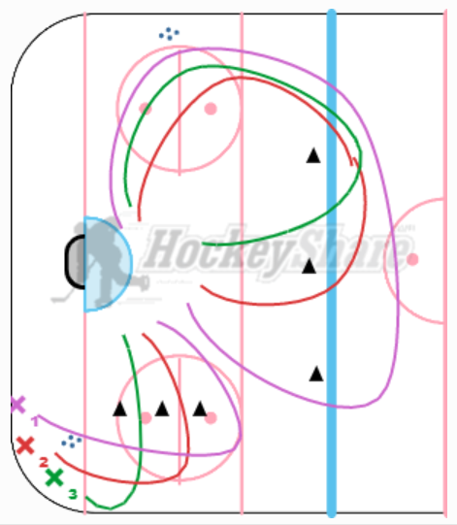

**4 Line Shoot and Race**

1. When we do this – Players on side of the net (Line 3 and 4) make passes to Line 1 and 2.
2. Staggered Line 1 and 2 so not to have 2 shots at once.

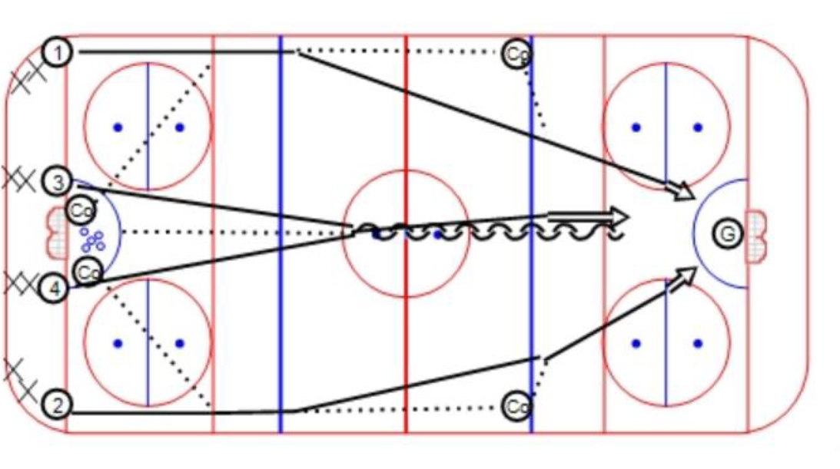

**Mike and Taylor Flow Drill**

X1 skates behind net and makes drop pass to X2 who is approach from the blue line (make drop pass away from goalie)

X2 then makes quick pass to X3

X3 make flat pass to X4 around the ringette line who is attacking the goal.

X4 becomes X1, X3 ->X4, X2->X3

